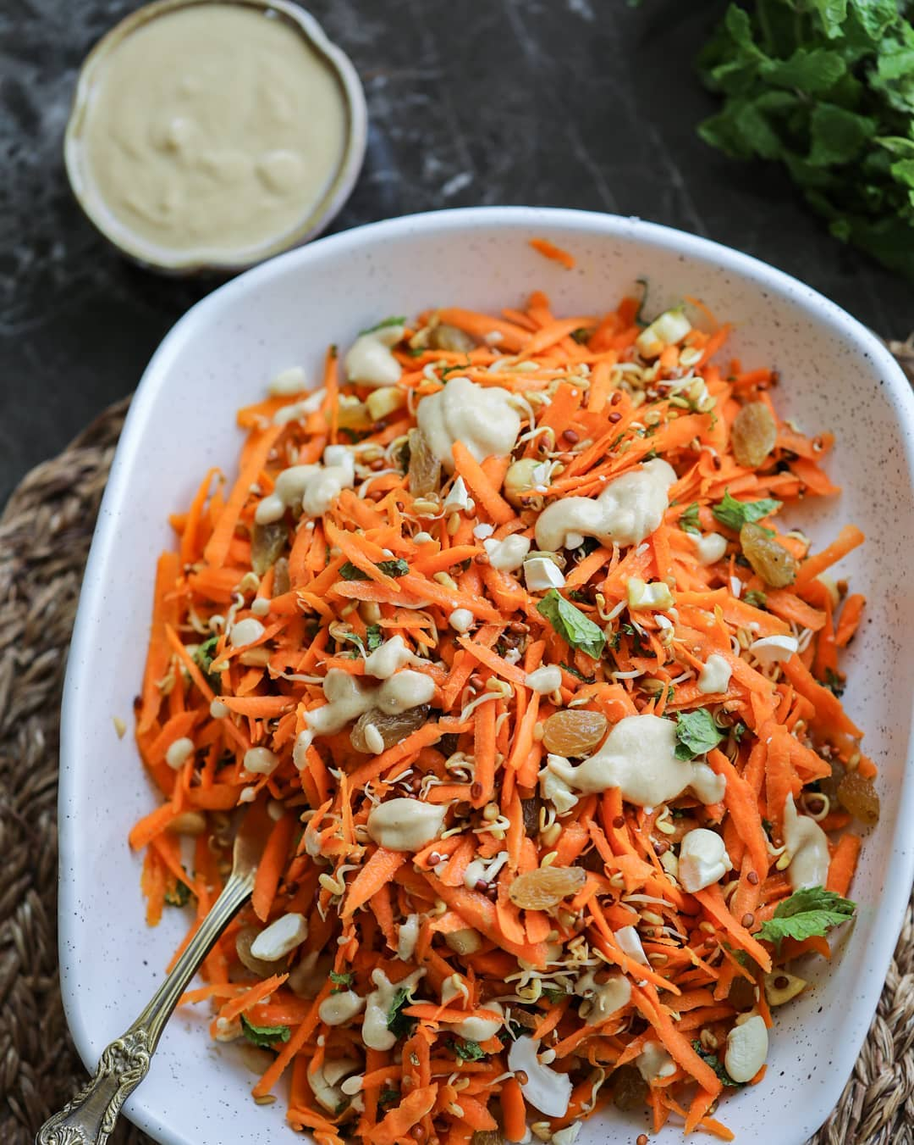

Carrot Raisin Salad  
  
When I looked at the red winter carrots at my vegetable vendor, I immediately knew that I wanted to make a dish out of it! And so, I made a delicious carrot raisin salad, with refreshing mint and a creamy tahini dressings! The ingredients are easily available in any Indian Kitchen.  
  
__________  
  
Serves: 2 as main meal  
  
INGREDIENTS  
3 cups shredded carrots  
1 cup vegetable sprouts - can be alfalfa, radish or fenugreek  
2 tablespoon finely chopped mint  
1⁄4 cup cashews, broken into pieces  
3 tablespoons raisins (kishmish)  
Tahini Dressing (makes 1⁄2 cup)  
1 cup white sesame seeds or 2 tbsp homemade tahini  
1⁄4 cup water  
2 dates  
1 tablespoon lemon juice 1⁄2 tablespoon jaggery  
1⁄8 green chilli  
1⁄4 teaspoon rock salt  
  
METHOD  
  
First, prepare the tahini. Tahini is a paste made from sesame seeds and is common in Mediterranean cuisine.  
1. To prepare tahini, add sesame seeds to  
a saucepan over medium heat and toast, stirring constantly until the seeds become fragrant and very lightly colored (not brown), 3 to 5 minutes. Careful, sesame seeds can burn quickly.  
2. Once sesame seeds have completely cooled, add them to a small blender and blend until  
a paste forms, about 30 seconds. The tahini should be extra smooth, not gritty.  
3. To prepare the tahini dressing, place 2 tablespoons of this homemade tahini into a blender, along with water, dates, lemon juice, jaggery, chili and salt. Blend until smooth.  
4. Place the carrots, sprouts, mint, cashews and raisins to a large mixing bowl. Mix well. Pour the tahini dressing on top and serve.

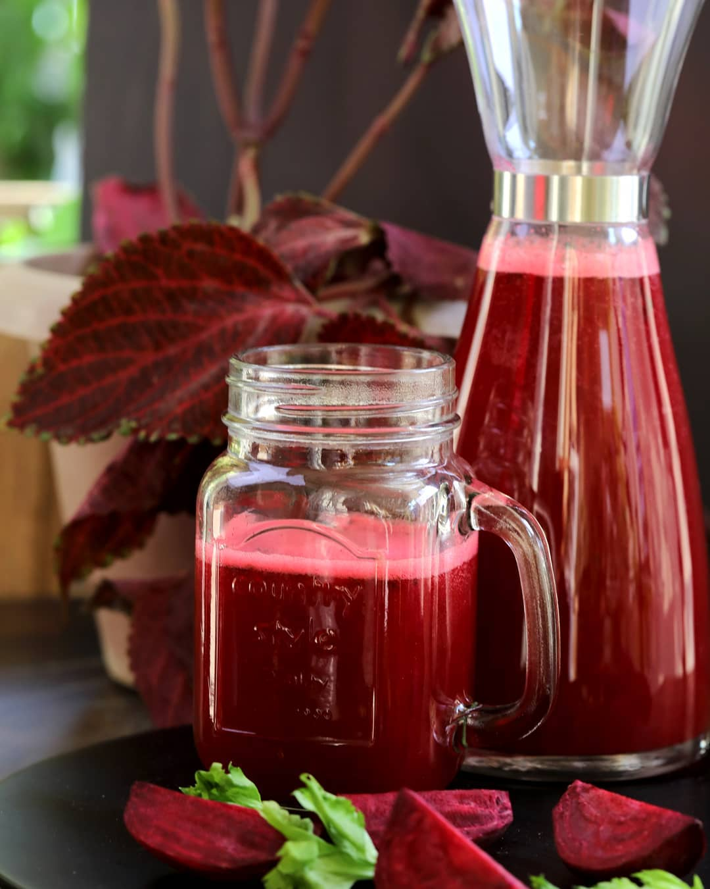

Pink Power Juice  
  
Juices are highly alkaline in nature. 70% of your diet should consist of alkaline foods. Juices digest quicker than even fruits and vegetables (about 1 hour). They cleanse your body by flushing out the waste in your intes$nes. While drinking juices, your body gets more of what it needs with less food. Introduce juicing as a culture in your life and you will see the benefits!  
  
__________  
  
Serves 2 (Makes 600 ml)  
  
INGREDIENTS  
  
3 cups chopped apples (approx. 2 apples)  
1 cup chopped beetroot (approx. 1 beetroot)  
2 cups chopped carrot (approx. 2 carrots)  
2 cups chopped cucumber (approx. 2 cucumbers) 3 coins ginger  
2 teaspoons lemon juice  
  
METHOD  
  
1. Simply juice everything.  
2. Add the lemon juice from the top and serve.  
  
Substitution: You can replace apples with pears.

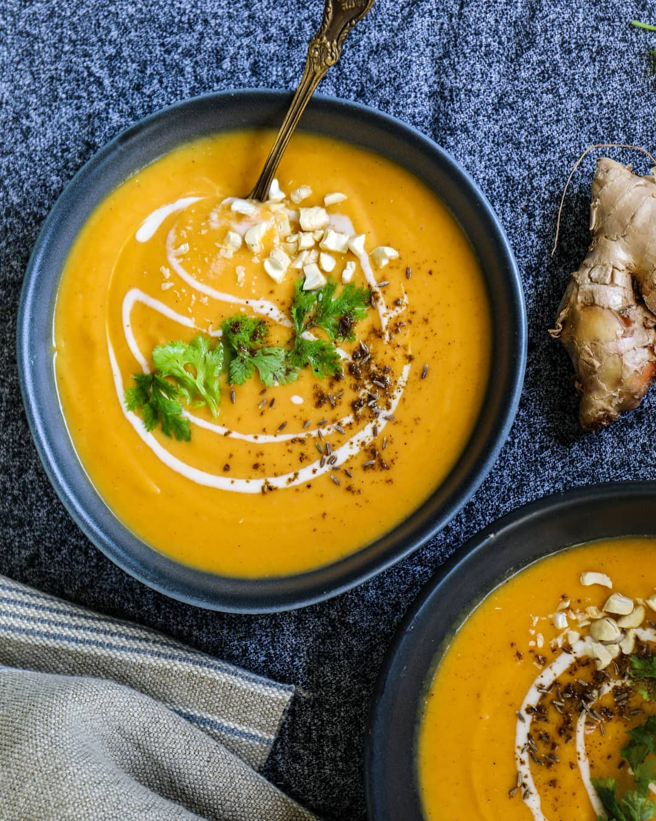

Carrot Cumin Soup  
  
This soup is unbelievably healthy (no oils, no processed foods) and easy (few ingredients). The finished soup has a wonderful creamy texture, especially considering there is no cream or cheese in it.  
  
__________  
  
Serves: 2 to 3 servings (Makes 1 liter)  
  
INGREDIENTS  
  
1 teaspoons cumin seeds  
1 inch coin of ginger, chopped  
1/2 teaspoon coriander powder  
2 cups diced carrots  
1 cup cauliflower florets  
3 cups water  
1 bay leaf  
1 cups coconut milk  
2 teaspoons rock salt  
1/2 teaspoon black pepper  
  
Garnish  
1 tablespoon coriander  
1 tablespoon chopped cashews  
pinch cumin seeds  
  
METHOD  
  
1. Heat a saucepan over medium heat. Add cumin seeds, ginger and coriander powder. Stir well and cook for one minute, till the spices become fragrant.  
2. Add diced carrot and cauli ower orets to the saucepan and cook for 5 minutes while stirring occasionally.  
3. Pour in the water and add the bay leaf. Bring to a boil. Partially cover the pot with a lid, reduce the heat to medium and simmer for 20 minutes.  
4. Blend the ingredients in the saucepan using a hand-blender.  
5. Add coconut milk, salt, pepper. Stir well.  
6. Garnish with coriander, cashews and cumin seeds. Serve hot.

Top of Form

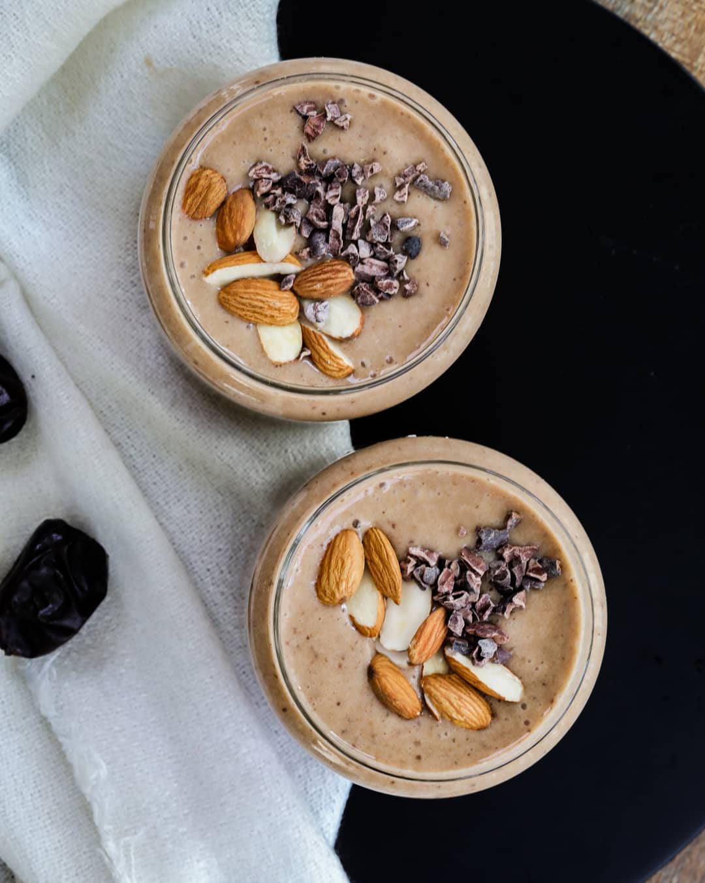Bottom of Form

Banana Date Shake  
  
Have you ever had a date shake? Here’s a healthier version of it. It tastes like dessert and the only sweeteners used are dates and bananas. No sugar, no dairy.  
__________  
  
Serves: 3cups  
  
INGREDIENTS  
1 1/2 cups coconut milk  
3 bananas  
6 dates, seedless  
4 ice cubes  
1/2 teaspoon cinnamon  
1 teaspoon cacao nibs (optional)  
6 chopped almonds (optional)  
  
METHOD  
  
1. Place coconut milk, bananas, dates, ice and cinnamon into a blender and blend until smooth.  
2. Top with cacao nibs and chopped almonds, to add an extra crunch (optional).  
3. Serve  
  
__________  
  
[**#healthyfood**](https://www.facebook.com/hashtag/healthyfood?__eep__=6&__tn__=*NK*F) [**#vegan**](https://www.facebook.com/hashtag/vegan?__eep__=6&__tn__=*NK*F) [**#plantbaseddiet**](https://www.facebook.com/hashtag/plantbaseddiet?__eep__=6&__tn__=*NK*F) [**#highvibration**](https://www.facebook.com/hashtag/highvibration?__eep__=6&__tn__=*NK*F) [**#loveandlight**](https://www.facebook.com/hashtag/loveandlight?__eep__=6&__tn__=*NK*F) [**#holisticliving**](https://www.facebook.com/hashtag/holisticliving?__eep__=6&__tn__=*NK*F) [**#mindfulliving**](https://www.facebook.com/hashtag/mindfulliving?__eep__=6&__tn__=*NK*F) [**#healthmatters**](https://www.facebook.com/hashtag/healthmatters?__eep__=6&__tn__=*NK*F) [**#mindbodygram**](https://www.facebook.com/hashtag/mindbodygram?__eep__=6&__tn__=*NK*F) [**#nourishyourself**](https://www.facebook.com/hashtag/nourishyourself?__eep__=6&__tn__=*NK*F) [**#holisticmedicine**](https://www.facebook.com/hashtag/holisticmedicine?__eep__=6&__tn__=*NK*F) [**#healthyhappylife**](https://www.facebook.com/hashtag/healthyhappylife?__eep__=6&__tn__=*NK*F) [**#liveinspired**](https://www.facebook.com/hashtag/liveinspired?__eep__=6&__tn__=*NK*F) [**#organiclifestyle**](https://www.facebook.com/hashtag/organiclifestyle?__eep__=6&__tn__=*NK*F) [**#nontoxicliving**](https://www.facebook.com/hashtag/nontoxicliving?__eep__=6&__tn__=*NK*F) [**#cleanliving**](https://www.facebook.com/hashtag/cleanliving?__eep__=6&__tn__=*NK*F) [**#greenlifestyle**](https://www.facebook.com/hashtag/greenlifestyle?__eep__=6&__tn__=*NK*F) [**#naturalhealth**](https://www.facebook.com/hashtag/naturalhealth?__eep__=6&__tn__=*NK*F) [**#selfloveclub**](https://www.facebook.com/hashtag/selfloveclub?__eep__=6&__tn__=*NK*F) [**#ipreview**](https://www.facebook.com/hashtag/ipreview?__eep__=6&__tn__=*NK*F)

Top of Form

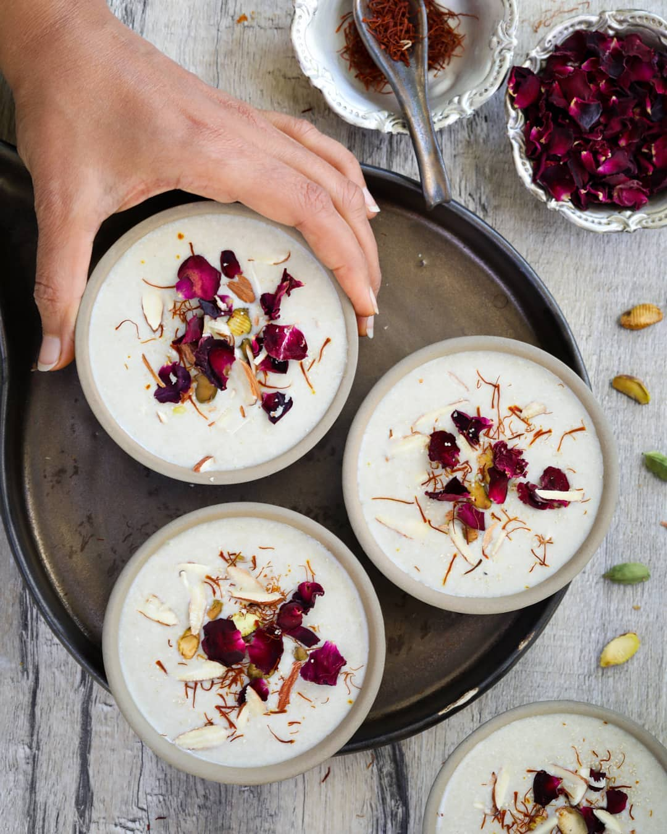

Bottom of Form

Delicious thandai without milk, sugar or the stove!  
  
__________  
  
Serves: 3 ( Makes 600 ml)  
  
INGREDIENTS  
8 almonds, soaked in water & drained  
1 tablespoon fennel, soaked in water & drained  
1 tablespoon poppy seeds, soaked in water & drained  
1 1/2 cups coconut milk  
1/2 cup water  
4 dates, seedless  
1 teaspoon powdered jaggery  
1/8th teaspoon rock salt  
1/8th teaspoon black pepper  
  
Garnishing  
Chopped pistachio  
Saffron  
Dried rose petals  
  
METHOD  
  
1. Place everything except coconut milk into a blender and blend until smooth.  
2. Add coconut milk and blend again.  
3. Let the drink cool in the refrigerator for a while. Garnish & serve

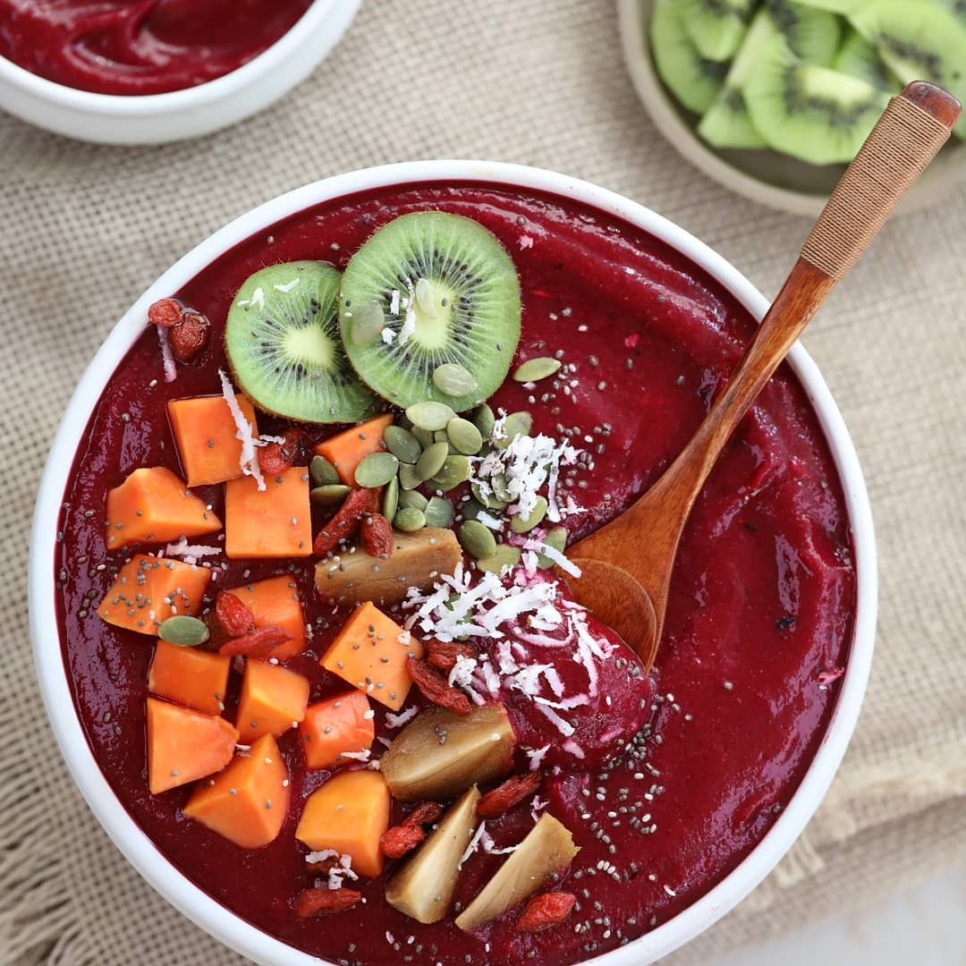

Super delicious smoothie bowl that can be prepared within minutes.  
This blush smoothie bowl provides you with just pure, clean oxygen powered energy which makes it the perfect post- workout breakfast. It is loaded with minerals, vitamins and healthy fats. Beetroot purifies the blood. Pears are alkaline fruits which improve intestinal health, and the bananas give it a perfect texture.  
Wishing you all a Merry Christmas   
  
__________  
  
Serves 2  
  
INGREDIENTS  
  
2 Frozen bananas  
3 Chopped pears  
1/2 cup chopped beetroot  
  
Topping  
Any seasonal fruits and nuts  
  
METHOD  
1. Take the bananas, peel, slice and put in freezer for about 5-6 hours.  
2. Place the pears, beetroot and frozen bananas in a blender and blend until smooth.  
3. Pour this smoothie base into bowls and top with any fresh seasonal fruits and nuts. I have used papaya, chikoo, kiwi, coconut, pumpkin seeds, goji berries and Chia seeds.  
  
__________  
  
[**#satvicmovement**](https://www.facebook.com/hashtag/satvicmovement?__eep__=6&__tn__=*NK*F) [**#healthyeating**](https://www.facebook.com/hashtag/healthyeating?__eep__=6&__tn__=*NK*F) [**#fresh**](https://www.facebook.com/hashtag/fresh?__eep__=6&__tn__=*NK*F) [**#plantbased**](https://www.facebook.com/hashtag/plantbased?__eep__=6&__tn__=*NK*F) [**#eeeeeats**](https://www.facebook.com/hashtag/eeeeeats?__eep__=6&__tn__=*NK*F) [**#holisticliving**](https://www.facebook.com/hashtag/holisticliving?__eep__=6&__tn__=*NK*F) [**#naturalliving**](https://www.facebook.com/hashtag/naturalliving?__eep__=6&__tn__=*NK*F) [**#healthy**](https://www.facebook.com/hashtag/healthy?__eep__=6&__tn__=*NK*F) [**#nontoxicliving**](https://www.facebook.com/hashtag/nontoxicliving?__eep__=6&__tn__=*NK*F) [**#mindbodygram**](https://www.facebook.com/hashtag/mindbodygram?__eep__=6&__tn__=*NK*F) [**#cleaneating**](https://www.facebook.com/hashtag/cleaneating?__eep__=6&__tn__=*NK*F) [**#nutrition**](https://www.facebook.com/hashtag/nutrition?__eep__=6&__tn__=*NK*F) [**#fruits**](https://www.facebook.com/hashtag/fruits?__eep__=6&__tn__=*NK*F) [**#healthylifestyle**](https://www.facebook.com/hashtag/healthylifestyle?__eep__=6&__tn__=*NK*F) [**#eatclean**](https://www.facebook.com/hashtag/eatclean?__eep__=6&__tn__=*NK*F) **#**

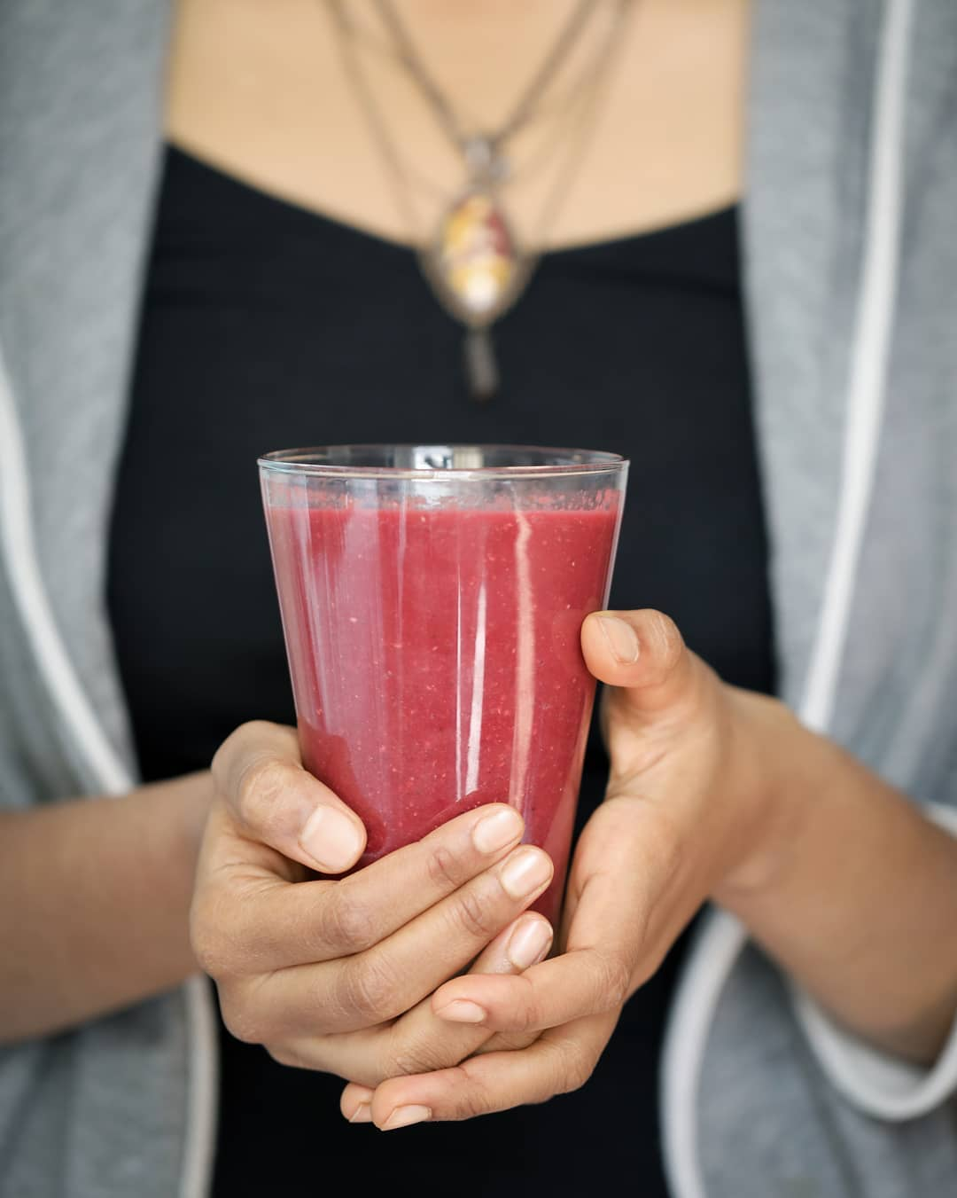

Watermelon Chia Smoothie   
  
Watermelon is absolutely perfect for summer drinks. It’s amazingly hydrating. Chia seeds are a great source of fiber, and help you keeping full for longer. They plump up and thicken any liquid that you add them to. Mint is another great addition, as it adds a refreshing flavour to the smoothie.  
__________  
  
Serves 2  
INGREDIENTS  
2 cups watermelon, diced  
1 cup pomegranate  
1⁄4 beetroot, peeled and chopped 1 tablespoon mint leaves  
1 tablespoon chia seeds  
METHOD  
1. Blend watermelon, pomegranate, beetroot and mint.  
2. Place the smoothie in a pitcher and s$r in the chia  
seeds. Before serving, let the smoothie sit in the refrigerator for 15 minutes to allow the chia seeds to absorb some of the juice and plump up.

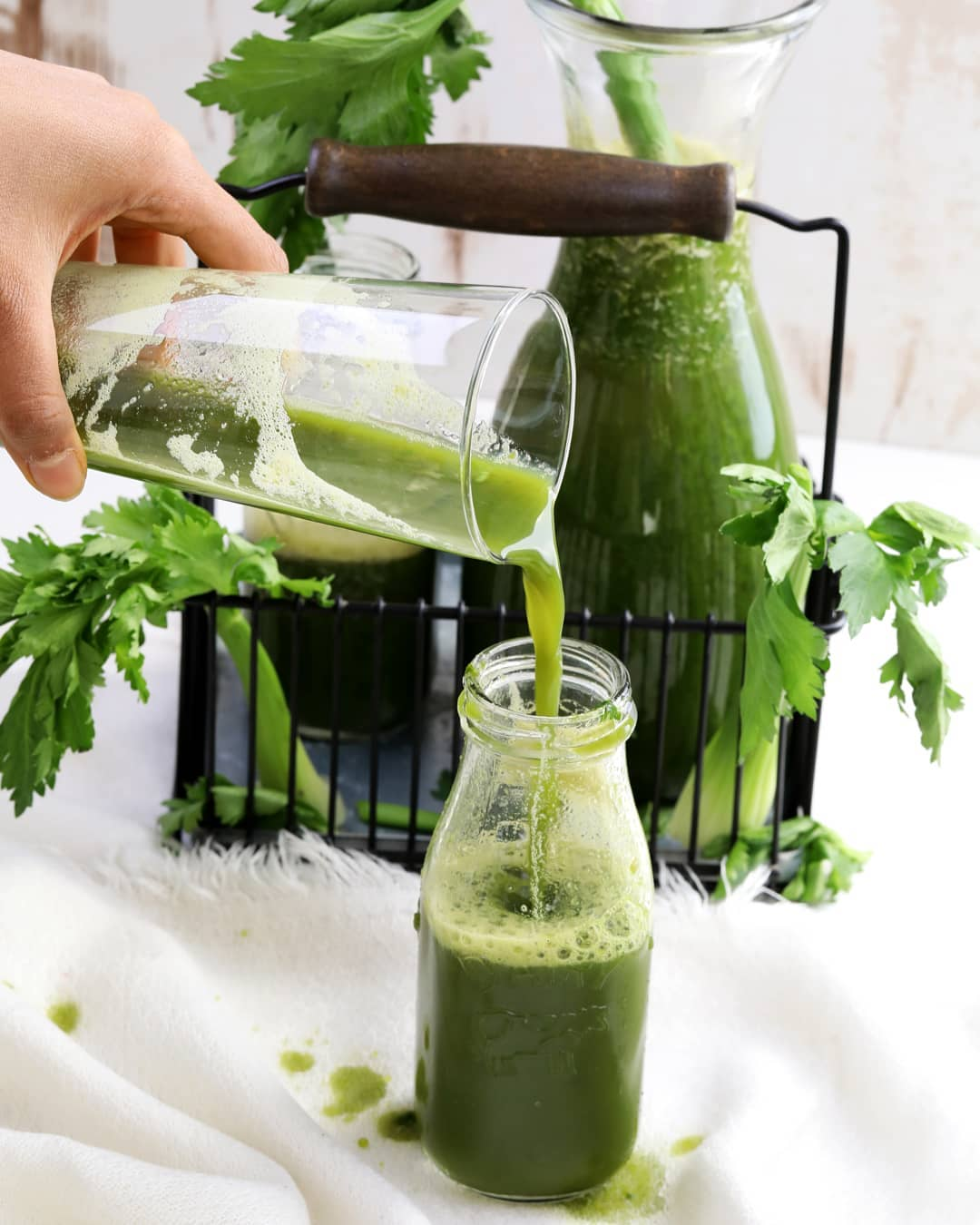

This is my FAVORITE Green Juice Recipe. I’ve actually been drinking it for almost two years now and I can’t believe I never had the thought to share it with you! The best part is that it’s  
made using all local ingredients.  
__________  
SERVES 2 (Makes 600 ml)  
  
INGREDIENTS  
2 cups chopped cucumber (approx. 1 cucumber)  
1 cup chopped boale gourd  
1 cup roughly chopped spinach, $ghtly packed  
¼ cup mint leaves, $ghtly packed  
2 cups chopped apple (approx. 2 apples)  
1 teaspoon lemon juice  
METHOD  
1. Simply juice all the ingredients.  
2. Add the lemon juice from the top and serve.  
Tip:  
When juicing leafy greens like spinach and mint, alternate them with watery ingredients such as cucumber and apples. This helps your juicer to keep things moving.  
Variation:  
You can replace apples with pears.

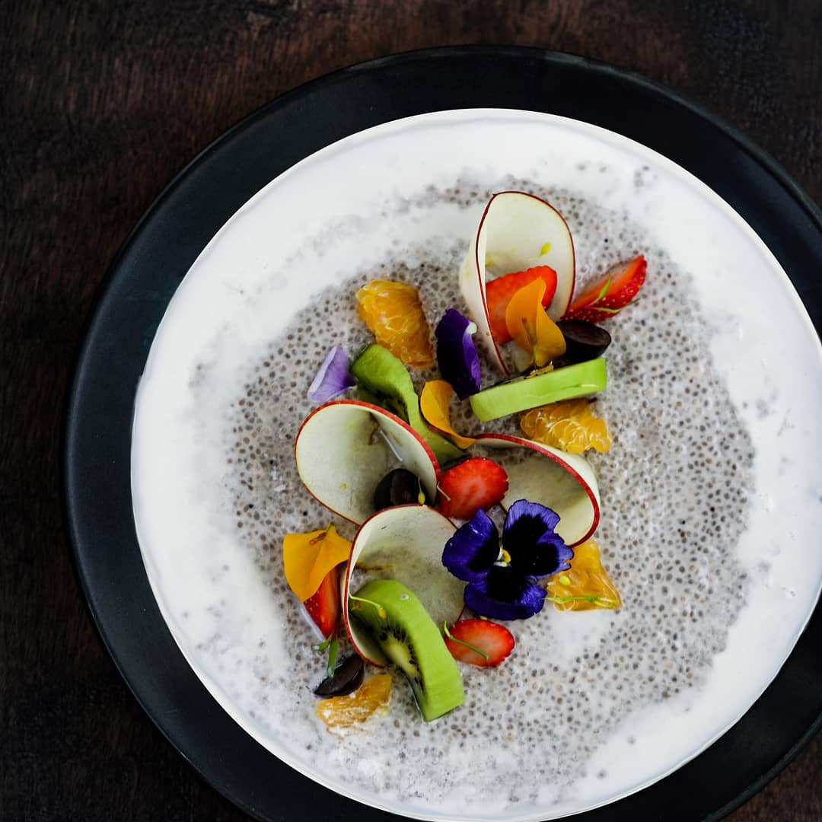

This chia pudding recipe has been a staple for me, ever since I’ve started living the Satvic lifestyle. It’s fully vegan and raw and only made using life giving nuts and fruits!  
  
__________  
  
Serves 2-3 (MAKES 2 CUPS)  
  
INGREDIENTS  
1 cup coconut milk  
1½ tablespoon powdered jaggery  
½ ripe banana  
⅛ teapsoon rock salt  
2 tablespoons chia seeds  
1 cup chopped mixed fruits (such as banana, mango, grapes, pear, kiwi, orange, pomegreate, berries)  
  
Garnish  
Edible flowers  
  
Topping  
Fresh seasonal fruits  
Edible flowers (optional)  
  
METHOD  
1. Place coconut milk, jaggery, banana and salt into a blender and blend until smooth.  
2. Pour this mixture over chia seeds and let them soak for about 2 hours on the kitchen counter. The chia seeds will swell up and thicken the mixture.  
3. Add the chopped fruits to the chia seed mixture. Place the pudding in the refrigerator for 30 minutes before serving, to make it cold.  
Tip: You don’t need to plate this dish like I have in the photo. You can just throw in some fresh fruits in your pudding and mix it all up. But if you do wish to plate it, here’s some tips: thinly slice your fruits using a sharp knife or mandolin, roll them up and place them on top of your pudding. I did so using an apple. If you want to take it a step further, garnish with edible flowers such as pansies.  
__________  
  
[**#satvicmovement**](https://www.facebook.com/hashtag/satvicmovement?__eep__=6&__tn__=*NK*F) [**#naturalliving**](https://www.facebook.com/hashtag/naturalliving?__eep__=6&__tn__=*NK*F) [**#healthylifestyle**](https://www.facebook.com/hashtag/healthylifestyle?__eep__=6&__tn__=*NK*F) [**#healthy**](https://www.facebook.com/hashtag/healthy?__eep__=6&__tn__=*NK*F) [**#vegan**](https://www.facebook.com/hashtag/vegan?__eep__=6&__tn__=*NK*F) **#**

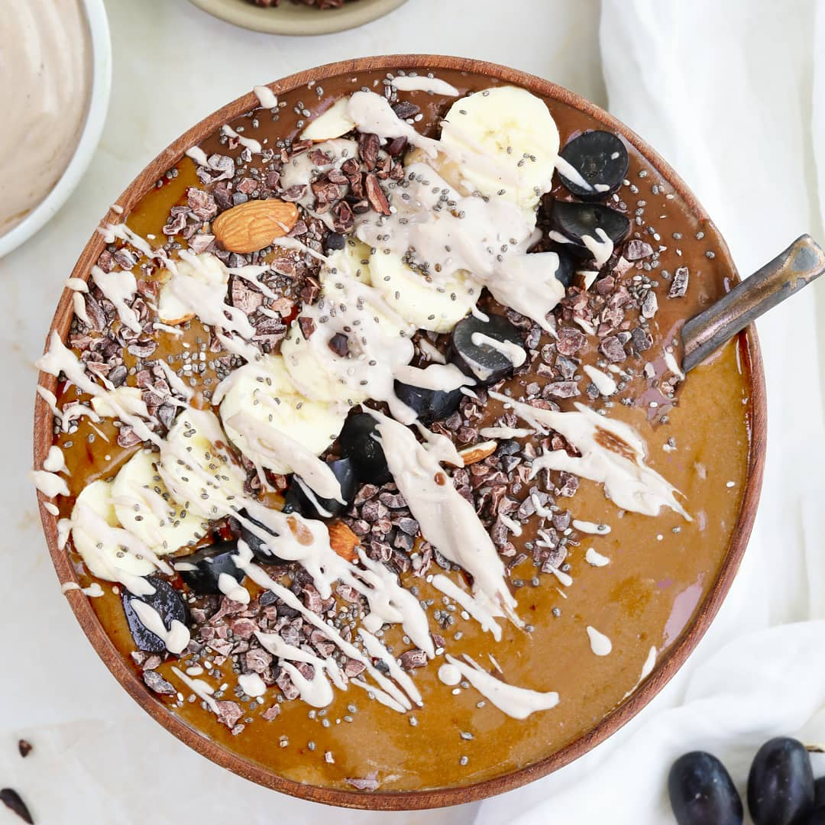

Coco Crunch Smoothie Bowl  
Would you believe me if I told you that this bowl is actually healthy? It is raw, unprocessed and the only sweetener we use is banana. It may look fancy, but making it is simple and fun. I love having it as a breakfast treat!  
  
__________  
  
Serves 2  
INGREDIENTS  
  
3 frozen bananas  
¼ cup coconut water  
1½ cups coconut cream  
1 tablespoon carob or cacao powder  
1 coin ginger  
½ teaspoon cinnamon  
a pinch of salt  
any seasonal fruits and nuts for topping  
  
METHOD  
1. Take 4 bananas, peel, slice and put to freeze for about 5-6 hours.  
2. Blend together the frozen bananas, coconut water, coconut cream, cacao powder, ginger, cinnamon and salt.  
3. Pour into bowls and top with your favorite toppings. I used banana, grapes, almonds, cacao nibs, and some coconut cream blended with some dates.  
Tip: Nuts and seeds are great, to add texture to your bowl, but please don’t go overboard with them. At the end of the day, they are dry in nature and must be eaten in limited amounts. Focus on fresh, water-rich fruits for your topping.  
Don’t forget to freeze your bananas. They are key to achieving a good texture for your smoothie base.  
__________  
  
[**#satvicmovement**](https://www.facebook.com/hashtag/satvicmovement?__eep__=6&__tn__=*NK*F) [**#smoothiebowls**](https://www.facebook.com/hashtag/smoothiebowls?__eep__=6&__tn__=*NK*F) [**#holisticliving**](https://www.facebook.com/hashtag/holisticliving?__eep__=6&__tn__=*NK*F) [**#breakfast**](https://www.facebook.com/hashtag/breakfast?__eep__=6&__tn__=*NK*F) [**#fruits**](https://www.facebook.com/hashtag/fruits?__eep__=6&__tn__=*NK*F) [**#healthy**](https://www.facebook.com/hashtag/healthy?__eep__=6&__tn__=*NK*F)

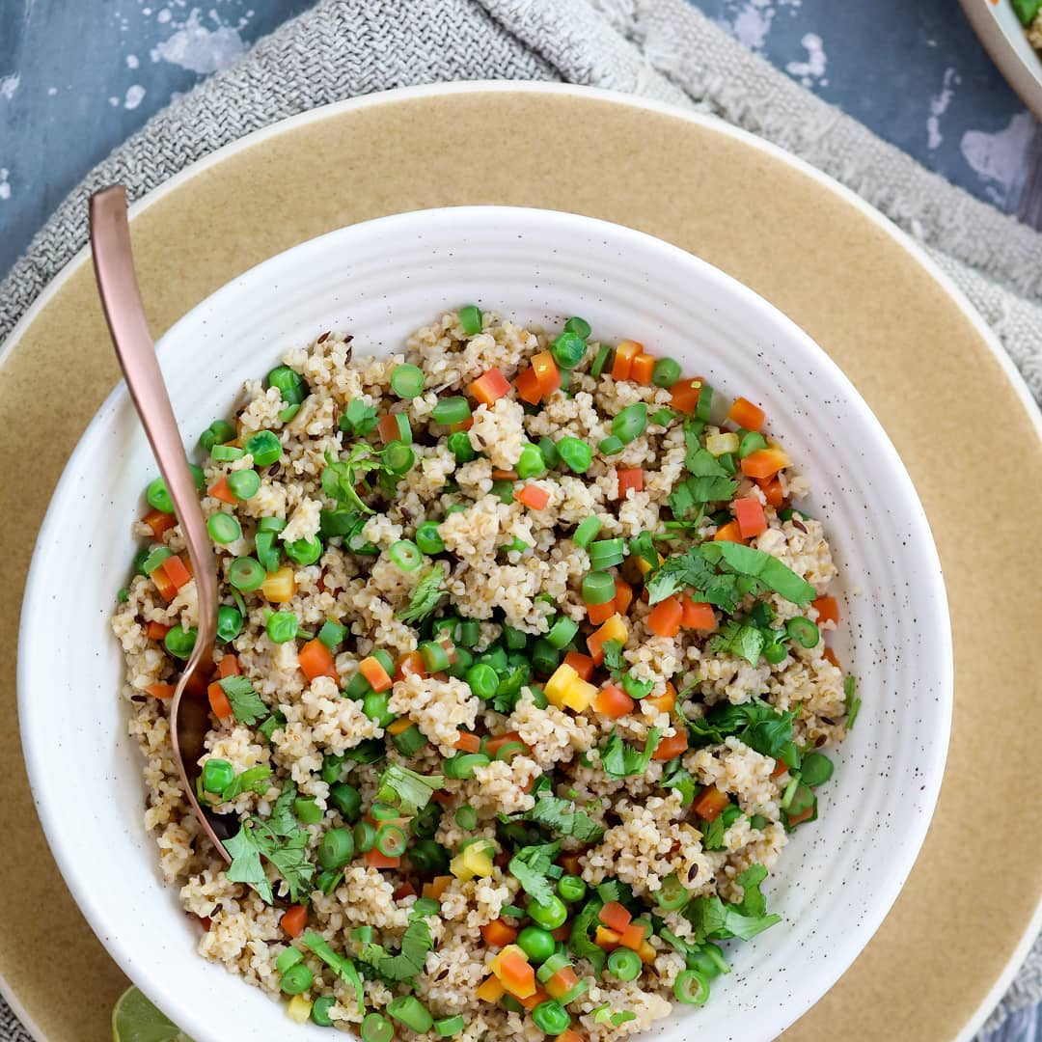

The SATVIC Daliya uses less grain and more vegetables. The ratio is 1:3 (1 cup grain to 3 cups vegetables). Why? Because grains are hard to digest. The human body has to spend a  
lot of time processing grains (about 18 hours to be precise). But when combined with vegetables, ultimately, less grain goes inside the body, which means that the body can spend less time digesting grains and more time healing itself.  
  
__________  
  
Serves 2-3  
  
INGREDIENTS  
1 cup broken wheat porridge  
1 ½ teaspoons cumin seeds  
1 cup green beans, finely chopped  
1 cup carrots, finely chopped  
1 cup green peas  
2 small green chillies, very finely crushed  
4 cups water  
2 teaspoons rock salt  
freshly ground pepper  
handful fresh coriander  
  
METHOD  
1. Roast the broken wheat porridge lightly in a pan till it turns light brown. Then, take it out in a bowl.  
2. Take another pan. Heat it on a medium flame. Add the cumin seeds and roast till they are dark brown. Add the beans, carrots and peas and stir well. Add the finely crushed green chillies and stir again.  
3. Add 4 cups of water to the pan and let it come to a boil. Then, add the roasted porridge to the pan. Cover the pan and keep the stove on a medium flame till the porridge absorbs all the water.  
4. Once everything is cooked, turn off the stove. Add rock salt and keep it covered for 5 minutes.  
5. Garnish with generous amounts of fresh coriander and enjoy with green chutney. Eat within 3-4 hours of preparing it.  
  
__________  
  
[**#satvicmovement**](https://www.facebook.com/hashtag/satvicmovement?__eep__=6&__tn__=*NK*F) [**#healthy**](https://www.facebook.com/hashtag/healthy?__eep__=6&__tn__=*NK*F) [**#fresh**](https://www.facebook.com/hashtag/fresh?__eep__=6&__tn__=*NK*F) **#**

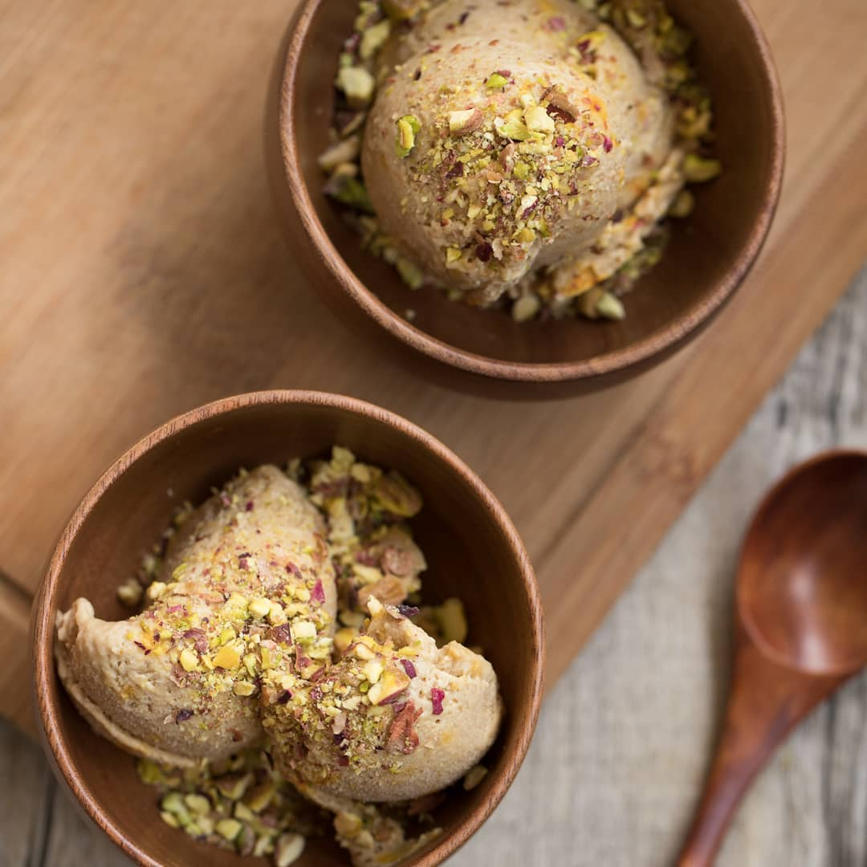

Satvic Kulfi  
  
Imagine eating Kulfi that is good for your body and contains no sugar or milk, and is made using ingredients straight from nature ___________  
  
Serves 3  
  
INGREDIENTS  
1⁄2 cup cashews, soaked in water for about 6 hours  
1 cup coconut malai  
1⁄4 cup jaggery, powdered  
4 dates, seedless  
1⁄3 cup coconut water  
10 strands of saffon  
pinch green cardomom powder  
pinch rock salt  
  
Topping  
1 tablespoon chopped pistachios  
  
___________  
  
METHOD  
1. Place all the ice cream ingredients in a blender and blend until smooth.  
2. Pour the mixture into a shallow glass dish or a steel container, and let it freeze for about 6 hours in the freezer.  
3. Before serving, let the ice cream thaw on a counter for 15-30 minutes, until it becomes soft enough to scoop.  
4. Top with chopped pistachios and serve.  
  
_________  
  
[**#healthyfood**](https://www.facebook.com/hashtag/healthyfood?__eep__=6&__tn__=*NK*F) [**#vegan**](https://www.facebook.com/hashtag/vegan?__eep__=6&__tn__=*NK*F) [**#plantbaseddiet**](https://www.facebook.com/hashtag/plantbaseddiet?__eep__=6&__tn__=*NK*F) [**#eatclean**](https://www.facebook.com/hashtag/eatclean?__eep__=6&__tn__=*NK*F) [**#eattherainbow**](https://www.facebook.com/hashtag/eattherainbow?__eep__=6&__tn__=*NK*F) [**#veganlife**](https://www.facebook.com/hashtag/veganlife?__eep__=6&__tn__=*NK*F) [**#holistichealth**](https://www.facebook.com/hashtag/holistichealth?__eep__=6&__tn__=*NK*F) [**#holisticliving**](https://www.facebook.com/hashtag/holisticliving?__eep__=6&__tn__=*NK*F) [**#healthmatters**](https://www.facebook.com/hashtag/healthmatters?__eep__=6&__tn__=*NK*F) [**#organiclifestyle**](https://www.facebook.com/hashtag/organiclifestyle?__eep__=6&__tn__=*NK*F) [**#cleanliving**](https://www.facebook.com/hashtag/cleanliving?__eep__=6&__tn__=*NK*F) [**#mindandbody**](https://www.facebook.com/hashtag/mindandbody?__eep__=6&__tn__=*NK*F)

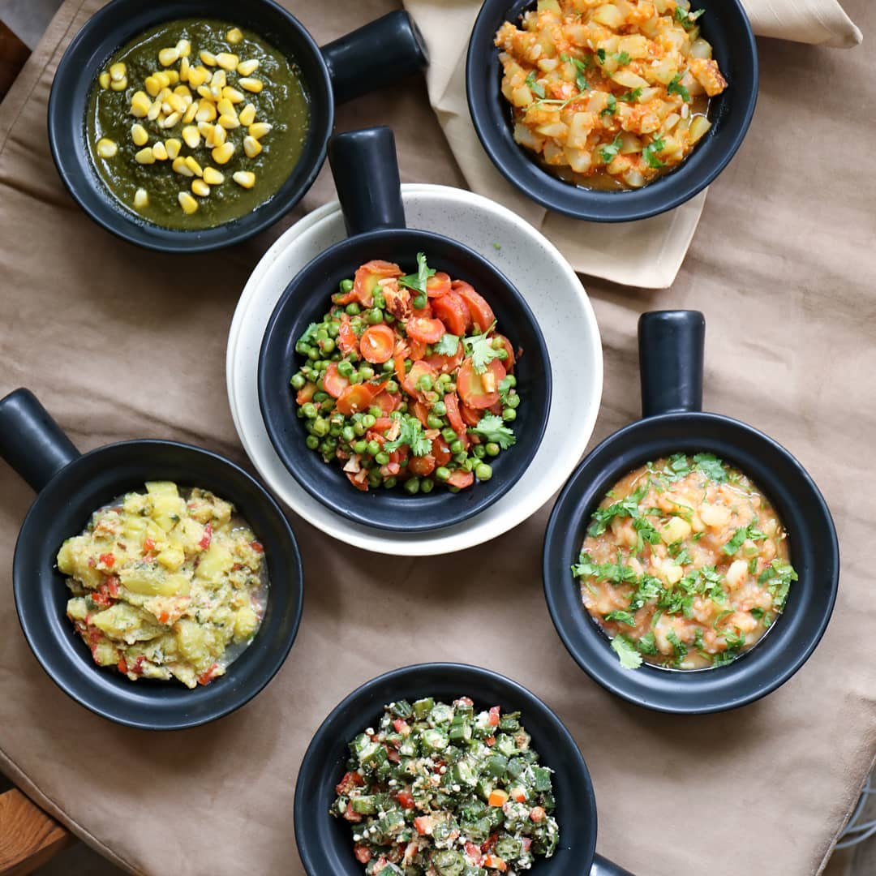

Satvic Sabzi  
  
__________  
  
Serves 2  
  
INGREDIENTS  
Any one or two seasonal veggies  
  
Gravy  
4 tomatoes  
100 grams grated coconut 1⁄2 teaspoon rock salt  
1 small green chilli  
cumin powder, to taste  
10-15 curry leaves  
  
METHOD  
1. Take any 1 or 2 seasonal vegetables.  
2. Soak in water for about 2 hours to reduce the impact of chemicals in the vegetables.  
3. Peel & chop the vegetables. Add to a claypot along with some water. Close the lid and let them cook in water until soft.  
4. Meanwhile, prepare the gravy. Blend together tomatoes, coconut, salt, chili, cumin and curry leaves until smooth.  
5. Combine gravy with boiled vegetables. Close the lid, switch off the stove & let the gravy cook through the steam inside the pot for 10 minutes.  
6.Top with coriander & serve.  
  
___________  
  
[**#satvicmovement**](https://www.facebook.com/hashtag/satvicmovement?__eep__=6&__tn__=*NK*F) [**#seasoneating**](https://www.facebook.com/hashtag/seasoneating?__eep__=6&__tn__=*NK*F) [**#fresh**](https://www.facebook.com/hashtag/fresh?__eep__=6&__tn__=*NK*F) [**#healthy**](https://www.facebook.com/hashtag/healthy?__eep__=6&__tn__=*NK*F)

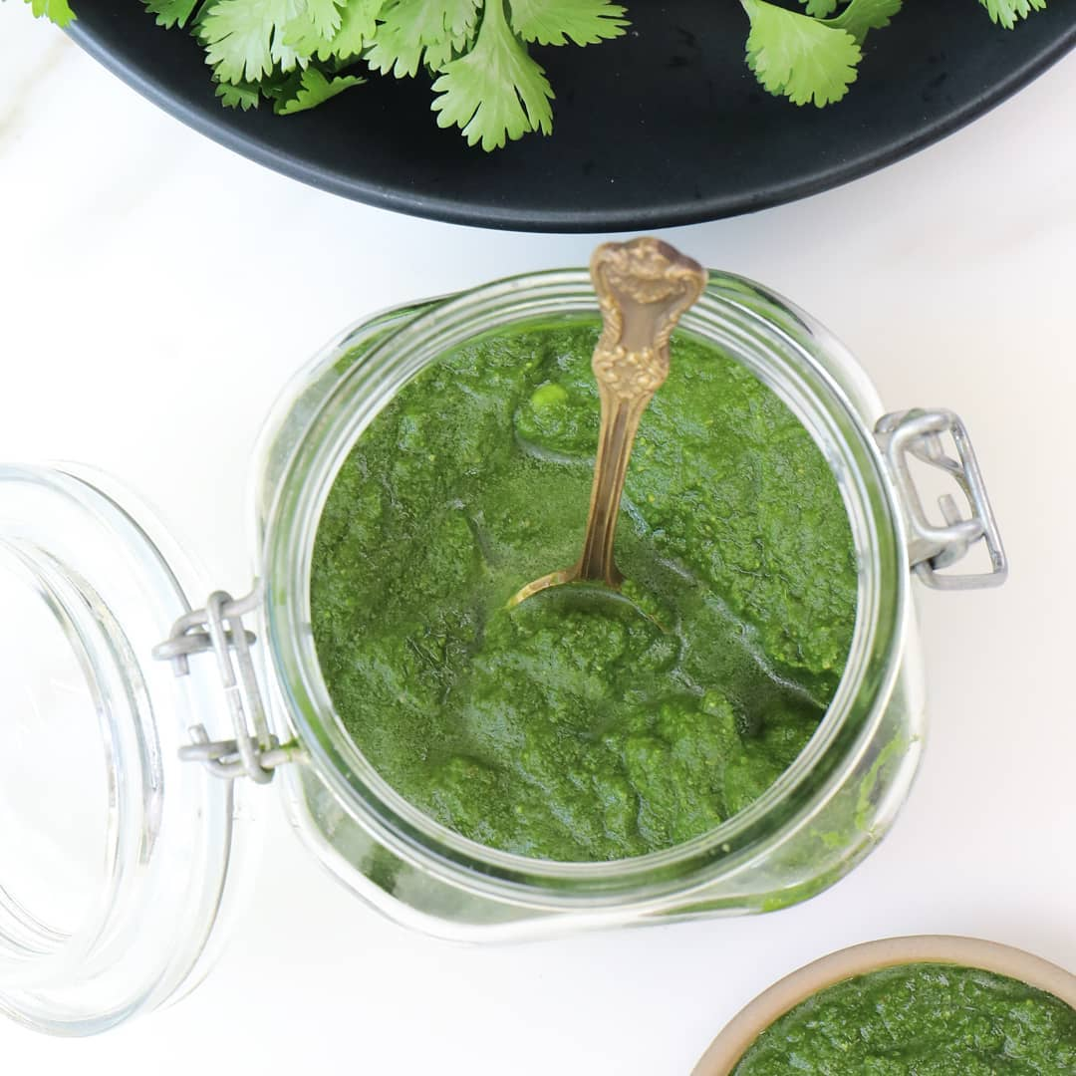

Green Chutney  
  
__________  
  
INGREDIENTS  
1 cup coriander leaves  
½ cup mint leaves  
½ cup unripe mango, roughly chopped  
1 teaspoon cumin seeds  
1 teaspoon salt  
1 small green chilli  
  
METHOD  
Simply process all ingredients together in a blender until smooth. Serve as a condiment with Indian dishes such as sabzi, khichdi or cheela.  
__________  
  
[**#satvicmovement**](https://www.facebook.com/hashtag/satvicmovement?__eep__=6&__tn__=*NK*F) [**#fresh**](https://www.facebook.com/hashtag/fresh?__eep__=6&__tn__=*NK*F) **#green**

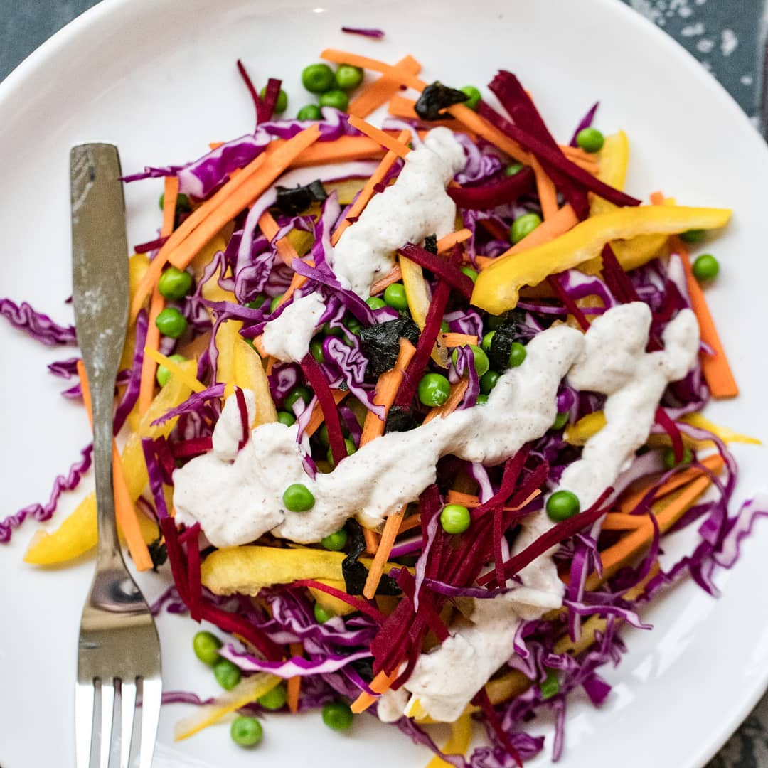

Rainbow Almond Salad  
  
This salad is inspired by the phrase 'eat your rainbow'. You can always substitute the ingredients according to what's easily available in your season and region.  
  
__________  
  
Serves 2  
  
INGREDIENTS  
1⁄2 red cabbage  
1 carrot  
1 yellow bell pepper 1 beetroot  
1 nori sheet (optional)  
1 cup boiled peas  
  
For the Almond Chilli Dressing  
1⁄2 cup water  
1⁄4 cup almonds, soaked  
2 teaspoons lemon juice  
1/8 small green chilli  
1 coin ginger  
1⁄2 teaspoon salt  
  
METHOD  
1. Simply chop the cabbage, carrot, bell pepper. beetroot and nori sheet into long strips and add to a mixing bowl. Then stir in the boiled peas.  
2. Now its time for the dressing. Blend together all the dressing ingredients and pour over your vegetables. Toss well, and serve. •Tip: Add vegetable sprouts to the salad for maximum nutrition  
  
__________  
  
[**#eatwell**](https://www.facebook.com/hashtag/eatwell?__eep__=6&__tn__=*NK*F) [**#plantbased**](https://www.facebook.com/hashtag/plantbased?__eep__=6&__tn__=*NK*F) [**#eatclean**](https://www.facebook.com/hashtag/eatclean?__eep__=6&__tn__=*NK*F) [**#healthyfood**](https://www.facebook.com/hashtag/healthyfood?__eep__=6&__tn__=*NK*F) [**#healthyeating**](https://www.facebook.com/hashtag/healthyeating?__eep__=6&__tn__=*NK*F) [**#vegan**](https://www.facebook.com/hashtag/vegan?__eep__=6&__tn__=*NK*F) [**#healthylifestyle**](https://www.facebook.com/hashtag/healthylifestyle?__eep__=6&__tn__=*NK*F) [**#healthydiet**](https://www.facebook.com/hashtag/healthydiet?__eep__=6&__tn__=*NK*F) [**#getfit**](https://www.facebook.com/hashtag/getfit?__eep__=6&__tn__=*NK*F) [**#satvicdiet**](https://www.facebook.com/hashtag/satvicdiet?__eep__=6&__tn__=*NK*F) [**#satvicmovement**](https://www.facebook.com/hashtag/satvicmovement?__eep__=6&__tn__=*NK*F)

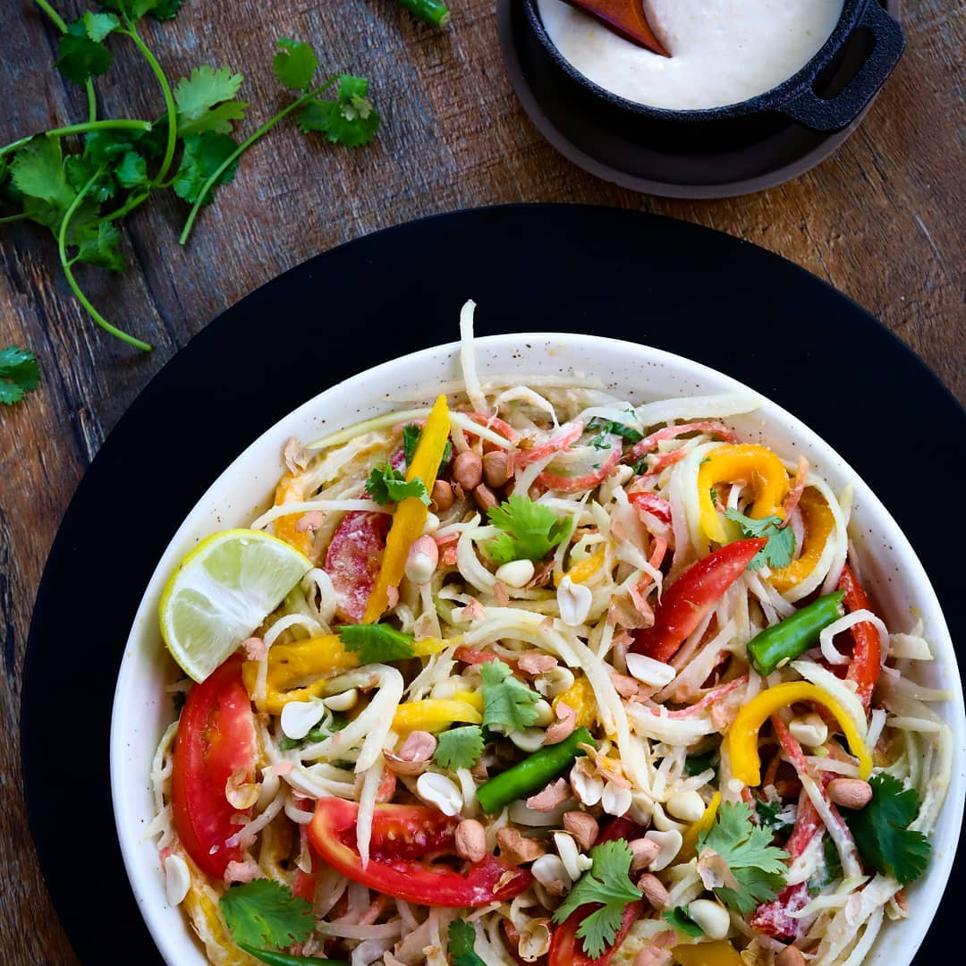

Recipe for Thai Papaya Salad - made using all fresh ingredients, no processed foods, no sugars, nothing packaged, boxed, tinned or canned. Everything fresh, straight from Nature   
__________  
  
Serves 2 - 3  
  
INGREDIENTS  
1⁄2 small unripe green papaya  
1 large mango (or 1 soft pear)  
1 medium carrot  
2 medium tomatoes  
1⁄2 cup fresh coriander  
  
Peanut Dressing  
2 tablespoons raw peanuts, soaked in water for 3 hrs  
1 tablespoon lemon juice  
1⁄8 small green chilli  
1⁄2 teaspoon rock salt  
1 tablespoon jaggery  
2 tablespoons water  
  
Topping  
1 tablespoon raw peanuts, chopped  
  
METHOD  
1. Peel the skin of the papaya.  
2. Cut the papaya and carrot into thin long strips. You can use a julienne vegetable peeler to do this.  
3. Also cut the mango and tomatoes into thin long strips, using a knife.  
4. Place the papaya, carrot, mango, tomatoes and coriander in a large bowl and mix well.  
5. To prepare the dressing, place all the dressing ingredients into a blender and blend until smooth.  
6. Combine the dressing with the salad and mix well.  
7. Top with chopped peanuts for an extra crunch.  
Substitution When mango is not in season, use a soft pear.  
  
Tip The papaya used is not the soft, ripe and orangey one, but the unripened green papaya, which is rm, green on the outside and a pale yellowish color on the inside.  
________  
  
[**#healthyeating**](https://www.facebook.com/hashtag/healthyeating?__eep__=6&__tn__=*NK*F) [**#healthyfood**](https://www.facebook.com/hashtag/healthyfood?__eep__=6&__tn__=*NK*F) [**#vegan**](https://www.facebook.com/hashtag/vegan?__eep__=6&__tn__=*NK*F) [**#healthylifestyle**](https://www.facebook.com/hashtag/healthylifestyle?__eep__=6&__tn__=*NK*F) [**#plantbaseddiet**](https://www.facebook.com/hashtag/plantbaseddiet?__eep__=6&__tn__=*NK*F) [**#healthymeal**](https://www.facebook.com/hashtag/healthymeal?__eep__=6&__tn__=*NK*F) [**#eatclean**](https://www.facebook.com/hashtag/eatclean?__eep__=6&__tn__=*NK*F) [**#veganfood**](https://www.facebook.com/hashtag/veganfood?__eep__=6&__tn__=*NK*F) [**#plantbased**](https://www.facebook.com/hashtag/plantbased?__eep__=6&__tn__=*NK*F) [**#delicious**](https://www.facebook.com/hashtag/delicious?__eep__=6&__tn__=*NK*F) [**#satvicfood**](https://www.facebook.com/hashtag/satvicfood?__eep__=6&__tn__=*NK*F) [**#satvicmovement**](https://www.facebook.com/hashtag/satvicmovement?__eep__=6&__tn__=*NK*F) **#recipes**

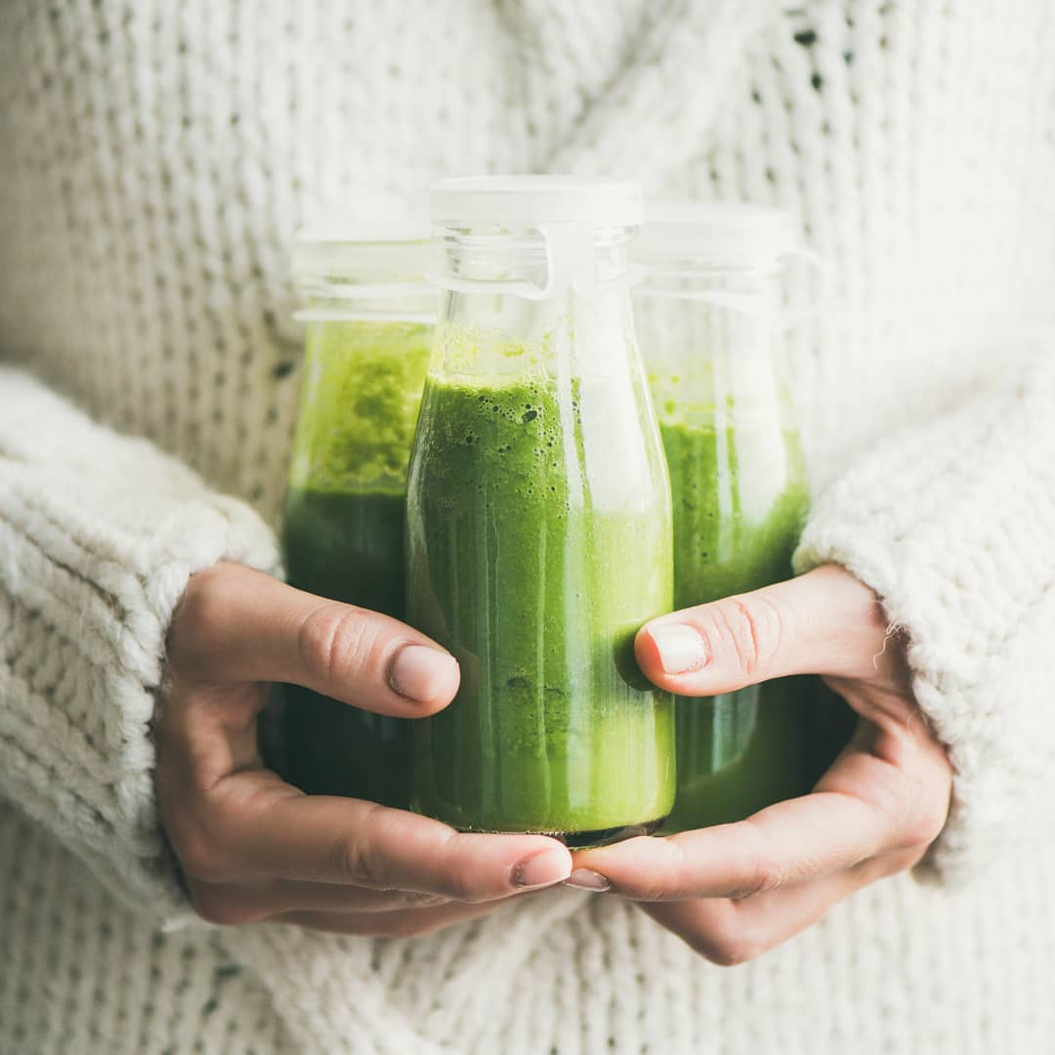



Tropical Green Smoothie  made using local ingredients easily found in India   
  
__________  
  
Serves 1 (makes 2 cups)  
  
INGREDIENTS  
1 cups coconut water  
1 cup chopped spinach  
1 cup chopped apple  
1 cup mango chunks  
1⁄2 teaspoon lemon juice  
  
METHOD  
1. Place all ingredients into a blender and blend until smooth.  
2. Let the smoothie cool in the refrigerator for about 20 minutes before serving.  
Substitution If mango is out of season, replace it with 1 cup chopped guava & 2 seedless dates.  
__________  
  
[**#holisticlifestyle**](https://www.facebook.com/hashtag/holisticlifestyle?__eep__=6&__tn__=*NK*F) [**#healthmatters**](https://www.facebook.com/hashtag/healthmatters?__eep__=6&__tn__=*NK*F) [**#naturalhealth**](https://www.facebook.com/hashtag/naturalhealth?__eep__=6&__tn__=*NK*F) [**#greenlifestyle**](https://www.facebook.com/hashtag/greenlifestyle?__eep__=6&__tn__=*NK*F) [**#smoothie**](https://www.facebook.com/hashtag/smoothie?__eep__=6&__tn__=*NK*F) [**#veganrecipes**](https://www.facebook.com/hashtag/veganrecipes?__eep__=6&__tn__=*NK*F) [**#indianvegetarian**](https://www.facebook.com/hashtag/indianvegetarian?__eep__=6&__tn__=*NK*F) [**#satvicmovement**](https://www.facebook.com/hashtag/satvicmovement?__eep__=6&__tn__=*NK*F) [**#satvicfood**](https://www.facebook.com/hashtag/satvicfood?__eep__=6&__tn__=*NK*F)

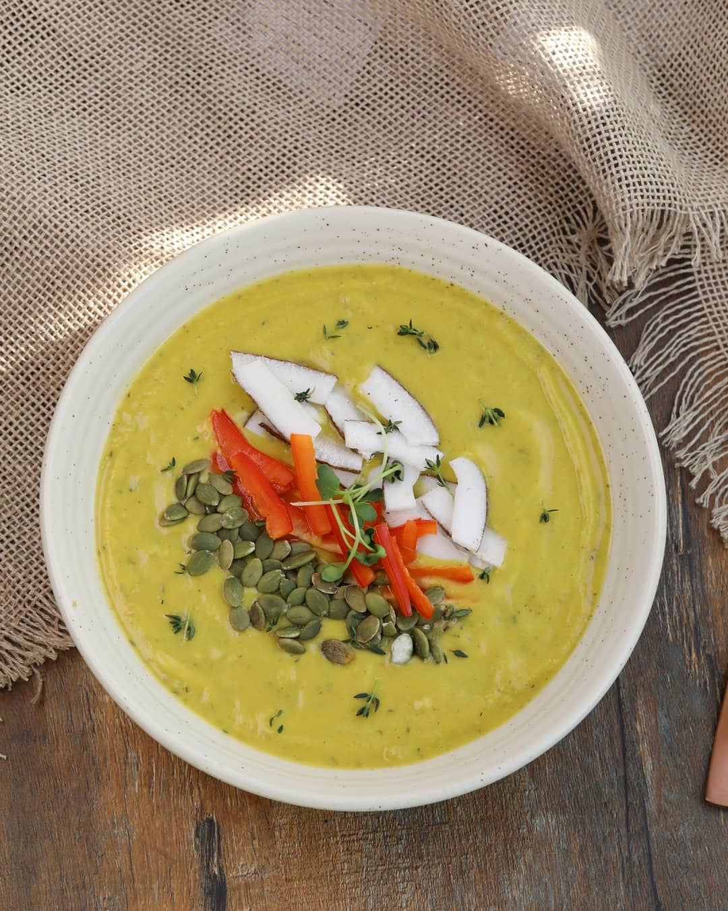

Pumpkin Soup  
  
The flavour in this recipe is incorporated using herbs and not spices. It is free from grains, oils, butter, or any fragmented foods.   
  
__________  
  
Serves 2  
  
INGREDIENTS  
Soup Base  
1⁄2 kg red pumpkin  
3 cups coconut milk  
2 tablespoons fresh thyme or 2 teaspoons dry thyme  
1 sprig fresh rosemary or 1⁄2 teaspoon dry rosemary  
1 tablespoon rock salt  
1⁄2 small green chilli, chopped  
Toppings  
2 tablespoons pumpkin seeds  
1⁄2 red bell pepper, cut into strips  
1⁄4 small coconut, cut into strips  
  
METHOD  
1. Chop the pumpkin into chunks. Do not take the peel off. Add it to a steamer and let it steam for about 20 minutes, until soft.  
2. Once the pumpkin has cooled, place it in a blender, along with the coconut milk, thyme, rosemary, salt and chilli. Blend until smooth.  
3. Pour the soup into bowls, add the toppings from above and serve.  
  
Tip Do not re-heat the soup because we should never cook coconut or coconut milk on the stove.  
Tip Do not omit the rosemary and thyme from this soup, since they carry all the flavour. In case fresh is not available, use their dried versions.  
__________  
  
[**#satvicmovement**](https://www.facebook.com/hashtag/satvicmovement?__eep__=6&__tn__=*NK*F) [**#healthylifestyle**](https://www.facebook.com/hashtag/healthylifestyle?__eep__=6&__tn__=*NK*F) [**#healthmatters**](https://www.facebook.com/hashtag/healthmatters?__eep__=6&__tn__=*NK*F) **#souprecipe**

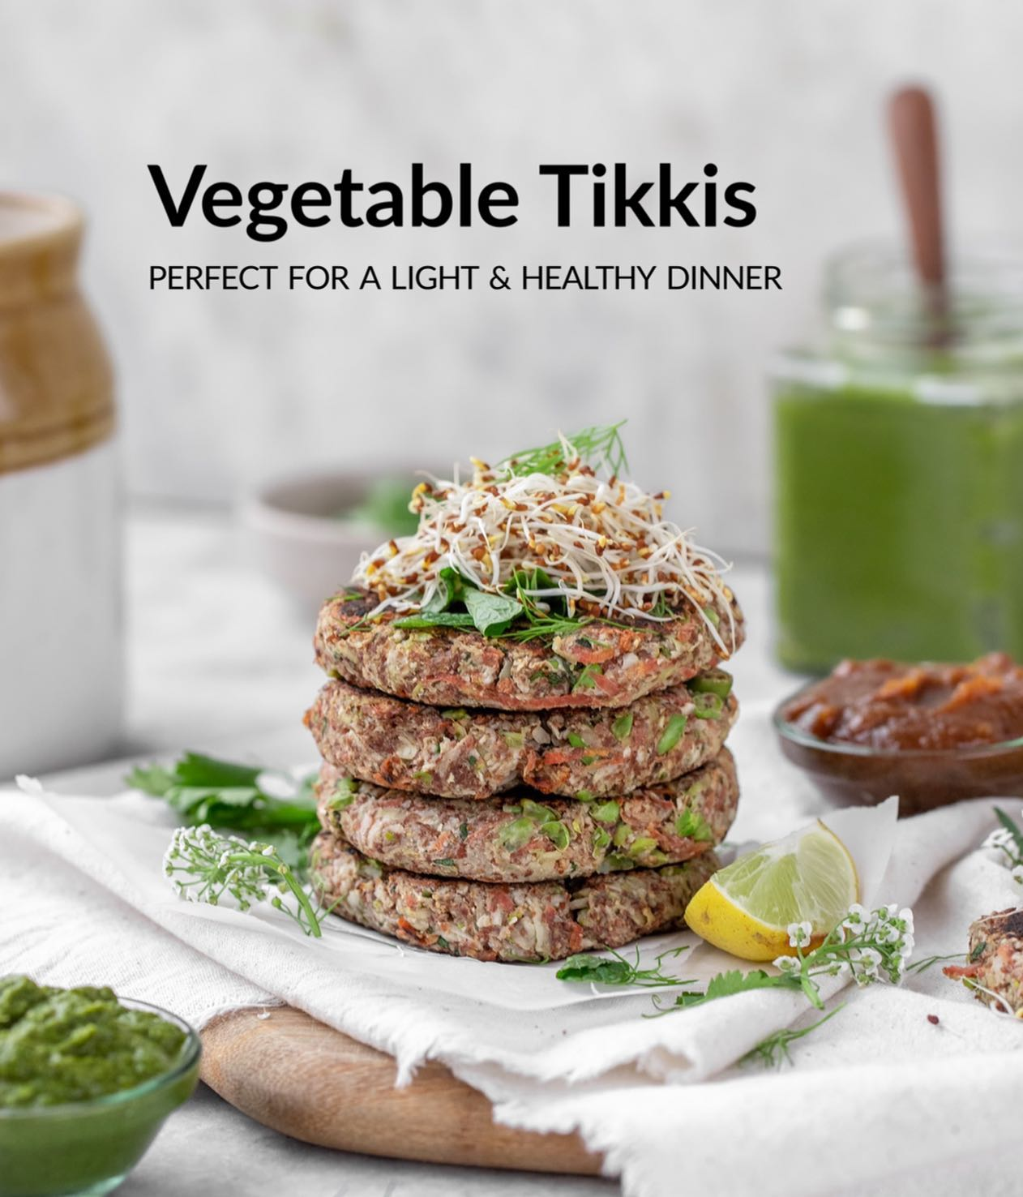These vegetable tikkis are made of only vegetables. We replaced potato with bottle guard to make the tikkis even lighter & more nutritious. They taste delicious paired with the chutneys.⁣  
⁣  
INGREDIENTS ⁣  
MAKES 7 TIKKIS⁣  
Vegetable tikki⁣  
• 3⁄4 cup bottle guard, finely grated⁣  
• 1⁄2 cup cauliflower, chopped⁣  
• 1⁄8 cup green peas⁣  
• 1⁄8 cup carrot, chopped⁣  
• 1 1⁄2 tablespoon flax seed, powdered*⁣  
• 1 tablespoon coriander, chopped⁣  
• 1⁄2 tablespoon mint leaves, chopped⁣  
• 1 teaspoon green chillies, finely chopped⁣  
• 1⁄2 teaspoon cumin seeds⁣  
• 1 teaspoon lemon juice⁣  
• 1⁄4 teaspoon rock salt⁣  
• extra flax seed powder for rolling⁣  
  
Flax seed powder is made by blending dry flax seeds in a blender.⁣  
⁣  
⁣  
METHOD⁣  
•To prepare the tikkis, add all ingredients, except for salt and bottle guard, to your blender and blend till combined.⁣  
•Take out this batter in a bowl.⁣  
•Take the grated bottle gourd and squeeze out the water from it.⁣  
•Combine the squeezed bottle gourd with the batter.⁣  
•Add salt to the batter right before rolling the tikkis.⁣  
•Divide the mixture into 7 equal balls, and flatten each ball to form a thin tikki. Roll the tikkis in flax powder till they are evenly coated.⁣  
•Heat a non-stick pan (griddle) and cook the tikkis on a medium flame. Press them using a spatula till they are fully cooked and turn golden brown from both sides. Do not use oil.⁣  
•Serve hot with Sweet Date Chutney and Green Chutney.⁣  
_________⁣  
⁣  
For more such delicious and healing recipes, order Satvic Food Book from our website⁣  
[**satvicmovement.org**](https://l.facebook.com/l.php?u=http%3A%2F%2Fsatvicmovement.org%2F%3Ffbclid%3DIwZXh0bgNhZW0CMTAAAR1agVlN7a67zE2KzzDbeSU8W7EkOuJ1Xfetfw0USQQchBhCKG31sOo6IZI_aem_V0CFB2uoMGa8yMpa3_nNcA&h=AT0OGUKLccTwj8M2eBG8_CDqZIjfJFS0AOrdNHsGkhaYjPypQm41hHp2NMaM1iVNSg7XUqlTetiT9FIQUiv6WxvWUpdr2cDdV4RXrTQtO1G2pYv60vprp0AozRSeS2B_cSE5T2BAIDQTZ1dBwvhj&__tn__=-UK*F)⁣  
_________⁣  
⁣  
[**#SatvicMovement**](https://www.facebook.com/hashtag/satvicmovement?__eep__=6&__tn__=*NK*F) [**#SatvicLifestyle**](https://www.facebook.com/hashtag/satviclifestyle?__eep__=6&__tn__=*NK*F) [**#MotherNature**](https://www.facebook.com/hashtag/mothernature?__eep__=6&__tn__=*NK*F) [**#HealingRecipe**](https://www.facebook.com/hashtag/healingrecipe?__eep__=6&__tn__=*NK*F) [**#RawFood**](https://www.facebook.com/hashtag/rawfood?__eep__=6&__tn__=*NK*F) [**#Nutrition**](https://www.facebook.com/hashtag/nutrition?__eep__=6&__tn__=*NK*F) [**#CleanEating**](https://www.facebook.com/hashtag/cleaneating?__eep__=6&__tn__=*NK*F) [**#HealthFood**](https://www.facebook.com/hashtag/healthfood?__eep__=6&__tn__=*NK*F) [**#PlantBasedFood**](https://www.facebook.com/hashtag/plantbasedfood?__eep__=6&__tn__=*NK*F) **#Nutrition**

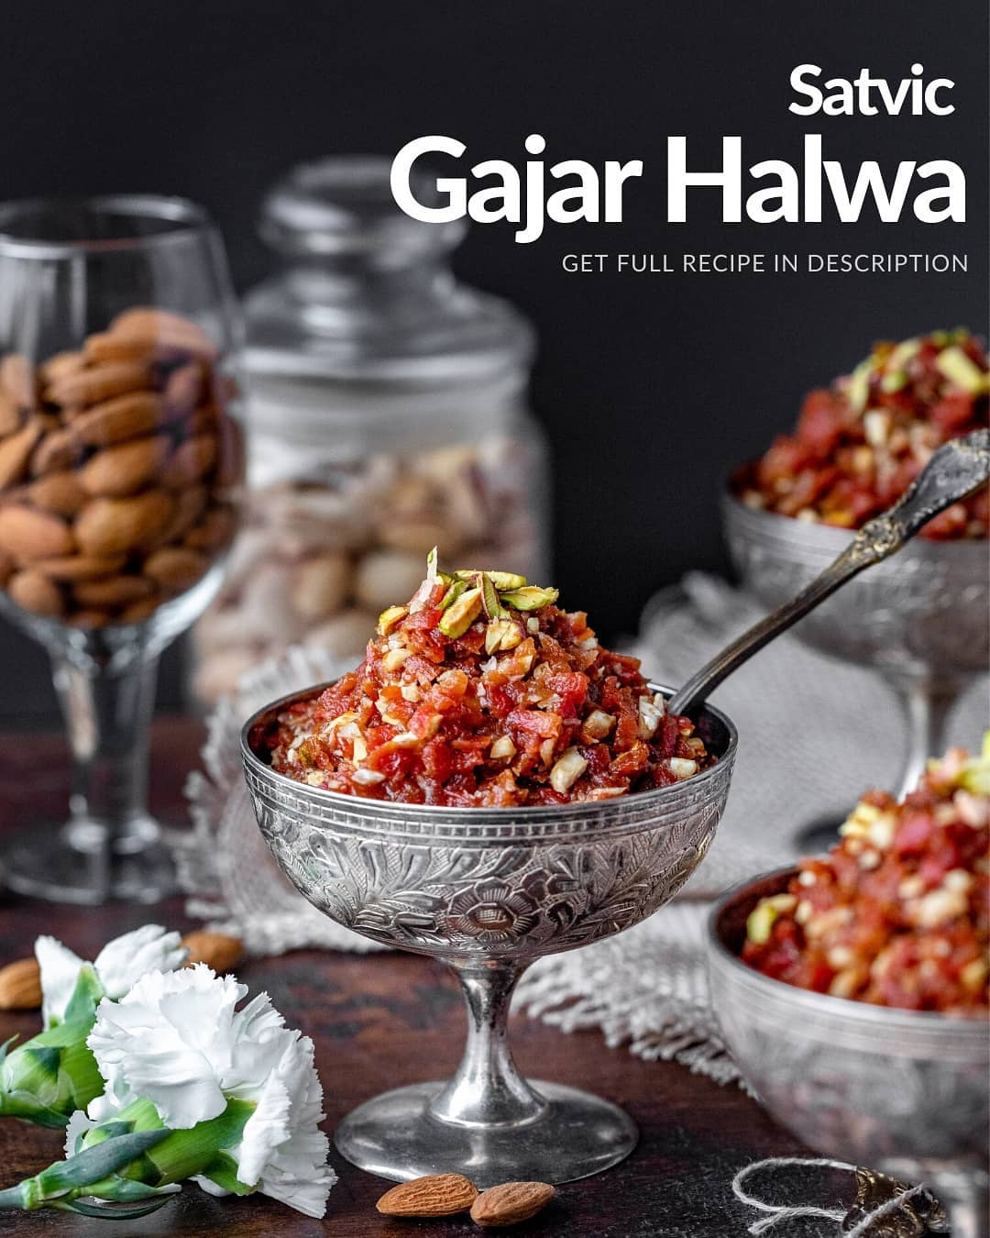

Winters are here and so is the season of most of ours favorite dish, Gajar Halwa. We certainly can’t live without Gajar Halwa in our meals and we are sure you can’t either. So, would you believe us if we told you that this Satvic Gajar Halwa is actually healthy and fully vegan? Imagine eating a dessert that contains no sugar, no milk, no ghee, is made using ingredients straight from nature and tastes just as delicious!  
  
This mouth-watering dish can be served at your Satvic dinner parties and inspire your friends and your family to join you in this beautiful way of living and eating in sync with Mother Nature.  
  
SERVES 6  
INGREDIENTS  
4 cups finely shredded red carrots  
20 strands of saffron  
⅓ cup powdered jaggery  
1 teaspoon green cardamom powder  
¼ teaspoon rock salt  
1 teaspoon lemon juice  
  
Thick Coconut Milk  
½ cup dessicated coconut  
½ cup water  
  
Date Paste  
½ cup chopped dates. seedless  
¼ cup warm water  
  
Topping  
¼ cup chopped almonds (soaked)  
¼ cup chopped cashews (soaked)  
2 tablespoons chopped pistachios  
  
INSTRUCTIONS  
1) Place the grated carrots and saffron into a pan and cook on a medium heat for about 30 minutes, till all the water is absorbed and carrots are soft.  
2) Meanwhile, prepare date paste by blending dates and warm water together until smooth.  
3) Prepare the thick coconut milk by blending coconut & water together. Sieve the mixture through a nut milk bag / muslin cloth & keep the liquid to be used later.  
4) Once carrots have cooked, reduce flame to low. Add jaggery and date paste to the pan and stir together for 30 seconds.  
5) Switch off the stove. Add the thick coconut milk, stir & immediately close the lid. Let the coconut milk cook from the heat inside the pan, not directly on flame.  
6) Add cardamom, lemon and salt. Stir.  
7) Add almonds, cashews and pistachios. Stir. Serve warm.  
  
Tip: Use red carrots to make this halwa. These carrots are available only in winter  
  
Tip If you keep the halwa in the refrigerator for 30 minutes before serving, it tastes even better!  
  
For more recipes like this order our food book from our website – [**www.satvicmovement.org**](http://www.satvicmovement.org/?fbclid=IwZXh0bgNhZW0CMTAAAR1agVlN7a67zE2KzzDbeSU8W7EkOuJ1Xfetfw0USQQchBhCKG31sOo6IZI_aem_V0CFB2uoMGa8yMpa3_nNcA)  
  
[**#satvicmovement**](https://www.facebook.com/hashtag/satvicmovement?__eep__=6&__tn__=*NK*F) [**#satvicfood**](https://www.facebook.com/hashtag/satvicfood?__eep__=6&__tn__=*NK*F) **#healingfood**

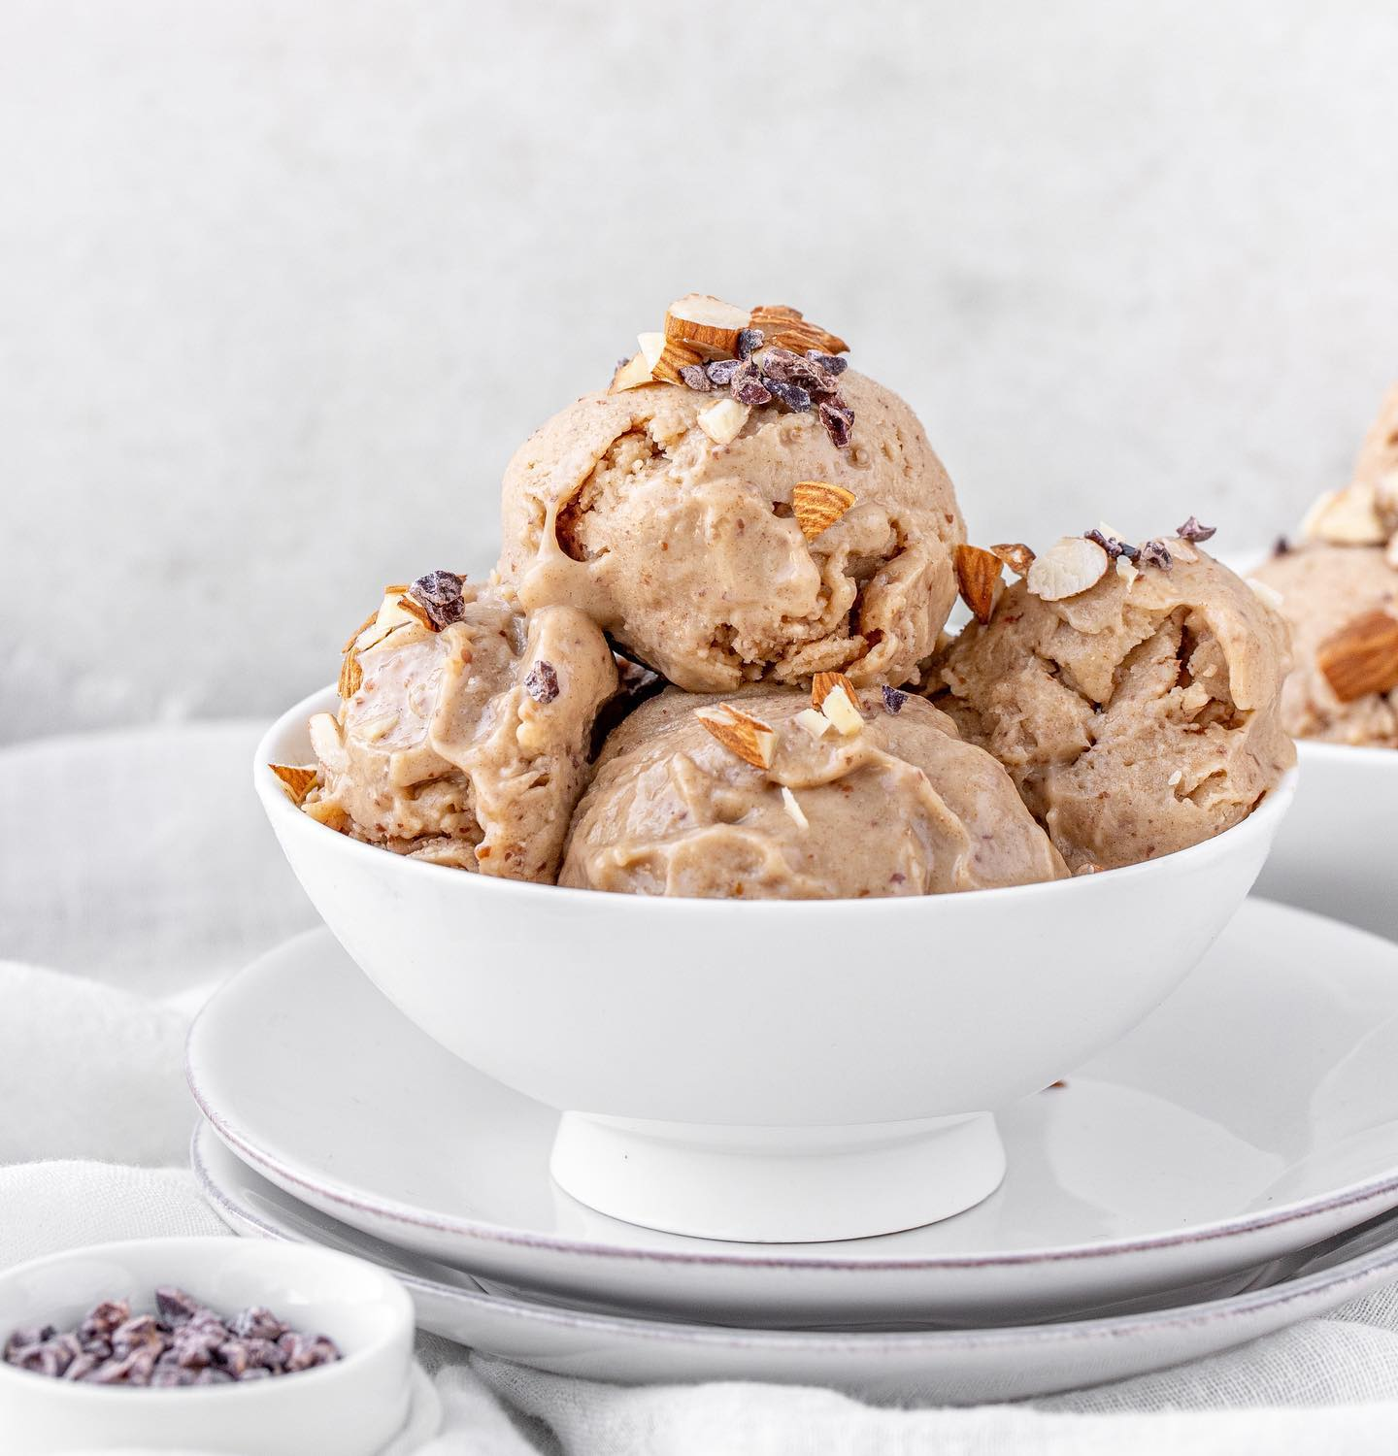This dessert replaces conventional ice cream very well. It is ultra creamy, nutty, sweet, and just the right amount of savory. Ask your friends to guess the ingredients and they’ll be surprised to know that it is actually healthy - no sugar, no cream, and no milk!⁣  
⁣  
INGREDIENTS ⁣  
SERVES 3, MAKES 1 1/2 Cups⁣  
⁣  
For Making Peanut Butter⁣  
• 1 cup peanuts⁣  
⁣  
For Making the Ice Cream⁣  
• 6 dates, seedless⁣  
• 1⁄4 cup water⁣  
• 4 frozen bananas⁣  
• 1 tablespoon peanut butter⁣  
• 1⁄2 tablespoon powdered jaggery⁣  
• 1⁄8 teaspoon rock salt Topping⁣  
• 1 tablespoon almonds, chopped⁣  
• 1 tablespoon date paste (optional)⁣  
• few banana slices ⁣  
⁣  
PRE-PREPARATION⁣  
⁣  
Take the bananas, peel, slice and put in the freezer for about 6 hours.⁣  
⁣  
METHOD⁣  
For making peanut butter⁣  
1. Heat a pan, add the peanuts and reduce the flame to low. Roast peanuts while continuously stirring for 4-5 minutes.⁣  
2. Transfer peanuts to a blender and blend for 2-3 minutes, till you get a creamy butter. You will feel it’ll never blend, but be patient! The peanuts will first convert into powder and then turn creamy. Do not add any water.⁣  
For making peanut butter ice cream⁣  
3. Place the dates and water in a blender and blend till a paste is formed.⁣  
4. Add the frozen bananas, peanut butter, jaggery, and salt to the date paste & blend again until smooth. Do not over blend.⁣  
5. Scoop out the ice cream into bowls. Top with almonds, date paste (optional) and banana slices and serve immediately for a soft-serve style dessert.⁣  
_________⁣  
⁣  
For more such delicious recipes, order the Satvic Food Book⁣  
Visit- [**satvicmovement.org**](https://l.facebook.com/l.php?u=http%3A%2F%2Fsatvicmovement.org%2F%3Ffbclid%3DIwZXh0bgNhZW0CMTAAAR3EzUYgHO78z10X4b4vL5fHFuv9aQQRMAI5_ZqSrsIzACzHrnNmVbOSJwo_aem_ikeM1YdpwU7uOUPWudWNlg&h=AT0OGUKLccTwj8M2eBG8_CDqZIjfJFS0AOrdNHsGkhaYjPypQm41hHp2NMaM1iVNSg7XUqlTetiT9FIQUiv6WxvWUpdr2cDdV4RXrTQtO1G2pYv60vprp0AozRSeS2B_cSE5T2BAIDQTZ1dBwvhj&__tn__=-UK*F)⁣  
_________⁣  
⁣  
[**#SatvicMovement**](https://www.facebook.com/hashtag/satvicmovement?__eep__=6&__tn__=*NK*F) [**#SatvicLifestyle**](https://www.facebook.com/hashtag/satviclifestyle?__eep__=6&__tn__=*NK*F) [**#SatvicRecipes**](https://www.facebook.com/hashtag/satvicrecipes?__eep__=6&__tn__=*NK*F) [**#HealthyLiving**](https://www.facebook.com/hashtag/healthyliving?__eep__=6&__tn__=*NK*F)⁣

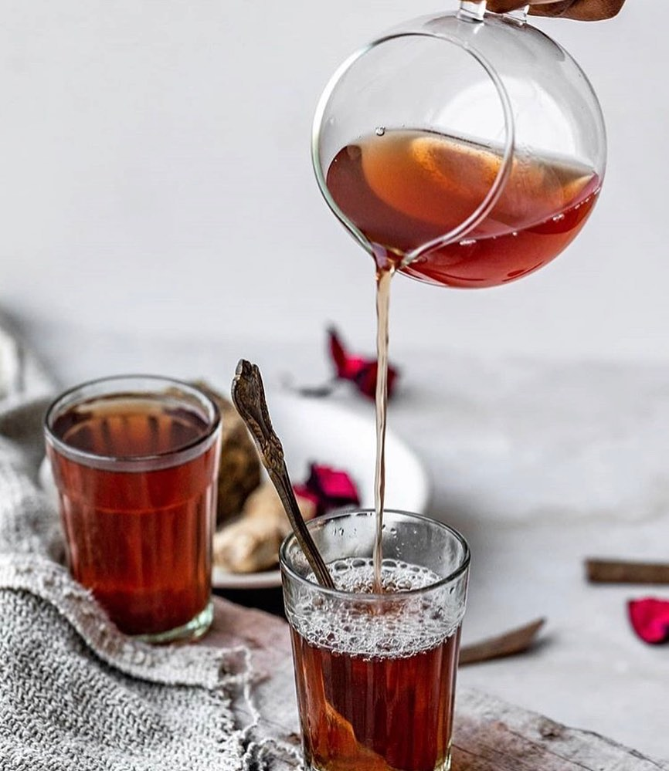

This herbal tea is a replacement for the traditional Indian tea made using milk and tea leaves  
  
It helps get rid off tea addiction. It is made using a blend of herbs and natural flavors, without milk and tea leaves. You can use any fresh herb to make this tea - rosemary, curry leaves, tulsi, rose.  
⁣  
  
INGREDIENTS  
SERVES 2⁣  
• 2-3 inches of lemongrass stems, chopped⁣  
• Cinnamon sticks, 2 inches⁣  
• 6 green cardamom buds⁣  
• 1⁄2 inch coin ginger⁣  
• 2 cups water⁣  
• 1 teaspoon jaggery (optional)⁣  
⁣  
Substitution Instead of lemongrass, you can use rosemary, curry leaves, tulsi or rose.⁣  
⁣  
METHOD⁣  
• Take a saucepan, add the water and bring it to a boil.⁣  
• Crush the lemongrass steams, cinnamon sticks, cardamom buds & ginger in a mortar and pestle. Add to the water and cover the pan for 3 minutes, to let the flavors infuse.⁣  
• Strain the tea through the strainer into cups.⁣  
• If you like your tea sweetened, add jaggery from the top and serve.⁣  
_________⁣  
⁣  
For more such delicious and healing recipes, order the Satvic Food Book⁣  
Visit- [**satvicmovement.org**](https://l.facebook.com/l.php?u=http%3A%2F%2Fsatvicmovement.org%2F%3Ffbclid%3DIwZXh0bgNhZW0CMTAAAR3R_-wFAXtDpz2yiJ03NjxRI6uOgs88MwYypsEVu5jxwnfV1T-glPHA4nU_aem_g5IdzjywY6E7Heslj38BWQ&h=AT0OGUKLccTwj8M2eBG8_CDqZIjfJFS0AOrdNHsGkhaYjPypQm41hHp2NMaM1iVNSg7XUqlTetiT9FIQUiv6WxvWUpdr2cDdV4RXrTQtO1G2pYv60vprp0AozRSeS2B_cSE5T2BAIDQTZ1dBwvhj&__tn__=-UK*F) ⁣  
__________⁣  
  
[**#SatvicMovement**](https://www.facebook.com/hashtag/satvicmovement?__eep__=6&__tn__=*NK*F) [**#SatvicLifestyle**](https://www.facebook.com/hashtag/satviclifestyle?__eep__=6&__tn__=*NK*F) [**#plantbasedfood**](https://www.facebook.com/hashtag/plantbasedfood?__eep__=6&__tn__=*NK*F) [**#rawfood**](https://www.facebook.com/hashtag/rawfood?__eep__=6&__tn__=*NK*F) [**#healthyliving**](https://www.facebook.com/hashtag/healthyliving?__eep__=6&__tn__=*NK*F) [**#healthylifestyle**](https://www.facebook.com/hashtag/healthylifestyle?__eep__=6&__tn__=*NK*F) [**#herbaltea**](https://www.facebook.com/hashtag/herbaltea?__eep__=6&__tn__=*NK*F) [**#nodairy**](https://www.facebook.com/hashtag/nodairy?__eep__=6&__tn__=*NK*F) **#nosugar**

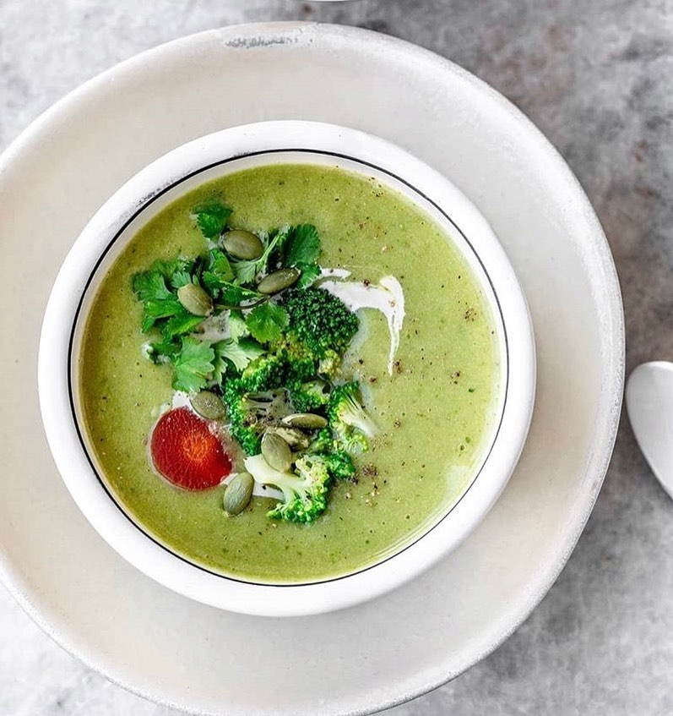

Our broccoli potato soup is a perfect winter warmer. When you make this recipe, you will be surprised how good whole, unprocessed food can taste. Replace your lunch or dinner with this soup and you will see instant improvements in your health. ⁣  
⁣  
INGREDIENTS⁣  
SERVES 2-3, MAKES 11⁄2 litres⁣  
Soup Base⁣  
• 21⁄2 cups fresh broccoli, roughly cut⁣  
• 11⁄2 cups potatoes, roughly cut⁣  
• 3 cups water⁣  
• 11⁄2 teaspoons rock salt⁣  
• 1 inch fresh ginger, grated⁣  
• 1⁄4 teaspoon black pepper powder⁣  
• 1 cup coconut milk Topping⁣  
• 1 cup fresh broccoli, roughly cut⁣  
• 1⁄2 carrot, cut into circles⁣  
• 1⁄4 cup fresh coriander,⁣  
chopped⁣  
• 1 tablespoon pumpkin seed⁣  
⁣  
Pre-Preparation⁣  
Prepare the coconut milk⁣  
⁣  
METHOD⁣  
Soup Base⁣  
•Heat a saucepan over medium heat. Add the broccoli, potato and water. Cover the pot and let the vegetables cook for 20 minutes, or until the potatoes are fork tender.⁣  
•Add the ginger to the saucepan and let it cook with the vegetables for another 3-4 minutes.⁣  
•Remove the pot from the stove and use an immersion blender to puree the vegetables.⁣  
•Add the salt and pepper and mix well.⁣  
•Right before serving, add the coconut milk.⁣  
Topping⁣  
•Steam the broccoli and carrot until soft. Add to your soup, along with coriander and pumpkin seeds. Serve the soup warm.⁣  
⁣  
For more such healing and delicious recipes, our the Satvic food book⁣  
Visit- [**satvicmovement.org**](https://l.facebook.com/l.php?u=http%3A%2F%2Fsatvicmovement.org%2F%3Ffbclid%3DIwZXh0bgNhZW0CMTAAAR2j7tTgkA8sEnO-hVmbHAVyVBH8abcbvEyiYvcesSh1Tg9uhP-1uRidreo_aem__5kQ1yS-k8YITQxg5Z2tvw&h=AT0OGUKLccTwj8M2eBG8_CDqZIjfJFS0AOrdNHsGkhaYjPypQm41hHp2NMaM1iVNSg7XUqlTetiT9FIQUiv6WxvWUpdr2cDdV4RXrTQtO1G2pYv60vprp0AozRSeS2B_cSE5T2BAIDQTZ1dBwvhj&__tn__=-UK*F) ⁣  
⁣  
[**#SatvicMovement**](https://www.facebook.com/hashtag/satvicmovement?__eep__=6&__tn__=*NK*F) [**#SatvicLifestyle**](https://www.facebook.com/hashtag/satviclifestyle?__eep__=6&__tn__=*NK*F) [**#plantbased**](https://www.facebook.com/hashtag/plantbased?__eep__=6&__tn__=*NK*F) [**#vegetarian**](https://www.facebook.com/hashtag/vegetarian?__eep__=6&__tn__=*NK*F) [**#rawfood**](https://www.facebook.com/hashtag/rawfood?__eep__=6&__tn__=*NK*F) [**#protein**](https://www.facebook.com/hashtag/protein?__eep__=6&__tn__=*NK*F) [**#cleaneating**](https://www.facebook.com/hashtag/cleaneating?__eep__=6&__tn__=*NK*F) [**#healthfood**](https://www.facebook.com/hashtag/healthfood?__eep__=6&__tn__=*NK*F) [**#vegetarianfood**](https://www.facebook.com/hashtag/vegetarianfood?__eep__=6&__tn__=*NK*F) [**#plantbasedfood**](https://www.facebook.com/hashtag/plantbasedfood?__eep__=6&__tn__=*NK*F) [**#sustainableliving**](https://www.facebook.com/hashtag/sustainableliving?__eep__=6&__tn__=*NK*F)

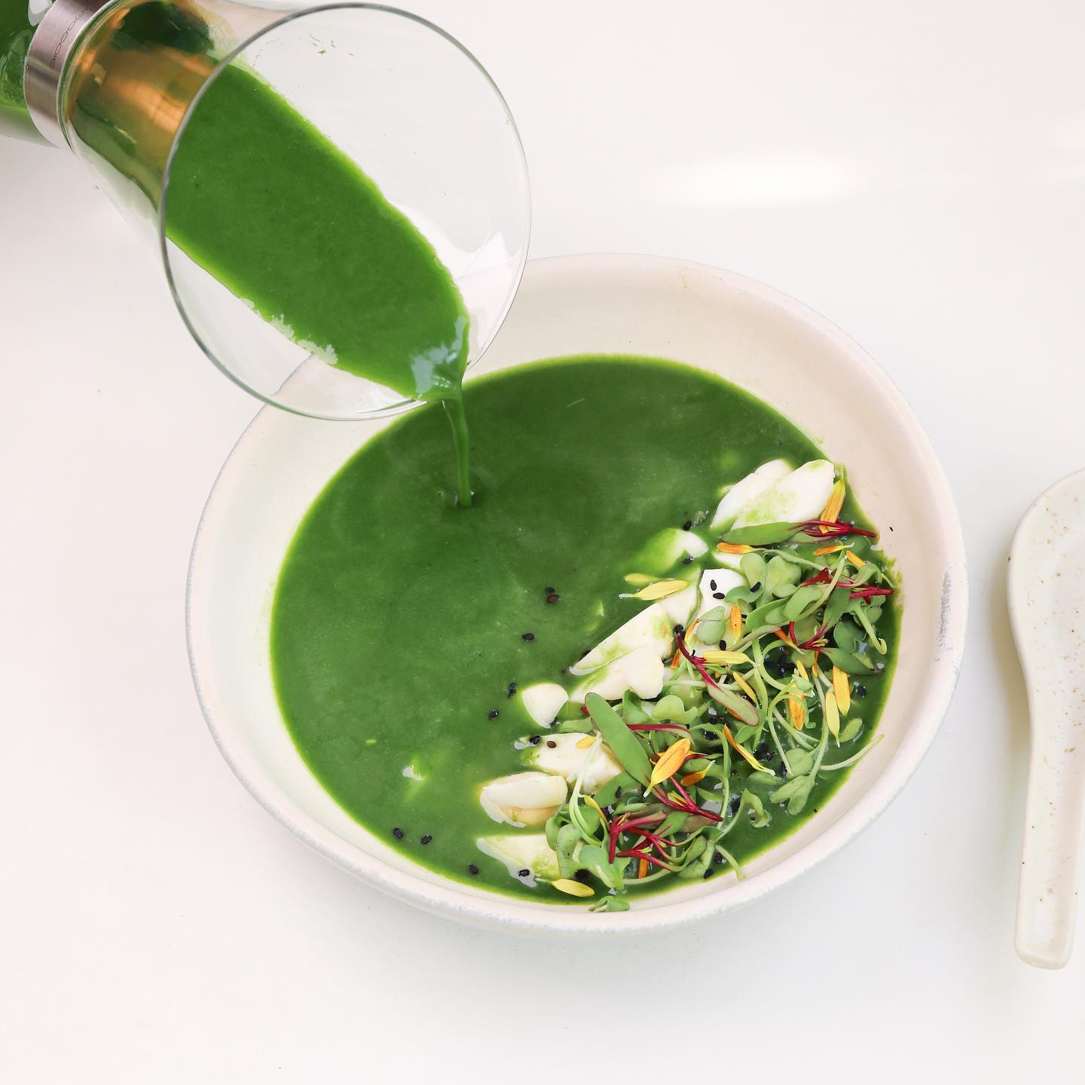





The Spinach Singhara Soup is a perfect winter warmer. Its hearty and comforting. The coconut milk gives it a subtle sweetness and also helps to thicken it. ⁣  
⁣  
INGREDIENTS⁣  
SERVES 2, MAKES 1400 ml⁣  
⁣  
Soup Base⁣  
• 1⁄2 kg spinach⁣  
• 3 cups water⁣  
• 3⁄4 cup singhara (water chestnuts) peeled and thinly sliced⁣  
• 21⁄2 teaspoons rock salt⁣  
• 1⁄2 teaspoon black pepper⁣  
• 1⁄2 cup coconut milk⁣  
⁣  
Garnish⁣  
• microgreens (optional)⁣  
• mary gold petals (optional)⁣  
⁣  
Substitution In case singhara is not available, use potato⁣  
⁣  
PRE- PREPARATION ⁣  
Prepare coconut milk⁣  
⁣  
METHOD⁣  
• Place the spinach and water in a pan. Heat on a low flame till the spinach is soft (about 15 minutes).⁣  
• Puree this mixture using a hand blender, till smooth.⁣  
• Pour this blended mixture through a sieve to get any stalks out.⁣  
• Keep the blended mixture back on the stove, on a low flame. Add the thinly sliced singhara and keep on a low flame for about 3 minutes.⁣  
• Turn off the heat and add salt and pepper.⁣  
• Right before serving, add the coconut milk to your soup and stir well.⁣  
• Garnish with microgreens (optional) and serve. Do not re-heat the soup after adding coconut milk. ⁣  
⁣  
________⁣  
⁣  
For more such healing recipes, order our food book from our website⁣  
[**satvicmovement.org**](https://l.facebook.com/l.php?u=http%3A%2F%2Fsatvicmovement.org%2F%3Ffbclid%3DIwZXh0bgNhZW0CMTAAAR3EzUYgHO78z10X4b4vL5fHFuv9aQQRMAI5_ZqSrsIzACzHrnNmVbOSJwo_aem_ikeM1YdpwU7uOUPWudWNlg&h=AT0OGUKLccTwj8M2eBG8_CDqZIjfJFS0AOrdNHsGkhaYjPypQm41hHp2NMaM1iVNSg7XUqlTetiT9FIQUiv6WxvWUpdr2cDdV4RXrTQtO1G2pYv60vprp0AozRSeS2B_cSE5T2BAIDQTZ1dBwvhj&__tn__=-UK*F)⁣  
________⁣  
⁣  
[**#SatvicMovement**](https://www.facebook.com/hashtag/satvicmovement?__eep__=6&__tn__=*NK*F) [**#SatvicLifestyle**](https://www.facebook.com/hashtag/satviclifestyle?__eep__=6&__tn__=*NK*F)

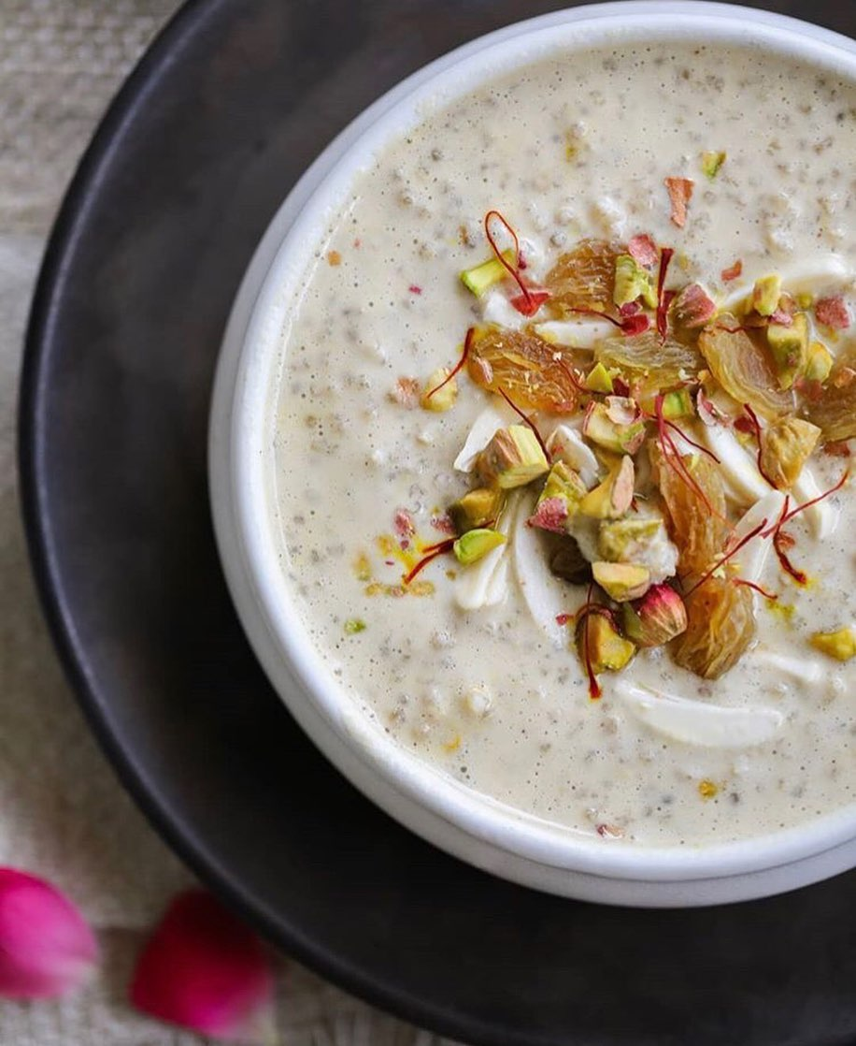

Tasty kheer for Diwali ⁣  
No sugar, no rice, no milk. Tell your family to guess what the ingredients & we promise they’ll be surprised⁣  
⁣  
INGREDIENTS ⁣  
SERVES 4-5⁣  
• 1 cup soaked almonds⁣  
• 1⁄2 cup quinoa⁣  
• 31⁄2 cups water⁣  
• 6 tablespoons powdered jaggery⁣  
• 1⁄4 teaspoon cardamom powder⁣  
• 20 strands of saffron (approx.)⁣  
• 1⁄8 teaspoon rock salt⁣  
⁣  
Topping⁣  
• 1 tablespoon chopped almonds⁣  
• 1 tablespoon chopped pistachios⁣  
• 1 tablespoon raisins⁣  
⁣  
PRE- PREPARATION⁣  
Soak the almonds in water for about 6 hours. After soaking peel the almonds.⁣  
⁣  
METHOD⁣  
1. Place the quinoa in a saucepan with 2 cups of water and bring to a boil. Then, let it simmer for about 45 minutes until the quinoa is fully cook.⁣  
2. Meanwhile, add the peeled almonds and 11⁄2 cups water to a blender and blend until very smooth.⁣  
3. Add jaggery, cardamom, saffron and salt and blend again.⁣  
4. Pour this mixture in a bowl, add the boiled quinoa and stir well. This is your kheer.⁣  
5. Place it in a refrigerator for at least 30 minutes. The quinoa will swell up and the kheer will get a little thick.⁣  
6. Top it with almonds, pistachios and raisins and serve.⁣  
_______⁣  
⁣  
For more such delicious recipes, order the Satvic Food Book from our website⁣  
[**satvicmovement.org**](https://l.facebook.com/l.php?u=http%3A%2F%2Fsatvicmovement.org%2F%3Ffbclid%3DIwZXh0bgNhZW0CMTAAAR3R_-wFAXtDpz2yiJ03NjxRI6uOgs88MwYypsEVu5jxwnfV1T-glPHA4nU_aem_g5IdzjywY6E7Heslj38BWQ&h=AT0OGUKLccTwj8M2eBG8_CDqZIjfJFS0AOrdNHsGkhaYjPypQm41hHp2NMaM1iVNSg7XUqlTetiT9FIQUiv6WxvWUpdr2cDdV4RXrTQtO1G2pYv60vprp0AozRSeS2B_cSE5T2BAIDQTZ1dBwvhj&__tn__=-UK*F)⁣  
_______⁣  
⁣  
[**#SatvicMovement**](https://www.facebook.com/hashtag/satvicmovement?__eep__=6&__tn__=*NK*F) [**#SatvicLifestyle**](https://www.facebook.com/hashtag/satviclifestyle?__eep__=6&__tn__=*NK*F) [**#DiwaliRecipes**](https://www.facebook.com/hashtag/diwalirecipes?__eep__=6&__tn__=*NK*F)

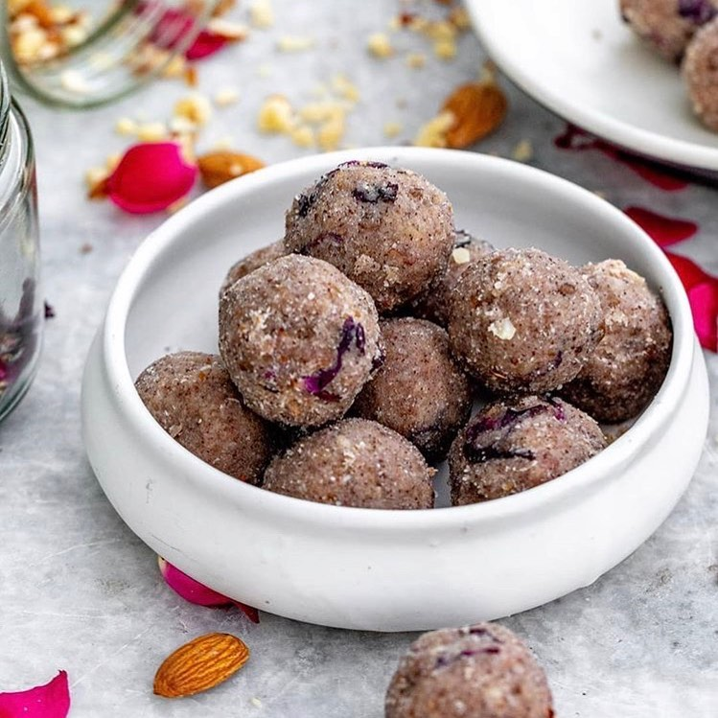

This Diwali, we’ve got you covered! No need to buy processed, sugary sweets from the market. Indulge in healthy desserts that you can make at home in little time, with few ingredients.⁣  
⁣  
These Satvic ladoos are quick to make. It’s also a great idea to gift them to your loved ones & inspire them towards a healthier lifestyle while bringing a big smile on their face ⁣  
⁣  
MAKES 12 LADOOS⁣  
⁣  
INGREDIENTS⁣  
1 dry coconut (gola)⁣  
1 tablespoon almond butter⁣  
1 tablespoon powdered jaggery⁣  
2 tablespoons soaked almonds, crushed⁣  
2 tablespoons dry rose petals⁣  
⁣  
How to make almond butter?⁣  
• Soak 1 cup of almonds in water for 4-6 hours. ⁣  
• Drain out the water and dry roast the almonds in a saucepan over medium flame for 5-7 minutes, stirring in between. Let the almonds cool.⁣  
• Transfer them to a high-speed blender. Blend until creamy, pausing to scrape down the sides as necessary. You will feel it’ll never blend, but be patient! The almonds will first convert into powder and then turn creamy. If the mixture gets too hot along the way, stop and let it cool for a few minutes.⁣  
• Transfer it to a jar. Store in the refrigerator for up to 1 week.⁣  
⁣  
METHOD⁣  
• Break the dry coconut into pieces and then shred it finely.⁣  
• Transfer the shredded coconut⁣  
to a high-speed blender. Blend until creamy, pausing to scrape down the sides as necessary. You will feel it’ll never blend, but be patient! The coconut will first convert into powder and then turn soft and buttery. It usually takes 5-7 minutes of blending. If the mixture gets too hot along the way, stop and let it cool for a few minutes.⁣  
• Add this coconut butter to a bowl, along with the almond butter, jaggery and chopped almonds. Mix it well using your hands.⁣  
• Shape this batter into small ladoos. Garnish with dry rose petals and serve. ⁣  
__________⁣  
⁣  
For more recipes, order our food book from our website - [**satvicmovement.org**](https://l.facebook.com/l.php?u=http%3A%2F%2Fsatvicmovement.org%2F%3Ffbclid%3DIwZXh0bgNhZW0CMTAAAR0ljRtqa5pjL6fpTjrUB7iwQS77GLW0DDUk18OWbPczJuOgVU59ZR7FHhE_aem_ym_izN14nQVtwi7ox8b_wg&h=AT2za2LoD1HRRloOtlYyOfQSGbs2BPK3vSXeBigvcdrLcPCFlCUAMpsibPV9ZxJLRxlu68acWkkYRPIgTFqt0SzZ-hr_NfP93HIERQ3PrT7Wvv5SWzZ0hzWeWbREWVVZhXITe1-C8-YIr6OTIf4v&__tn__=-UK*F) ⁣  
__________⁣  
⁣  
[**#satvicmovement**](https://www.facebook.com/hashtag/satvicmovement?__eep__=6&__tn__=*NK*F)⁣  
[**#satvicfood**](https://www.facebook.com/hashtag/satvicfood?__eep__=6&__tn__=*NK*F) **#indiansweets**

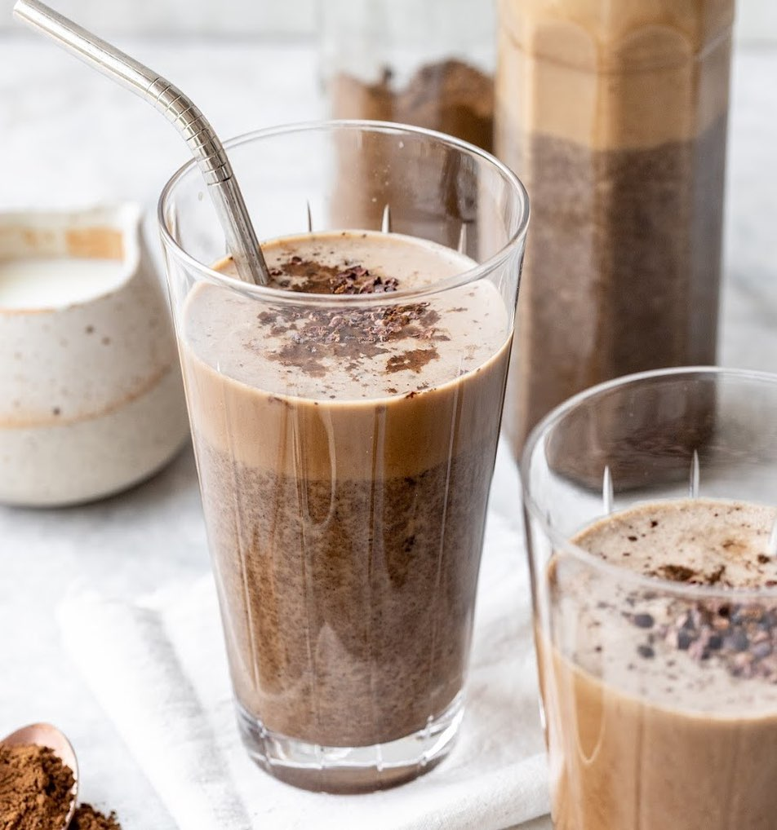

Every coffee-addict would agree that after drinking coffee, they feel instantly awake. You feel tired, gulp down a cup of coffee & become suddenly awake, but you have not suddenly become well rested & energetic. Coffee is a very strong stimulant. It brings us up and then suddenly dumps us down. Overtime, every cup of coffee makes your body weaker & weaker.⁣  
Here we have an unexpected substitute for coffee! It not just tastes like coffee, but even smells exactly like it. Even people from far away want to come and try it! Tell your friends that there’s no dairy, sugar or coffee powder in their mugs, and they’ll be busy guessing what’s inside.⁣  
Bear in mind - you should have this coffee only occasionally (not more than once a week). Although it matches coffee perfectly in taste and smell, it is still not a healing food.⁣  
⁣  
INGREDIENTS⁣  
⁣  
Coffee Powder⁣  
• 100 gm chickpeas (chole) ⁣  
⁣  
Cold Coffee⁣  
SERVES 1⁣  
• 1 cup coconut milk keep in freezer for 3 hours⁣  
• 3 dates, seedless⁣  
• 1 teaspoon coffee powder⁣  
⁣  
METHOD⁣  
Method for making coffee powder⁣  
1. Take a pan & roast the chickpeas on a medium⁣  
flame. Continuously stir for at least 20 minutes, until the chickpeas become dark chocolately brown⁣  
all across. Keep stirring continuously, otherwise they may burn. Make sure they are dark chocolatey brown, otherwise you will not get the coffee flavor.⁣  
2. Let the chickpeas cool. Then, grind them finely and sieve them.⁣  
3. Then, grind & sieve the leftover granules one more time. Repeat this procedure thrice.⁣  
4. Store the sieved powder in an air tight container in the fridge.⁣  
Method for making cold coffee⁣  
5. Place the coconut milk, dates & coffee powder in a blender & blend until smooth.⁣  
6. Pour in glasses and serve.⁣  
⁣  
For more such delicious recipes, order our Food book from our website⁣  
[**satvicmovement.org**](https://l.facebook.com/l.php?u=http%3A%2F%2Fsatvicmovement.org%2F%3Ffbclid%3DIwZXh0bgNhZW0CMTAAAR1N7veesCkdsDpd_KKvDGStI_pJ3UQ1XAv7On6R-H2W-WCpM431sU5BXbo_aem_20xdelGDcjqE6GCyxTUINQ&h=AT2za2LoD1HRRloOtlYyOfQSGbs2BPK3vSXeBigvcdrLcPCFlCUAMpsibPV9ZxJLRxlu68acWkkYRPIgTFqt0SzZ-hr_NfP93HIERQ3PrT7Wvv5SWzZ0hzWeWbREWVVZhXITe1-C8-YIr6OTIf4v&__tn__=-UK*F) ⁣  
⁣  
[**#SatvicMovement**](https://www.facebook.com/hashtag/satvicmovement?__eep__=6&__tn__=*NK*F) [**#SatvicLifestyle**](https://www.facebook.com/hashtag/satviclifestyle?__eep__=6&__tn__=*NK*F) [**#SatvicCoffee**](https://www.facebook.com/hashtag/satviccoffee?__eep__=6&__tn__=*NK*F)

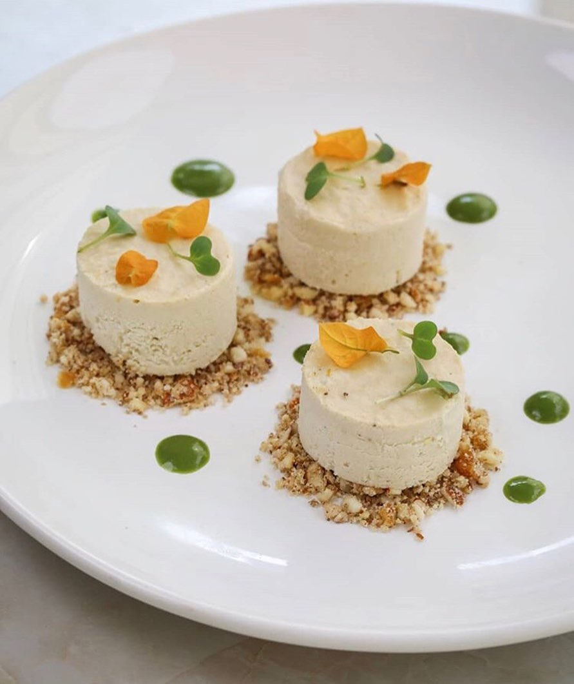

Would you believe this cheesecake is made without any cheese, sugar or any processed food? ⁣  
This recipe is best for an occasional treat⁣  
⁣  
INGREDIENTS ⁣  
SERVES 5⁣  
⁣  
Cheesecake⁣  
• 1 cup cashews, soaked⁣  
• 3 tablespoons powdered jaggery⁣  
• 1⁄4 cup water⁣  
• 3 tablespoons lemon juice⁣  
⁣  
Lime Gel⁣  
• 1⁄4 cup cashews, soaked overnight⁣  
• 1⁄4 cup powdered jaggery⁣  
• 4 medium leaves of spinach⁣  
• 1⁄2 tablespoon lemon juice⁣  
• 1⁄2 tablespoon lemon zest (zest is⁣  
prepared by finely grating the peel of a fresh lemon)⁣  
⁣  
Ginger Crumble⁣  
• 1⁄2 cup almonds⁣  
• 1⁄2 tablespoon jaggery powder⁣  
• 1⁄4 teaspoon ginger, grated⁣  
• pinch salt⁣  
Garnish (optional)⁣  
• microgreens⁣  
• edible flowers⁣  
⁣  
METHOD⁣  
1. To prepare the cheesecake, blend all ingredients in a blender. Pour in a pan. Chill in freezer for 5-6 hours. Once frozen, remove from the pan and cut into squares, circles or triangles. Store in refrigerator until ready to serve.⁣  
2. To prepare the lime gel, blend all ingredients until perfectly smooth. Pour in a squeeze bottle and refrigerate.⁣  
3. To prepare the ginger crumble, quickly pulse the almonds in a blender. Mix the rest of the ingredients by hand.⁣  
4. To assemble all components together, sprinkle 3 piles of ginger crumble on a plate. Place a piece of cheesecake on top of each pile. Garnish with lime gel, microgreens and edible flowers.⁣  
⁣  
Order the satvic food book from our website to try such delicious recipes.

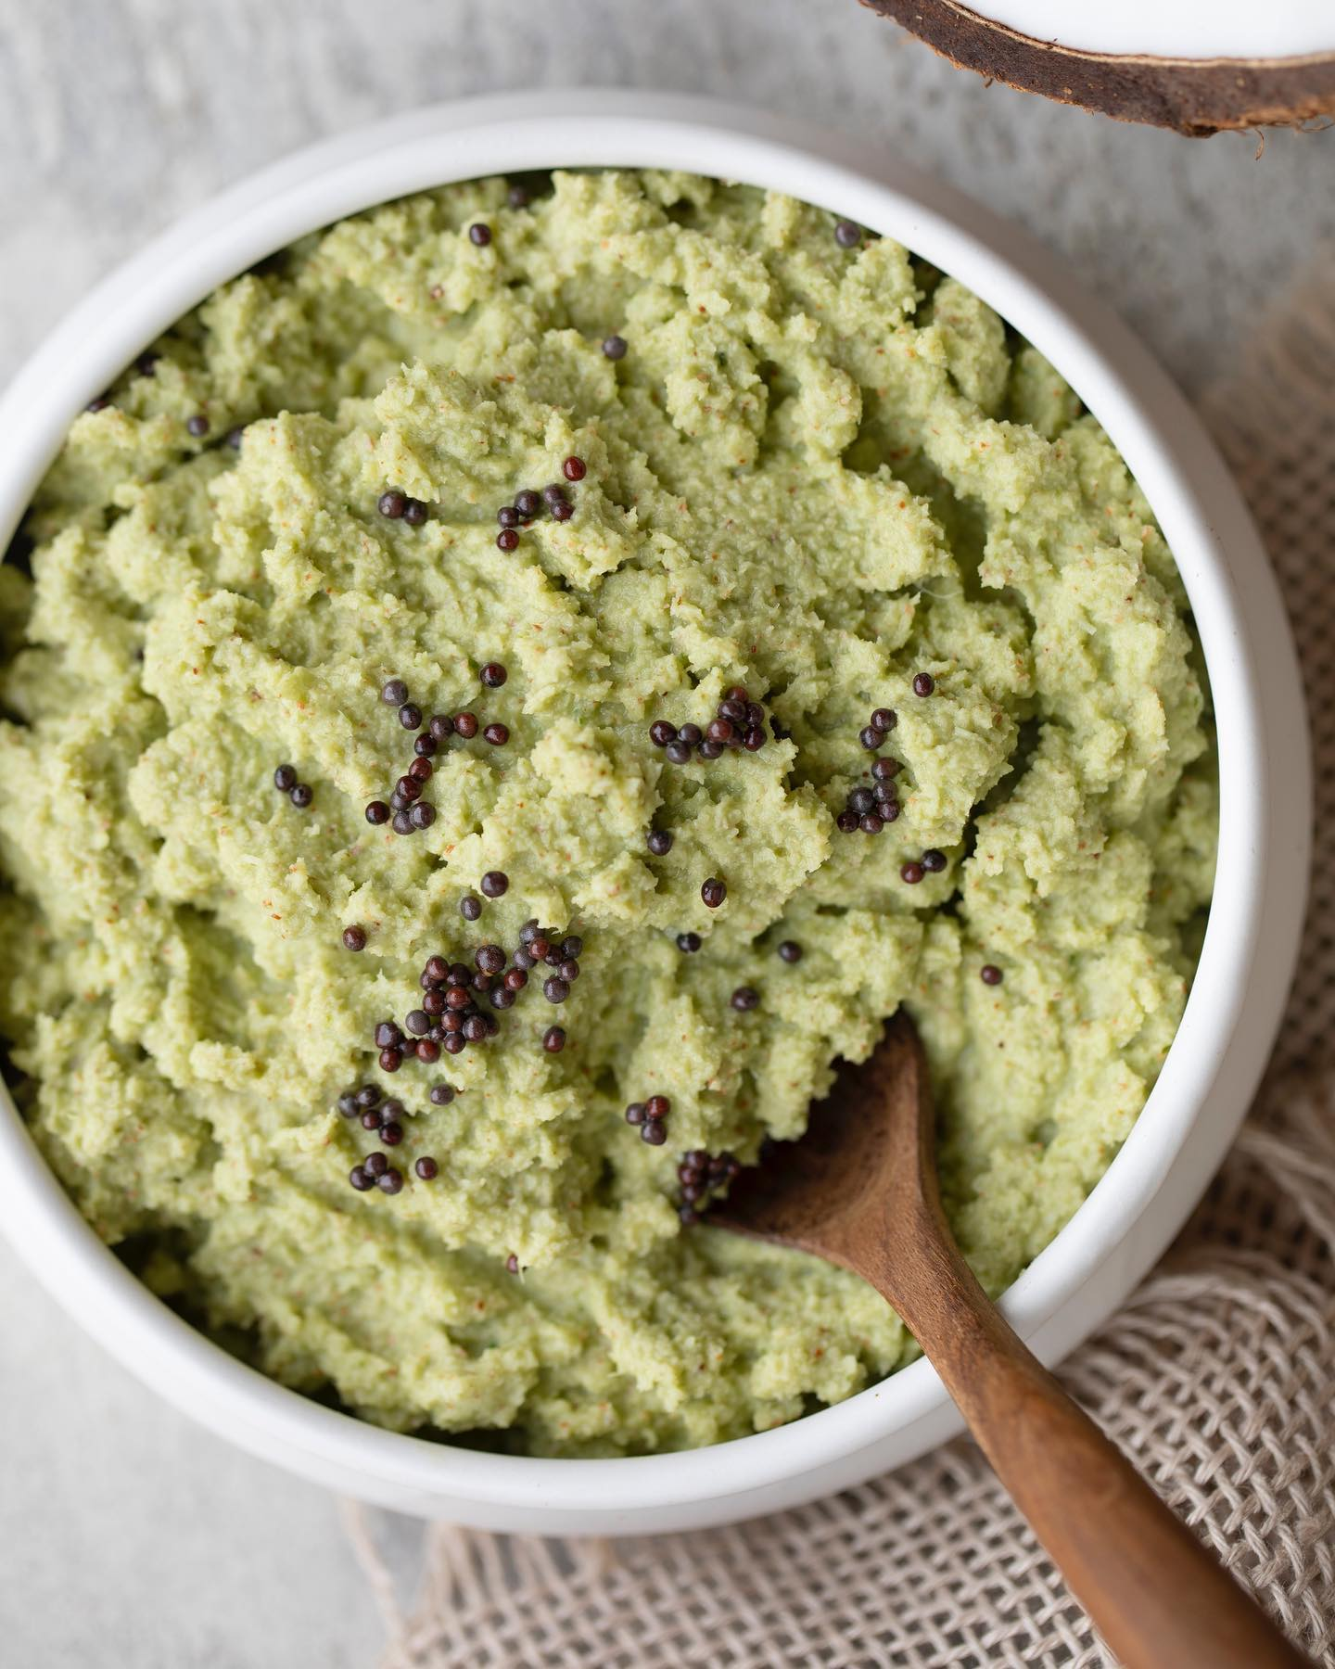

Coconut Chutney⁣  
  
⁣  
INGREDIENTS⁣  
• 1 1⁄2 cups chopped coconut⁣  
• 1⁄4 cup chopped coriander⁣  
• 1⁄2 cup water⁣  
• 1 coin ginger, chopped⁣  
• 2 tablespoons roasted chickpeas (bhuna chana)⁣  
• 2 tablespoons soaked tamarind water⁣  
• 1⁄4 green chilli, chopped⁣  
• 1 teaspoon rock salt⁣  
• 1 teaspoon black mustard seeds, roasted⁣  
⁣  
METHOD⁣  
1. Simply blend all the ingredients (except the mustard seeds) in a blender.⁣  
2. Top the chutney with roasted mustard seeds.⁣  
3. Refrigerate the chutney for 20-30 minutes before use to get a refreshing taste.⁣  
________⁣  
⁣  
Order the Satvic Food Book from our website to try more healing and delicious recipies. ⁣  
[**satvicmovement.org**](https://l.facebook.com/l.php?u=http%3A%2F%2Fsatvicmovement.org%2F%3Ffbclid%3DIwZXh0bgNhZW0CMTAAAR0ljRtqa5pjL6fpTjrUB7iwQS77GLW0DDUk18OWbPczJuOgVU59ZR7FHhE_aem_ym_izN14nQVtwi7ox8b_wg&h=AT2za2LoD1HRRloOtlYyOfQSGbs2BPK3vSXeBigvcdrLcPCFlCUAMpsibPV9ZxJLRxlu68acWkkYRPIgTFqt0SzZ-hr_NfP93HIERQ3PrT7Wvv5SWzZ0hzWeWbREWVVZhXITe1-C8-YIr6OTIf4v&__tn__=-UK*F)⁣  
________⁣  
⁣  
[**#SatvicMovement**](https://www.facebook.com/hashtag/satvicmovement?__eep__=6&__tn__=*NK*F) [**#SatvicLifestyle**](https://www.facebook.com/hashtag/satviclifestyle?__eep__=6&__tn__=*NK*F) [**#MotherNature**](https://www.facebook.com/hashtag/mothernature?__eep__=6&__tn__=*NK*F) [**#HealingRecipies**](https://www.facebook.com/hashtag/healingrecipies?__eep__=6&__tn__=*NK*F)

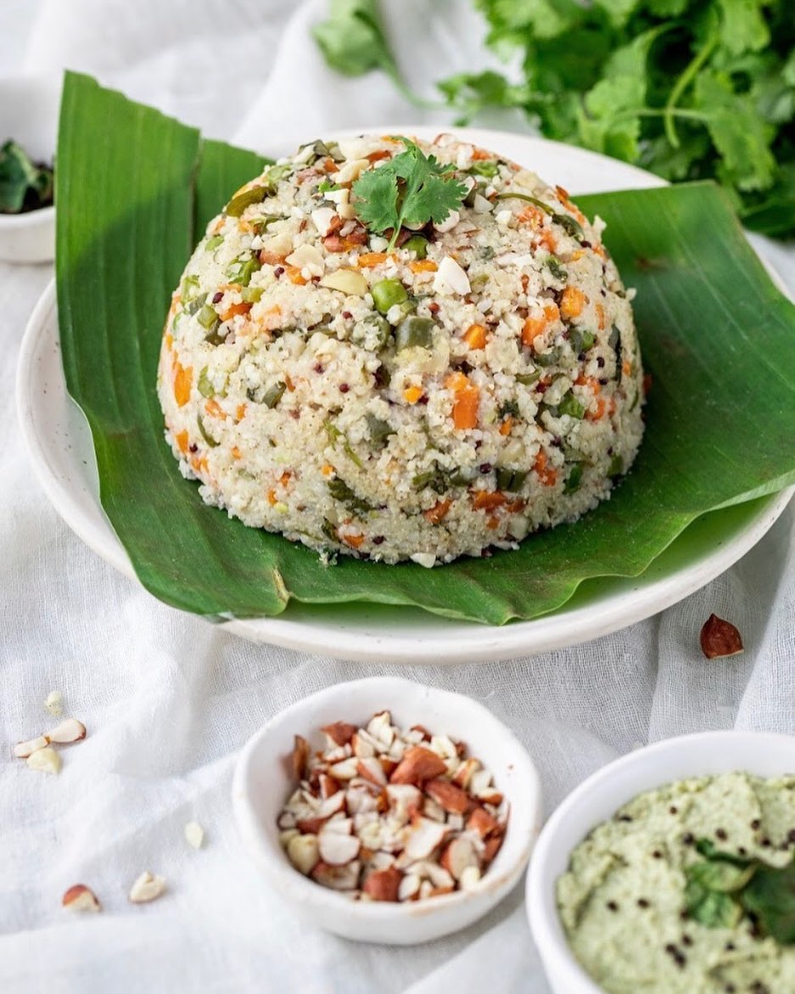

New recipe update - Millet Upma with Coconut Chutney⁣  
⁣  
A healthy occasional lunch, made with no oil, using millets instead of sooji & packed with 3 times more vegetables than grains ⁣  
⁣  
INGREDIENTS ⁣  
SERVES 3-4⁣  
• 1 cup millet (barnyard, proso or foxtail)⁣  
• 3 cups water⁣  
• 1 cup green beans, finely chopped⁣  
• 1 cup carrot, finely chopped⁣  
• 1 cup peas⁣  
• 1⁄4 cup coriander, finely chopped⁣  
Flavouring⁣  
• 2 teaspoons black mustard seeds⁣  
• 1 teaspoon cumin seeds⁣  
• 2 teaspoons grated fresh ginger⁣  
• 2 tablespoons peanuts, chopped⁣  
• 15-20 curry leaves⁣  
• 2 small green chilis, finely chopped⁣  
• 1⁄2 teaspoon asafoetida powder⁣  
• 2 tablespoons lemon juice⁣  
• 2 1⁄2 teaspoon rock salt⁣  
Garnish⁣  
• 1⁄2 tablespoon peanuts, crushed⁣  
⁣  
PRE-PREPARATION⁣  
• Soak the millets in water for 2-3 hours⁣  
⁣  
METHOD⁣  
1. Dry roast the mustard seeds, cumin seeds, green chillies, ginger and peanuts in a pot for about 5-8 minutes.⁣  
2. Then add curry leaves and roast for another minute.⁣  
3. Add beans, carrots and peas to the pot and sauté with roasted spices for about 2 minutes.⁣  
4. Add 2 cups of water to the pot and cover the lid to let the vegetables cook.⁣  
5. After 15 minutes, add the soaked millets and asafoetida with one cup of water to the vegetables and stir. Cover the lid and let the millets cook with vegetables for the flavours to come together. Add more water if needed. Let it cook till there’s no more water left in the pot and the millets are cooked with vegetables.⁣  
6. Switch off the stove and add lemon, salt and coriander and stir well. Cover the lid for another 2 minutes to let all the flavours come together.⁣  
7. Garnish with roasted peanuts and coriander and serve with coconut chutney⁣  
⁣  
________⁣  
⁣  
Order our food book, to try more healing and delicious recipes. ⁣  
________⁣  
⁣  
[**#SatvicMovement**](https://www.facebook.com/hashtag/satvicmovement?__eep__=6&__tn__=*NK*F) [**#SatvicLifestyle**](https://www.facebook.com/hashtag/satviclifestyle?__eep__=6&__tn__=*NK*F) [**#MotherNature**](https://www.facebook.com/hashtag/mothernature?__eep__=6&__tn__=*NK*F) [**#FoodisMedicine**](https://www.facebook.com/hashtag/foodismedicine?__eep__=6&__tn__=*NK*F)

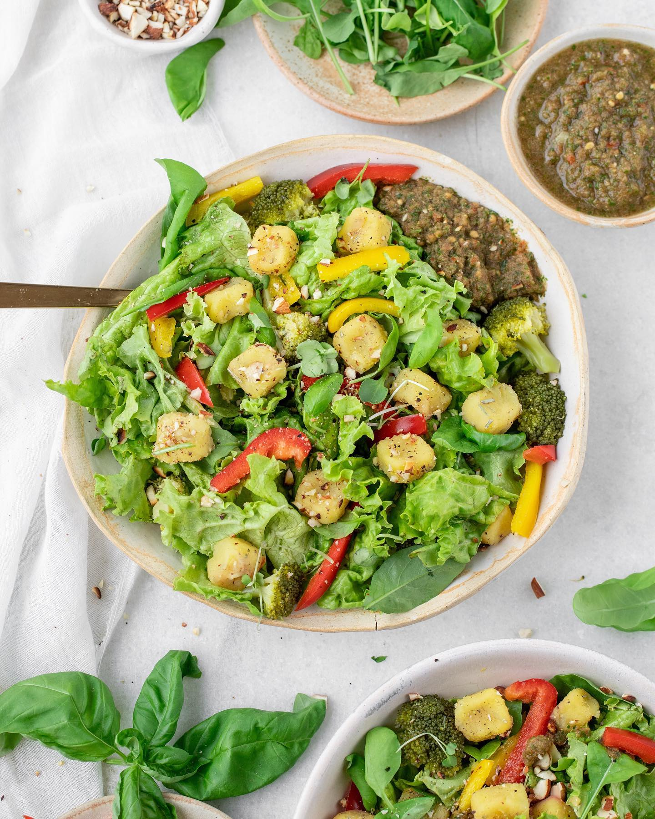

Sweet Potato Salad ⁣  
A delicious recipe to try out this weekend ⁣  
⁣  
INGREDIENTS  
SERVES 2-3⁣  
• 1 medium sweet potato, steamed⁣  
• 2 cups lettuce leaves, torn into pieces⁣  
• 11⁄2 cup broccoli, cut into florets⁣  
• 1⁄4 small red bell pepper,⁣  
thinly sliced & then cut half⁣  
• 1⁄4 small yellow bell pepper,⁣  
thinly sliced and then cut half⁣  
• 1 tablespoon dry rosemary⁣  
⁣  
For marinating sweet potato⁣  
• 1 tablespoon lemon juice⁣  
• 1⁄4 teaspoon black pepper⁣  
• 1⁄2 teaspoon salt⁣  
⁣  
Tomato Salsa Dressing ⁣  
• 2 cups frozen tomatoes, peeled & seedless⁣  
• 1⁄4 cup coriander⁣  
• 1 tablespoon chopped red bell pepper⁣  
• 1⁄2 teaspoon roasted cumin powder⁣  
• 1⁄2 teaspoon lemon juice⁣  
• 1⁄2 green chilli, chopped⁣  
• 1⁄2 teaspoon rock salt⁣  
• 1⁄8 teaspoon black pepper⁣  
  
Topping⁣  
• 2 tablespoons dry roasted almonds, chopped finely⁣  
⁣  
⁣  
METHOD⁣  
⁣  
For the salad⁣  
1. Peel the steamed sweet potato and mash it using a fork.⁣  
2. Add rosemary to the mashed potatoe and mix well. Using your hand, shape the mashed potatoes into small cubes.⁣  
3. Mix all the marination ingredients together and dip the sweet potato cubes in it till coated from all sides.⁣  
4. Meanwhile, dip the broccoli florets in water heated on a medium flame for about 10 minutes.⁣  
5. Combine the lettuce, bell peppers, steamed broccoli and marinated sweet potatoes in a mixing bowl.⁣  
⁣  
For the dressing⁣  
6. Blend all the dressing ingredients in the blender. Don’t blend it too much. Keep it a little chunky. Refrigerate the dressing for a refreshing taste before use.⁣  
7. Pour the dressing on top of the salad. Top with toasted almonds & enjoy!⁣  
⁣  
_________⁣  
⁣  
[**#SatvicMovement**](https://www.facebook.com/hashtag/satvicmovement?__eep__=6&__tn__=*NK*F) [**#SatvicLifestyle**](https://www.facebook.com/hashtag/satviclifestyle?__eep__=6&__tn__=*NK*F) [**#HealingFood**](https://www.facebook.com/hashtag/healingfood?__eep__=6&__tn__=*NK*F) [**#MotherNature**](https://www.facebook.com/hashtag/mothernature?__eep__=6&__tn__=*NK*F)

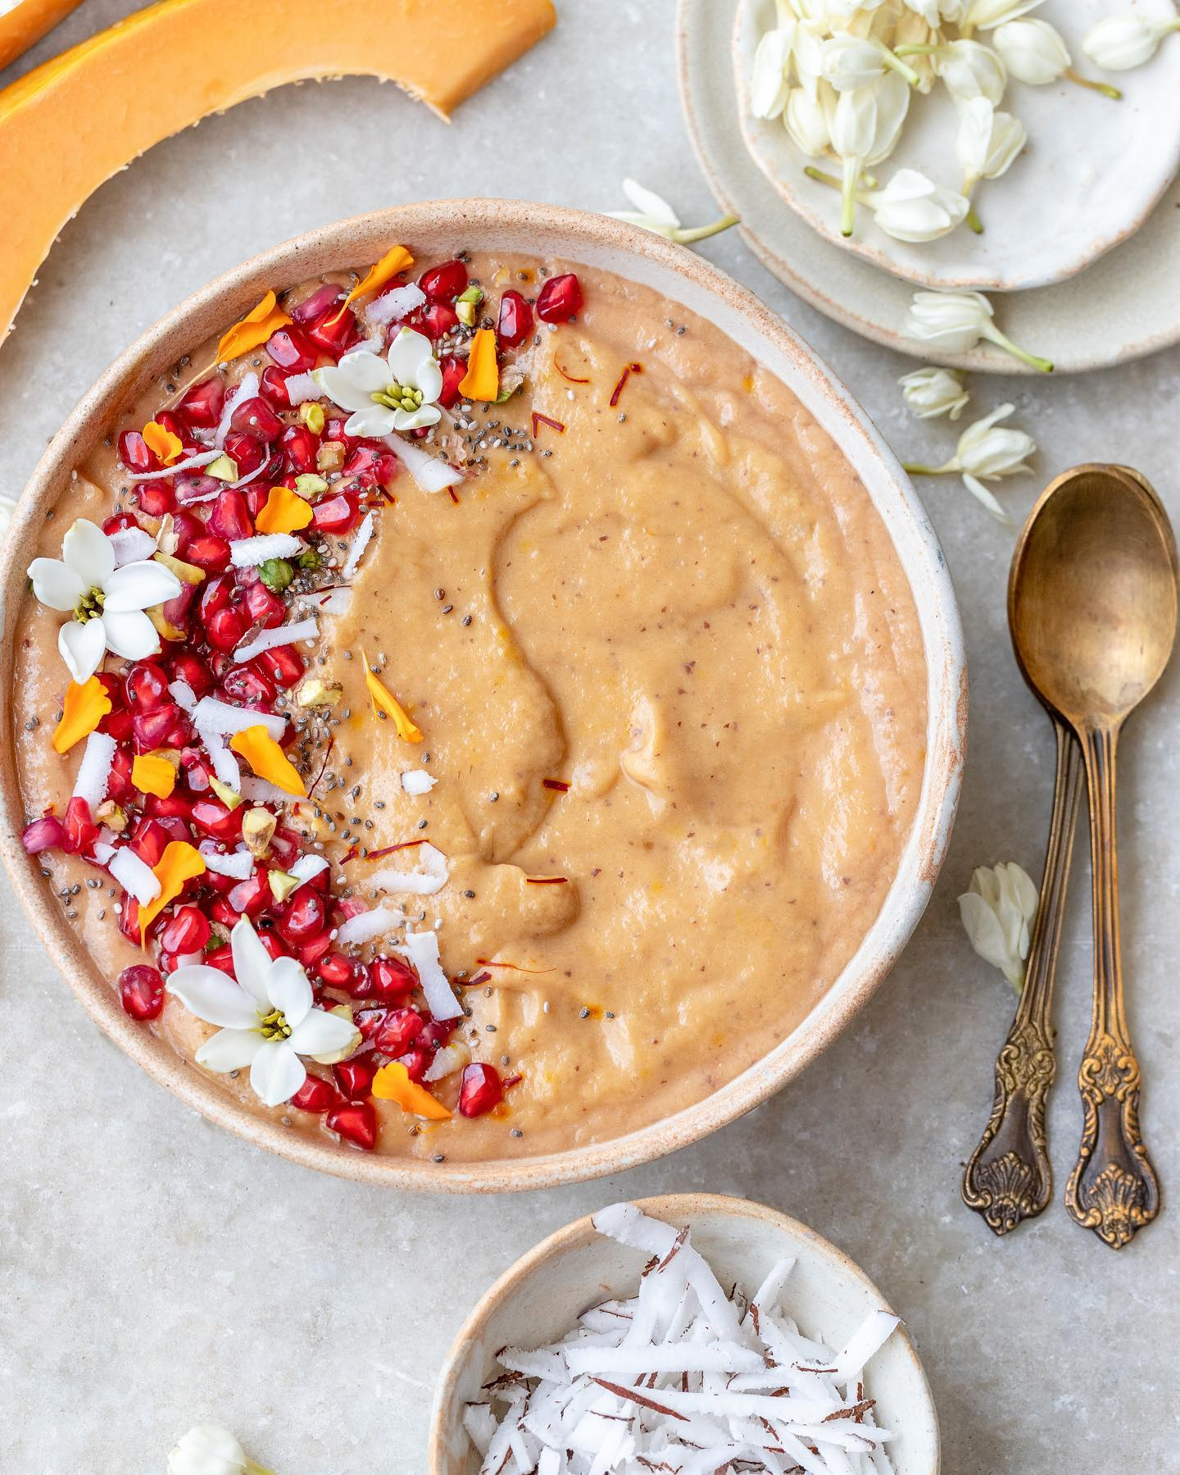

Marigold Smoothie Bowl   
Saffron & papaya come together to create and create a delicious unique flavour. Top this bowl with some fresh fruits & seeds, and enjoy as an occasional breakfast.  
  
INGREDIENTS  
SERVES 1  
  
• 1.5 cup frozen papayas (chop papaya and keep in the freezer for 4-6 hours)  
• 1 Frozen banana  
• 3 Dates, seedless  
• 6 Strands saffron  
• 1/4 cup coconut milk  
  
Topping  
Any seasonal fruits and nuts  
  
METHOD  
1. Place the frozen papaya, banana, dates, saffron and coconut milk in a blender and blend until smooth.  
2. Pour this smoothie base into bowls, and top with any fresh seasonal fruits and nuts.  
  
Tip- Nuts and seeds are great to add texture to your bowl, but eat them minimally as they are water-poor in nature. Focus on fresh, water-rich fruits for your topping.  
  
[**#SatvicLifestyle**](https://www.facebook.com/hashtag/satviclifestyle?__eep__=6&__tn__=*NK*F) [**#SatvicFood**](https://www.facebook.com/hashtag/satvicfood?__eep__=6&__tn__=*NK*F) [**#MotherNature**](https://www.facebook.com/hashtag/mothernature?__eep__=6&__tn__=*NK*F) [**#FoodisMedicine**](https://www.facebook.com/hashtag/foodismedicine?__eep__=6&__tn__=*NK*F)

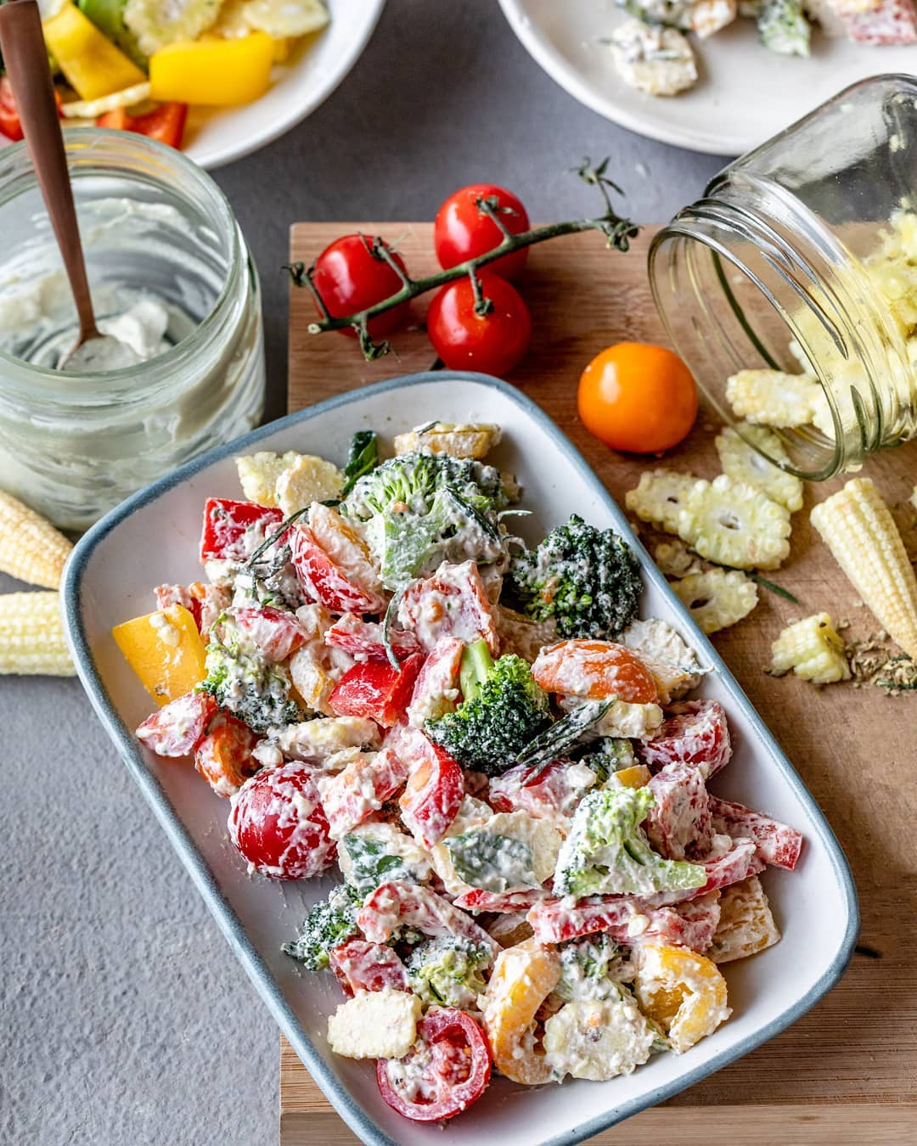

This cheesy salad is ideal for lunch or dinner and tastes best when served with a Satvic Soup. We don’t need to use real cheese to get a cheesy flavour in your salad. Simply blend soaked cashews with some flavouring and it tastes even better than Parmesan!   
__________  
SERVES 2 (if served with a soup)  
  
INGREDIENTS  
½ cup cashews. soaked  
¼ cup coconut milk  
½ small green chili  
1 cup broccoli florets  
1 cup thinly sliced baby corn  
1 cup chopped red bell pepper  
1 cup chopped yellow bellpepper  
1 teaspoon rock salt  
1 tablespoon dried oregano leaves  
  
PRE-PREPARATION  
Soak cashews in water for 6 hours.  
Prepare coconut milk  
  
METHOD  
1. Place the cashews, coconut milk and green chili into a blender and blend until smooth.  
2. Steam the broccoli and baby corn together for about 5 minutes.  
3. Pour the blended mixture into a mixing bowl. Add red bell pepper, yellow bell pepper, steamed broccoli, steamed baby corn, salt and oregano to the mixing bowl.  
4. Mix well and serve.  
__________  
  
For more healthy recipes order our Food Book from our website [**satvicmovement.org**](http://satvicmovement.org/?fbclid=IwZXh0bgNhZW0CMTAAAR1W2q7tAgoUt7g3Kbe9nRDqngiAMZ0Ivplz7-argokhbvRCDtyv-8jO_tY_aem_UTUPI0eMLJGTAeGAY-37fQ)  
___________  
  
[**#satvicmovement**](https://www.facebook.com/hashtag/satvicmovement?__eep__=6&__tn__=*NK*F) [**#satviclifestyle**](https://www.facebook.com/hashtag/satviclifestyle?__eep__=6&__tn__=*NK*F) [**#salad**](https://www.facebook.com/hashtag/salad?__eep__=6&__tn__=*NK*F) [**#satvicfood**](https://www.facebook.com/hashtag/satvicfood?__eep__=6&__tn__=*NK*F) [**#healthyrecipes**](https://www.facebook.com/hashtag/healthyrecipes?__eep__=6&__tn__=*NK*F) [**#healthylifestyle**](https://www.facebook.com/hashtag/healthylifestyle?__eep__=6&__tn__=*NK*F) [**#vegetables**](https://www.facebook.com/hashtag/vegetables?__eep__=6&__tn__=*NK*F) [**#eattherainbow**](https://www.facebook.com/hashtag/eattherainbow?__eep__=6&__tn__=*NK*F) [**#eatclean**](https://www.facebook.com/hashtag/eatclean?__eep__=6&__tn__=*NK*F) [**#plantpowered**](https://www.facebook.com/hashtag/plantpowered?__eep__=6&__tn__=*NK*F) [**#fresh**](https://www.facebook.com/hashtag/fresh?__eep__=6&__tn__=*NK*F) [**#eeeeeats**](https://www.facebook.com/hashtag/eeeeeats?__eep__=6&__tn__=*NK*F)

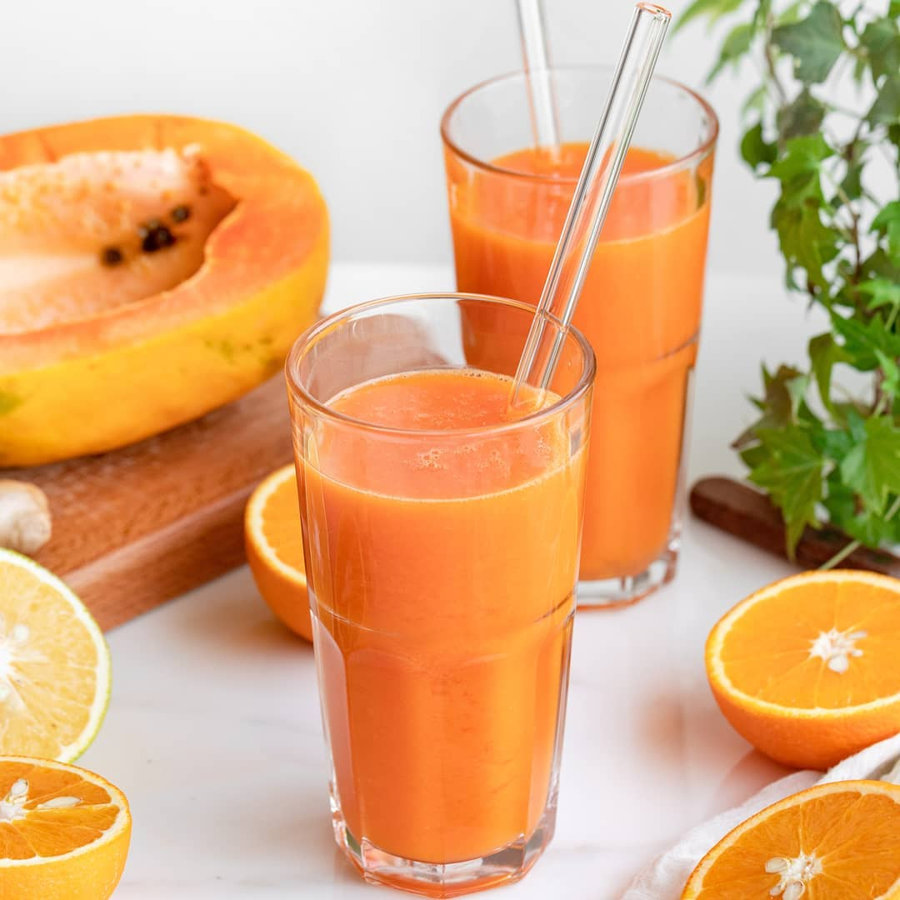

Introduce juicing as a culture in your life and you will see the benefits instantly. There must be times when you start to feel tired, worn out and not in your best shape, and that’s when you should go on 1 or 2 day juice cleanse. It flushes out the toxins from your body and gives you an unbeatable energy.  
  
If you feel bored of drinking ash gourd and coconut juice, you can give this CLEAN CARROT juice a chance. You will be amazed how easy and tasty this juice is!  
__________  
  
Serves 2 (Makes 600 ml)  
INGREDIENTS  
  
2 cups chopped carrots (approx. 2 carrots)  
3 cups chopped papaya  
2 oranges  
1 coin ginger  
  
METHOD  
1. Simply juice everything and serve.  
  
Substitution: You can replace oranges with kinnow.  
__________  
  
For many such healthy and healing recipes, order our Food Book from our website - [**satvicmovement.org**](https://l.facebook.com/l.php?u=http%3A%2F%2Fsatvicmovement.org%2F%3Ffbclid%3DIwZXh0bgNhZW0CMTAAAR1OGZAyLatybI-AlEgKVBtzog7D8SHwrfDLEjZJBQt6Jpm7w3gK52_hAk4_aem_WWlm8TIyNnx93W2a_D45Zw&h=AT2za2LoD1HRRloOtlYyOfQSGbs2BPK3vSXeBigvcdrLcPCFlCUAMpsibPV9ZxJLRxlu68acWkkYRPIgTFqt0SzZ-hr_NfP93HIERQ3PrT7Wvv5SWzZ0hzWeWbREWVVZhXITe1-C8-YIr6OTIf4v&__tn__=-UK*F)  
__________  
  
[**#satvicmovement**](https://www.facebook.com/hashtag/satvicmovement?__eep__=6&__tn__=*NK*F) [**#satviclifestyle**](https://www.facebook.com/hashtag/satviclifestyle?__eep__=6&__tn__=*NK*F) [**#satvicfood**](https://www.facebook.com/hashtag/satvicfood?__eep__=6&__tn__=*NK*F) [**#juice**](https://www.facebook.com/hashtag/juice?__eep__=6&__tn__=*NK*F) [**#detox**](https://www.facebook.com/hashtag/detox?__eep__=6&__tn__=*NK*F) [**#fresh**](https://www.facebook.com/hashtag/fresh?__eep__=6&__tn__=*NK*F) [**#healthyrecipes**](https://www.facebook.com/hashtag/healthyrecipes?__eep__=6&__tn__=*NK*F) [**#healthy**](https://www.facebook.com/hashtag/healthy?__eep__=6&__tn__=*NK*F) [**#eatclean**](https://www.facebook.com/hashtag/eatclean?__eep__=6&__tn__=*NK*F)

**See less**

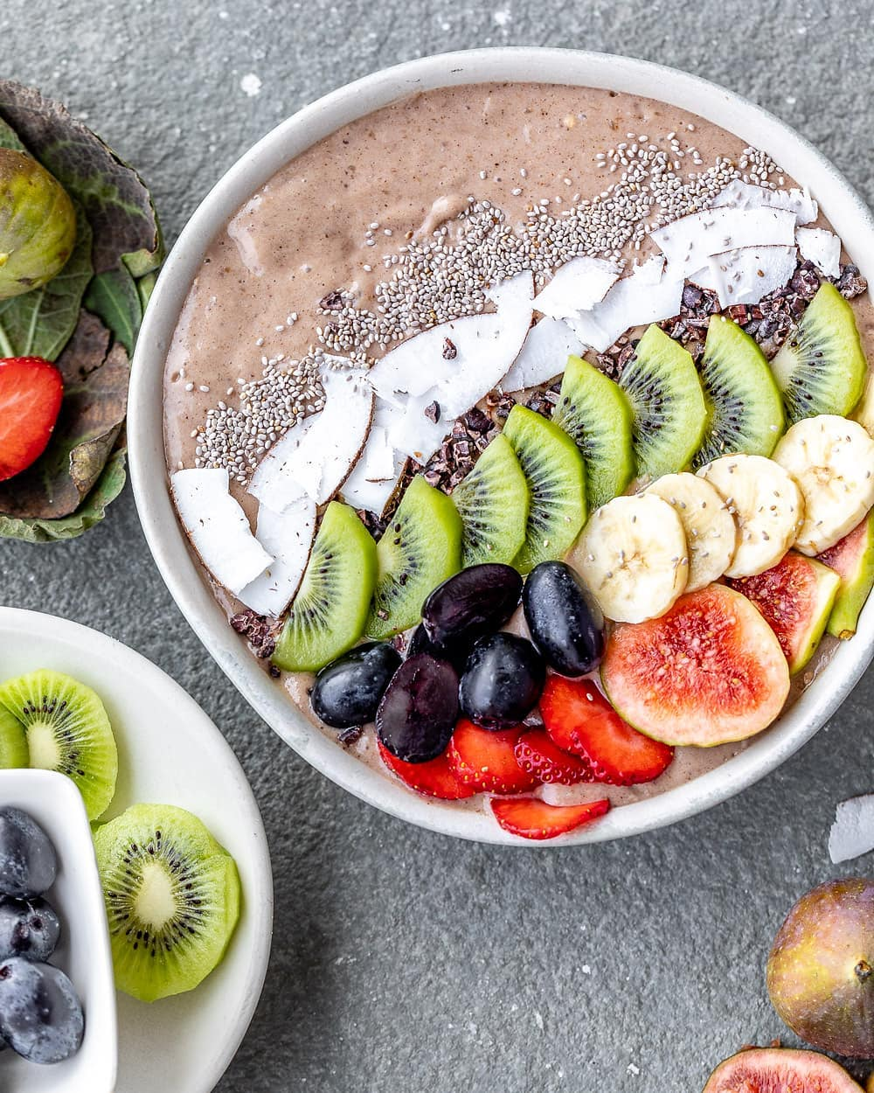

Chocolate Smoothe Bowl  
  
Would you believe us if we told you that the bowl you see is actually healthy? It is raw, unprocessed and the only sweetener we use is banana. This recipe is best for an occasional breakfast.  
___________  
  
SERVES 2, MAKES 700 ml  
  
INGREDIENTS  
3 frozen bananas  
1⁄4 cup water  
1 cups coconut cream (malai)*  
1 coin ginger  
2 dates, seedless  
1 tablespoon cacao powder or carob powder  
1⁄2 teaspoon cinnamon powder  
any seasonal fruits and nuts for topping *In case coconut cream (malai)is not available, use fresh gratedcoconut  
  
PRE-PREPARATION  
Take 3 bananas, peel, slice and put in the freezerfor about 5-6 hours.  
  
METHOD  
  
1. Blend together the frozen bananas, coconut water, coconut cream, cacao powder, gingerand cinnamon.  
  
2. Pour into bowls and top with any fresh seasonalfruits and nuts. I used banana, grapes, kiwi, figs, almonds, cacao nibs and chia seeds.  
  
Tip: Nuts and seeds are great, to add texture  
to your bowl, but please don’t go overboard with them. At the end of the day, they are dry innature and must be eaten in limited amounts.Focus on fresh, water-rich fruits for your topping  
  
Tip: Don’t forget to freeze your banana.They are key to achieving a good texture for your smoothie base.  
  
____________  
  
For many such healthy and delicious recipes order our Food Book from our website - [**satvicmovement.org**](https://l.facebook.com/l.php?u=http%3A%2F%2Fsatvicmovement.org%2F%3Ffbclid%3DIwZXh0bgNhZW0CMTAAAR0ljRtqa5pjL6fpTjrUB7iwQS77GLW0DDUk18OWbPczJuOgVU59ZR7FHhE_aem_ym_izN14nQVtwi7ox8b_wg&h=AT2za2LoD1HRRloOtlYyOfQSGbs2BPK3vSXeBigvcdrLcPCFlCUAMpsibPV9ZxJLRxlu68acWkkYRPIgTFqt0SzZ-hr_NfP93HIERQ3PrT7Wvv5SWzZ0hzWeWbREWVVZhXITe1-C8-YIr6OTIf4v&__tn__=-UK*F)  
____________  
  
[**#satvicmovement**](https://www.facebook.com/hashtag/satvicmovement?__eep__=6&__tn__=*NK*F) [**#satviclifestyle**](https://www.facebook.com/hashtag/satviclifestyle?__eep__=6&__tn__=*NK*F) [**#fresh**](https://www.facebook.com/hashtag/fresh?__eep__=6&__tn__=*NK*F) [**#breakfast**](https://www.facebook.com/hashtag/breakfast?__eep__=6&__tn__=*NK*F) [**#healthylifestyle**](https://www.facebook.com/hashtag/healthylifestyle?__eep__=6&__tn__=*NK*F) [**#healthyrecipes**](https://www.facebook.com/hashtag/healthyrecipes?__eep__=6&__tn__=*NK*F) [**#eattherainbow**](https://www.facebook.com/hashtag/eattherainbow?__eep__=6&__tn__=*NK*F) [**#sweettreats**](https://www.facebook.com/hashtag/sweettreats?__eep__=6&__tn__=*NK*F)

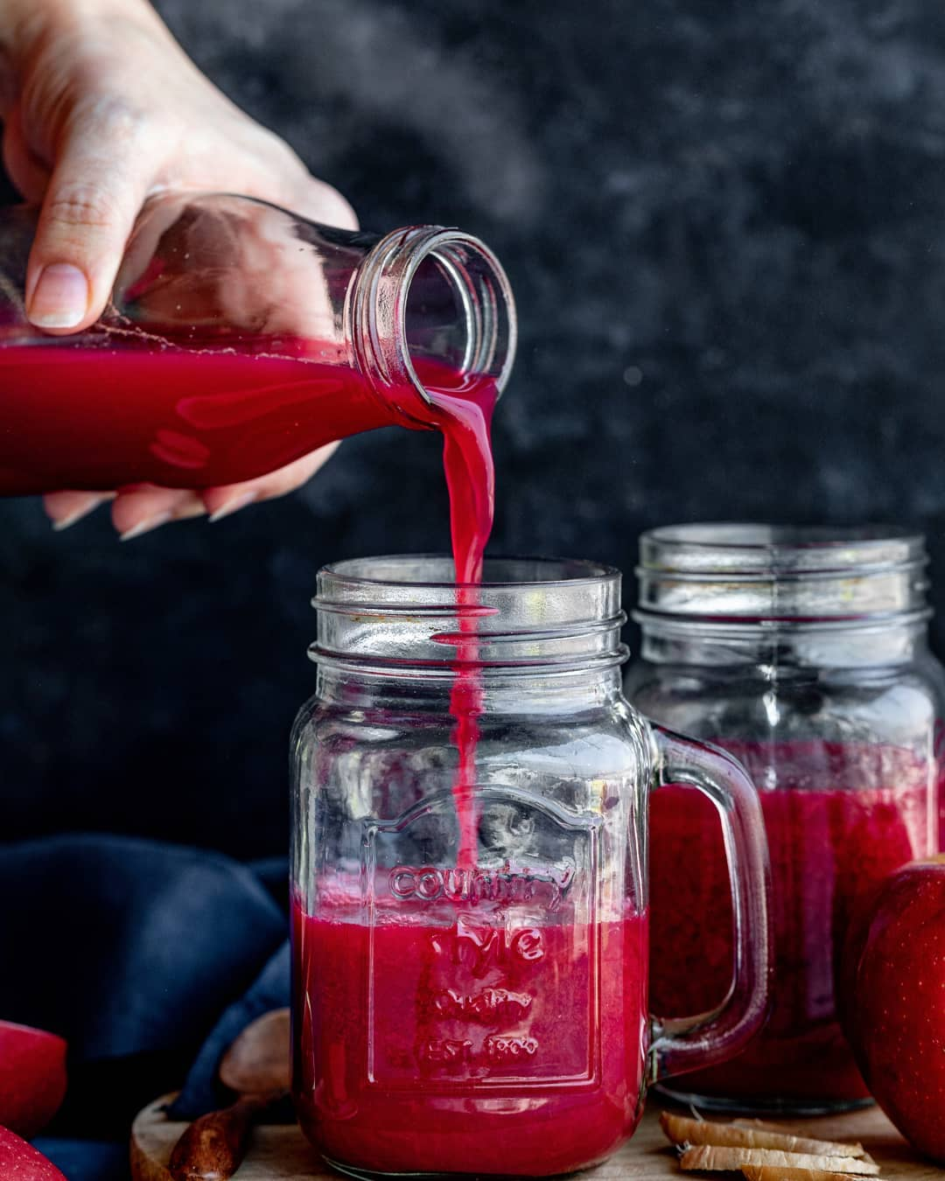

Juices are highly water-rich in nature. 70% of your diet should consist of water-rich foods. Juices cleanse your body by flushing out the waste in your intestines. While drinking juices, your body gets more of what it needs with less food.  Introduce juicing as a culture in your life and you will see the benefits!   
  
This Pink Power Juice is perfect as a mid-meal drink or if you decide to do a two or three-day juice cleanse.  
  
__________  
  
Serves 2 (Makes 600 ml)  
  
INGREDIENTS  
  
3 cups chopped apples (approx. 2 apples)  
1 cup chopped beetroot (approx. 1 beetroot)  
2 cups chopped carrot (approx. 2 carrots)  
2 cups chopped cucumber (approx. 2 cucumbers)  
3 coins ginger  
2 teaspoons lemon juice  
  
METHOD  
  
1. Simply juice everything.  
2. Add the lemon juice from the top and serve.  
  
Substitution: You can replace apples with pears.  
__________  
  
For many such healthy and healing recipes order our Food Book from our website - [**satvicmovement.org**](https://l.facebook.com/l.php?u=http%3A%2F%2Fsatvicmovement.org%2F%3Ffbclid%3DIwZXh0bgNhZW0CMTAAAR1OGZAyLatybI-AlEgKVBtzog7D8SHwrfDLEjZJBQt6Jpm7w3gK52_hAk4_aem_WWlm8TIyNnx93W2a_D45Zw&h=AT2za2LoD1HRRloOtlYyOfQSGbs2BPK3vSXeBigvcdrLcPCFlCUAMpsibPV9ZxJLRxlu68acWkkYRPIgTFqt0SzZ-hr_NfP93HIERQ3PrT7Wvv5SWzZ0hzWeWbREWVVZhXITe1-C8-YIr6OTIf4v&__tn__=-UK*F)  
__________  
  
[**#satvicmovement**](https://www.facebook.com/hashtag/satvicmovement?__eep__=6&__tn__=*NK*F) [**#satviclifestyle**](https://www.facebook.com/hashtag/satviclifestyle?__eep__=6&__tn__=*NK*F) [**#juice**](https://www.facebook.com/hashtag/juice?__eep__=6&__tn__=*NK*F) [**#detox**](https://www.facebook.com/hashtag/detox?__eep__=6&__tn__=*NK*F) [**#foodbook**](https://www.facebook.com/hashtag/foodbook?__eep__=6&__tn__=*NK*F) [**#plantbaseddiet**](https://www.facebook.com/hashtag/plantbaseddiet?__eep__=6&__tn__=*NK*F) [**#healthyrecipes**](https://www.facebook.com/hashtag/healthyrecipes?__eep__=6&__tn__=*NK*F) [**#eatlocal**](https://www.facebook.com/hashtag/eatlocal?__eep__=6&__tn__=*NK*F) [**#eatclean**](https://www.facebook.com/hashtag/eatclean?__eep__=6&__tn__=*NK*F) [**#plantpowered**](https://www.facebook.com/hashtag/plantpowered?__eep__=6&__tn__=*NK*F)

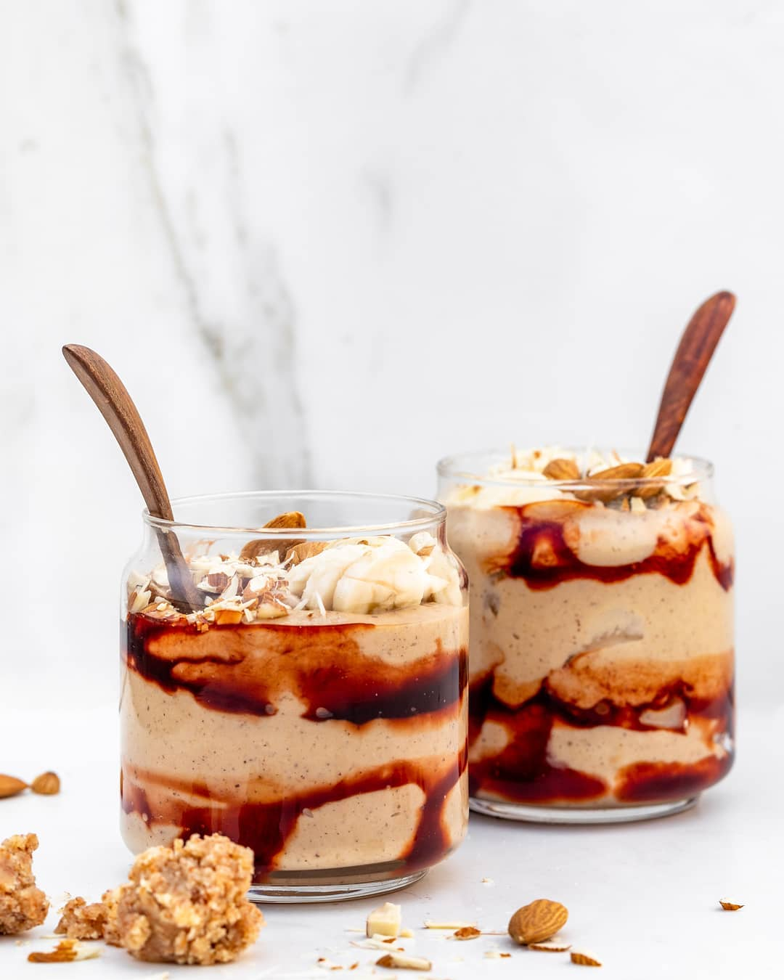

Craving something sweet lately? Try our Peanut Butter Ice Cream.   
The best thing about this dessert is that it takes only 7 minutes to make. It is ultra creamy, nutty, sweet, and just the right amount of savory. Ask your friends to guess the ingredients and they’ll be shocked to know that it is actually healthy - no sugar, no cream and no milk!   
__________  
  
SERVES 3, MAKES 1 1⁄2 cups  
INGREDIENTS  
For Making Peanut Butter  
1 cup peanuts  
For Making the Ice Cream  
6 dates, seedless  
1⁄4 cup water  
4 large ripe bananas, peeled, cut into pieces and frozen for at least 3 hours  
1 tablespoon peanut butter  
1⁄2 tablespoon powdered jaggery  
1⁄8 teaspoon rock salt  
Topping  
1 tablespoon almonds, chopped  
1 tablespoon date paste (optional)  
few banana slices  
METHOD  
For making peanut butter  
1) Heat a pan, add the peanuts, and reduce flame to low. Roast peanuts evenly while continuously stirring for 4-5 minutes.  
2) Transfer peanuts to a blender and blend for 2-3 minutes, till you get a creamy butter. Do not add any water.  
For making peanut butter ice cream  
1) Place the dates and water in a blender and blend till a paste is formed.  
2) Add the frozen bananas, peanut butter, jaggery and salt to the date paste & blend again until smooth. Do not over blend.  
3) Scoop out the ice cream into bowls. Top with almonds, date paste (optional) and banana slices and serve immediately for a soft-serve style dessert.

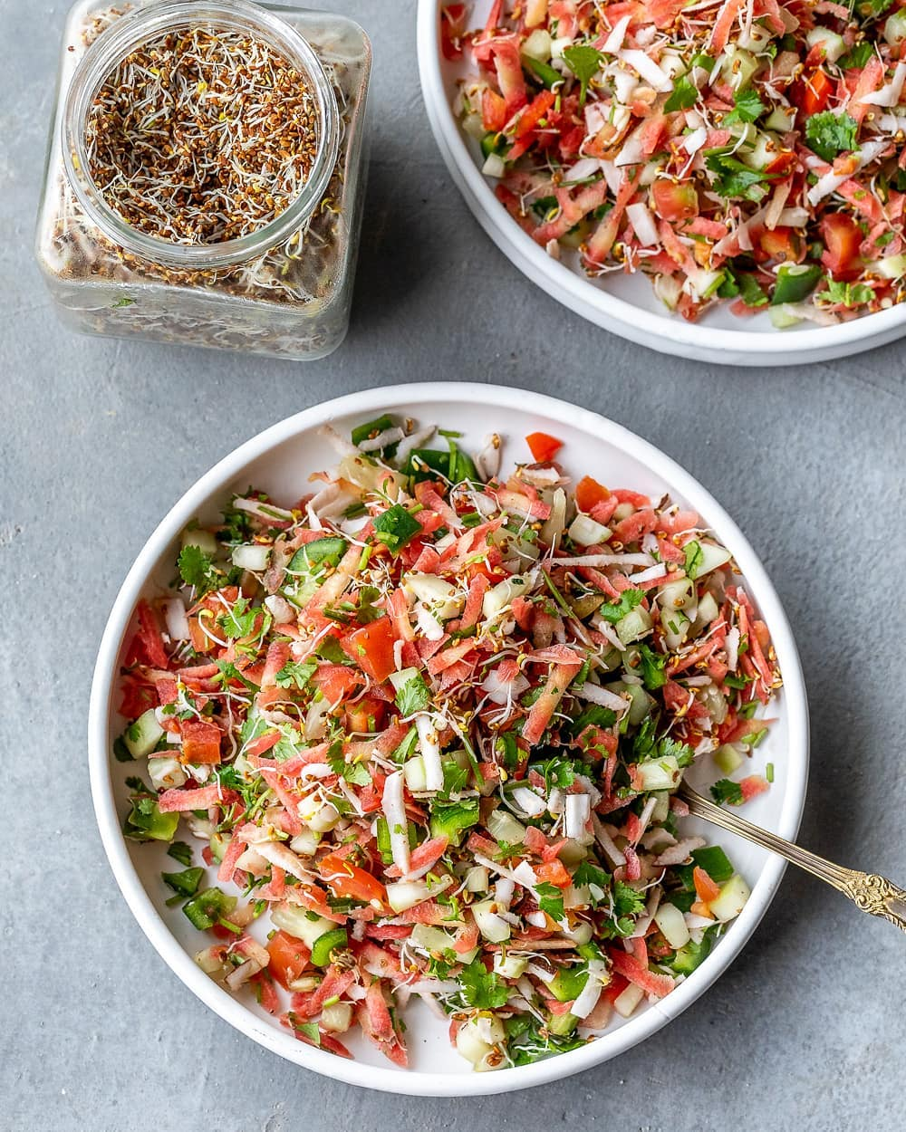Satvic Salad  
This salad is called the pure Satvic salad because it is the purest and cleanest salad amongst all the other salads. It does not contain any nuts, seeds, dressings, salt or lemon because ideally, a salad should be eaten without these things. Yet, this salad is flavourful (because of the coriander and coconut) and crunchy (because of the sprouts)  
  
__________  
  
SERVES 2, MAKES 7 CUPS  
  
INGREDIENTS  
2 cucumbers, chopped  
2 carrots, grated  
2 tomatoes, chopped  
1 small green capsicum, chopped  
1 cup coriander, chopped  
2 big slices of coconut, grated  
For a boost  
1⁄2 cup of vegetable sprouts (such as sprouts of alfalfa, clover, radish)  
  
METHOD  
Place all the ingredients into a large mixing bowl. Toss everything together and serve.  
  
Note: Make sure you use vegetable sprouts in this salad, not lentil sprouts, unless you are an athlete or a child below age 16.  
  
__________  
  
[**#satvicmovement**](https://www.facebook.com/hashtag/satvicmovement?__eep__=6&__tn__=*NK*F) [**#satvicfood**](https://www.facebook.com/hashtag/satvicfood?__eep__=6&__tn__=*NK*F) [**#satvicsalad**](https://www.facebook.com/hashtag/satvicsalad?__eep__=6&__tn__=*NK*F) **#healthy**

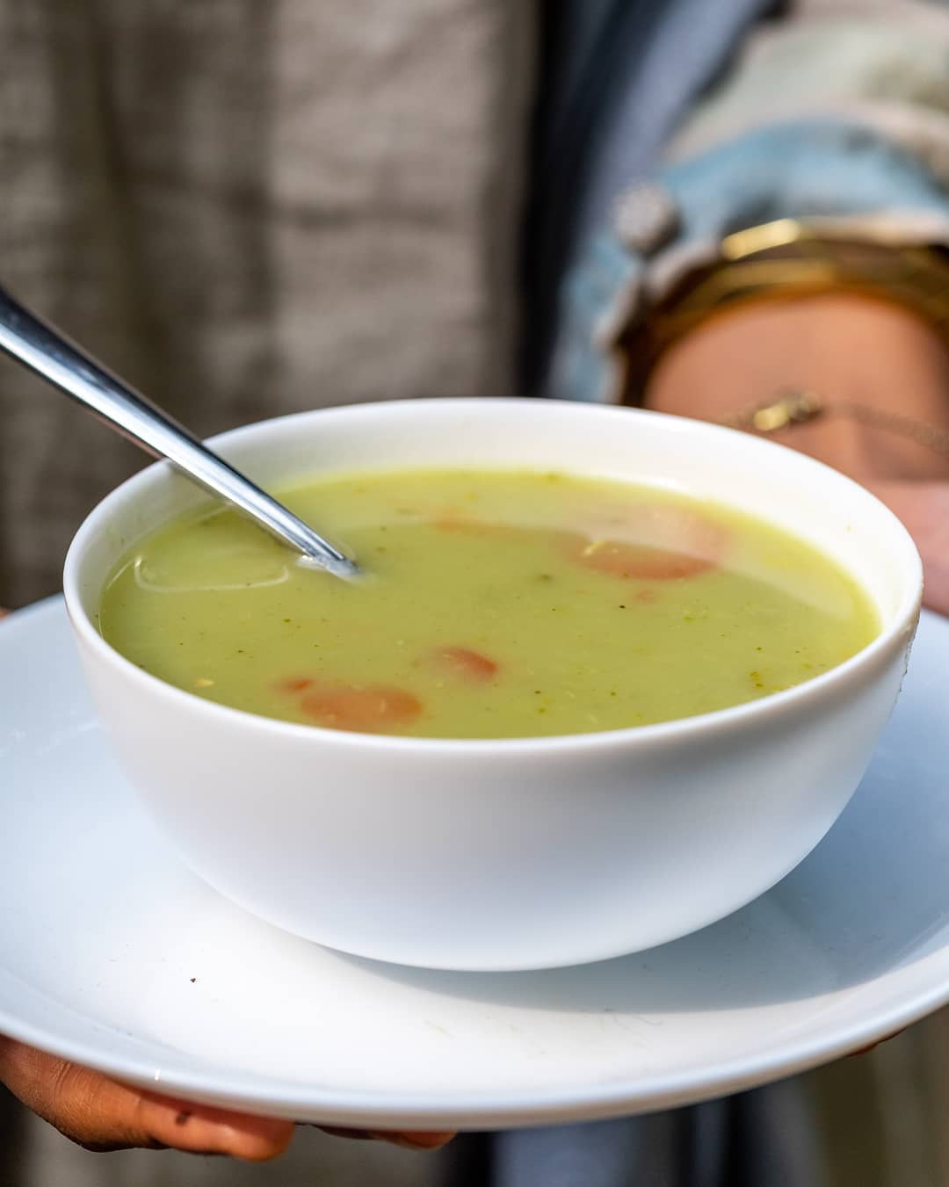

This delicious broccoli potato soup is a staple served at our Health Transformation Workshops. It is rich and creamy, without oil, dairy or other nasty ingredients. It is perfect to keep you warm during these winter months. When you make this recipe, you'll be surprised how good whole, unprocessed food can taste   
  
___________  
  
SERVES 2-3, MAKES 1 1⁄2 litres  
  
INGREDIENTS  
Soup Base  
2 1⁄2 cups fresh broccoli, roughly cut 2 1⁄2 cups potatoes, roughly cut  
3 cups water  
1 1⁄2 teaspoons rock salt  
1 inch fresh ginger, grated  
1⁄4 teaspoon black pepper powder  
1 cup coconut milk  
Topping  
1 cup fresh broccoli, roughly cut  
1⁄2 carrot, cut into circles  
1⁄4 cup fresh coriander, chopped  
1 tablespoon pumpkin seeds  
  
METHOD  
Soup Base  
1. Heat a saucepan over medium heat. Add the broccoli, potato and water. Cover the pot and let the vegetables cook for 20 minutes, or until the potatoes are fork tender.  
2. Add the ginger to the saucepan and let it cook with the vegetables for another 3-4 minutes.  
3. Remove the pot from the stove and use an immersion blender to puree the vegetables.  
4. Add the salt and pepper and mix well.  
5. Right before serving, add the coconut milk.  
  
Soup Topping  
6. Steam the broccoli, potato and carrot until soft. Add to your soup, along with coriander and pumpkin seeds. Serve the soup warm.  
  
__________  
  
[**#satvicmovement**](https://www.facebook.com/hashtag/satvicmovement?__eep__=6&__tn__=*NK*F) [**#satvicfood**](https://www.facebook.com/hashtag/satvicfood?__eep__=6&__tn__=*NK*F) [**#soup**](https://www.facebook.com/hashtag/soup?__eep__=6&__tn__=*NK*F) [**#healthyfood**](https://www.facebook.com/hashtag/healthyfood?__eep__=6&__tn__=*NK*F)

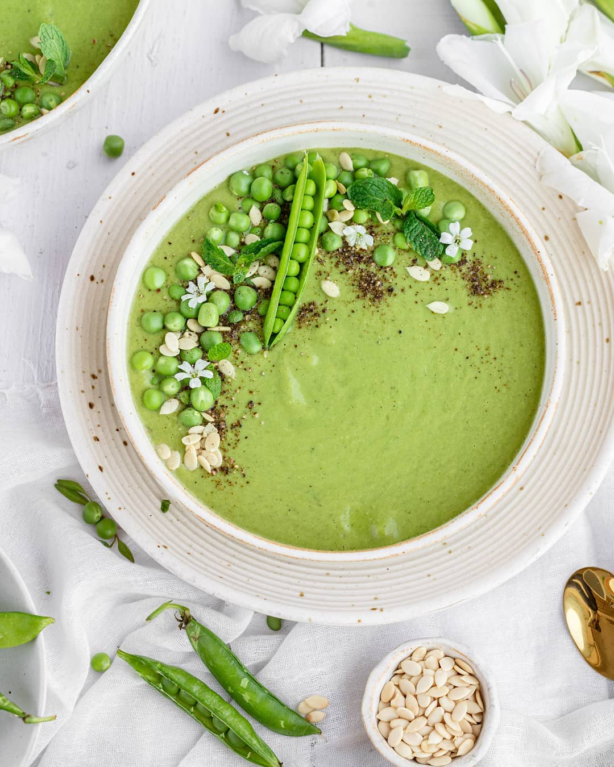

Mint Pea Soup   
  
Mint Pea Soup is a perfect winter warmer. Replace your dinner with this creamy & flavourful soup and see your health transform!  
  
Use only fresh peas (not frozen peas) to make this soup. Also, while preparing the soup, add salt, lemon & coconut milk towards the end. They should not be cooked on flame.  
__________  
  
INGREDIENTS  
  
• 5 cups peas  
• 5 cups water  
• 1 inch ginger, grated  
• ¾ cup homemade coconut milk  
• ¼ cup mint leaves  
• 3 teaspoons lemon juice  
• 2 teaspoon rock salt  
• ½ teaspoon black pepper powder  
  
METHOD  
  
1. Add peas, ginger and water in a claypot and heat the pot over medium flame for about 10 minutes and bring it to a boil.  
2. Once boiled, switch off the stove and keep aside to cool.  
3. Blend the mixture together in a blender till you get a smooth soup like consistency.  
4. Take out this mixture back in a claypot and heat it over medium flame for about 6-8 minutes till it’s warm.  
5. Meanwhile, blend together mint leaves, coconut milk, lemon juice, salt and pepper in a blender.  
6. Switch off the stove after the peas mixture has warmed up. Just before serving, add coconut milk and mint leaves mixture to the soup and stir it well. Serve warm.  
  
__________  
  
For more healthy and healing recipes, order our food book from our website [**satvicmovement.org**](https://l.facebook.com/l.php?u=http%3A%2F%2Fsatvicmovement.org%2F%3Ffbclid%3DIwZXh0bgNhZW0CMTAAAR2LhSN5mlITv2VNRSmSU6m919IjBxi7gXlrsIQrIoz4Rrnc6WYF4YkiZiE_aem_RQ1fp2hMubKapeNjrFP_YQ&h=AT2hWOT7hEk_JwYW0WXACYDHDr6WwmYTTDEPYxbnhtT9x6GHR1qAZnnaQ5cZoG_Y-XS9fXonms6Uq9rB-Fu6kBBysCDr_jkvx4QmjToH2SYPpVhb339TsO8xbSbE4sl7qSQnRz9rWfrngyUPcz0J&__tn__=-UK*F)  
__________  
  
[**#satvicmovement**](https://www.facebook.com/hashtag/satvicmovement?__eep__=6&__tn__=*NK*F) [**#satvicfood**](https://www.facebook.com/hashtag/satvicfood?__eep__=6&__tn__=*NK*F) [**#souprecipe**](https://www.facebook.com/hashtag/souprecipe?__eep__=6&__tn__=*NK*F) [**#healthylifestyle**](https://www.facebook.com/hashtag/healthylifestyle?__eep__=6&__tn__=*NK*F) [**#fresh**](https://www.facebook.com/hashtag/fresh?__eep__=6&__tn__=*NK*F) [**#plantpowered**](https://www.facebook.com/hashtag/plantpowered?__eep__=6&__tn__=*NK*F) [**#plantbased**](https://www.facebook.com/hashtag/plantbased?__eep__=6&__tn__=*NK*F) [**#healingfoods**](https://www.facebook.com/hashtag/healingfoods?__eep__=6&__tn__=*NK*F) [**#holisticliving**](https://www.facebook.com/hashtag/holisticliving?__eep__=6&__tn__=*NK*F) [**#healthyeating**](https://www.facebook.com/hashtag/healthyeating?__eep__=6&__tn__=*NK*F)

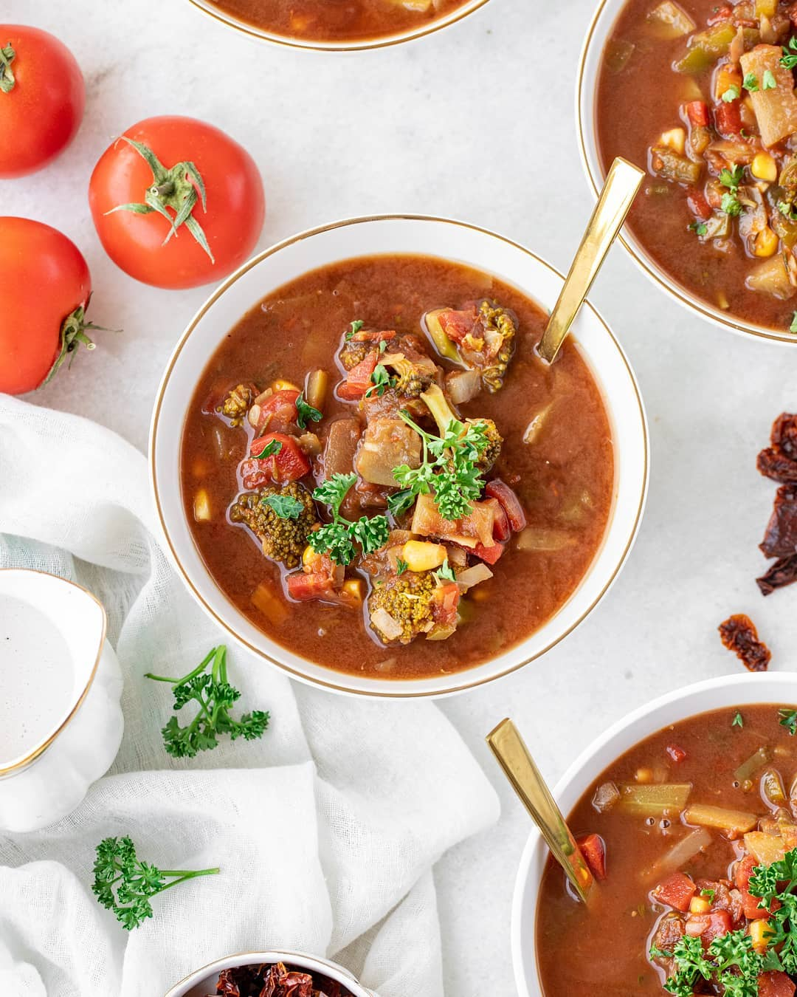

Minestrone Soup   
  
Minestrone soup is an Italian soup with a tomato-y broth. This satvic version of Minetsrone soup has uncooked purée of tomatoes and lots of local seasonal vegetables to provide you that tangy flavour without hampering the nutritional value. We have added herbs instead of extra spices to make it more healing and you’d be amazed to have a soup with no oil but the same consistency as the traditional minestrone soup.  
__________  
  
Serves 4-5 (1190 ml)  
  
Pre Preparation:  
  
Soak the sundried tomatoes and dates in water for 2 hours. In case you have to make it immediately for guests, soak the dates and sundried tomatoes in warm water for 15 minutes.  
  
Ingredients:  
  
¾ cup carrots, chopped finely  
¾ cup cabbage, chopped finely  
¾ cup capsicum, chopped finely  
¾ cup broccoli, finely cut into broccoli heads  
1 cup bottle gourd, peeled and cut into sticks  
½ cup corn  
3 bay leaves  
½ tablespoon dried thyme  
½ teaspoon dried rosemary  
⅓ cup fresh coriander, chopped finely  
2 teaspoon salt  
2 ½ teaspoon lemon juice  
  
For the tomato purée:  
  
½ cup sundried tomatoes, soaked for 2 hours  
2 cups tomatoes, roughly chopped  
1 tsp powdered jaggery  
1 teaspoon dried oregano  
1 ½ teaspoon black pepper  
  
Method :  
  
1. Put all the vegetables with 4 cups of water in a pot.  
2. Add bay leaves, rosemary and thyme. Let the vegetables cook with herbs for about 15-20 minutes till they become soft.  
3. Meanwhile prepare the soup purée by blending all the purée ingredients till you get a smooth running consistency.  
4. Switch off the stove after cooking all the vegetables in water and pour the tomato purée in the pot and stir well.  
5. Add coriander, lemon and salt and stir again. Cover the lid of the pot to let all the flavours come together for 5 minutes. Serve warm.  
__________  
  
For more healthy and healing recipes, order our food book from our website [**satvicmovement.org**](https://l.facebook.com/l.php?u=http%3A%2F%2Fsatvicmovement.org%2F%3Ffbclid%3DIwZXh0bgNhZW0CMTAAAR14EHu_w8uvKDr3729DJJ4gtE0uW-0ccKNcTU1PpwgBvblmzrgSYlNWGNo_aem_bmfH8juWMHaIO9WvTCMKzg&h=AT2EkAOUqSA8DNOI-MXWAoIyTcE78tDMhm6K7hc43tbUzj4tm2JY7oSEO0Y6cMEfegbEM3oYAlauY9TdcSigEq0tvQ9vJ3gY9xZ3WXg88N548Mw0pLGR-XhEAhbBpHzAVMVn_fOTVdsoUbBFSqPO&__tn__=-UK*F)  
__________  
  
[**#satvicmovement**](https://www.facebook.com/hashtag/satvicmovement?__eep__=6&__tn__=*NK*F) [**#satvicfood**](https://www.facebook.com/hashtag/satvicfood?__eep__=6&__tn__=*NK*F) [**#souprecipe**](https://www.facebook.com/hashtag/souprecipe?__eep__=6&__tn__=*NK*F) [**#healthylifestyle**](https://www.facebook.com/hashtag/healthylifestyle?__eep__=6&__tn__=*NK*F) [**#fresh**](https://www.facebook.com/hashtag/fresh?__eep__=6&__tn__=*NK*F) [**#plantpowered**](https://www.facebook.com/hashtag/plantpowered?__eep__=6&__tn__=*NK*F) [**#plantbased**](https://www.facebook.com/hashtag/plantbased?__eep__=6&__tn__=*NK*F) [**#healingfoods**](https://www.facebook.com/hashtag/healingfoods?__eep__=6&__tn__=*NK*F) [**#holisticliving**](https://www.facebook.com/hashtag/holisticliving?__eep__=6&__tn__=*NK*F) [**#healthyeating**](https://www.facebook.com/hashtag/healthyeating?__eep__=6&__tn__=*NK*F)

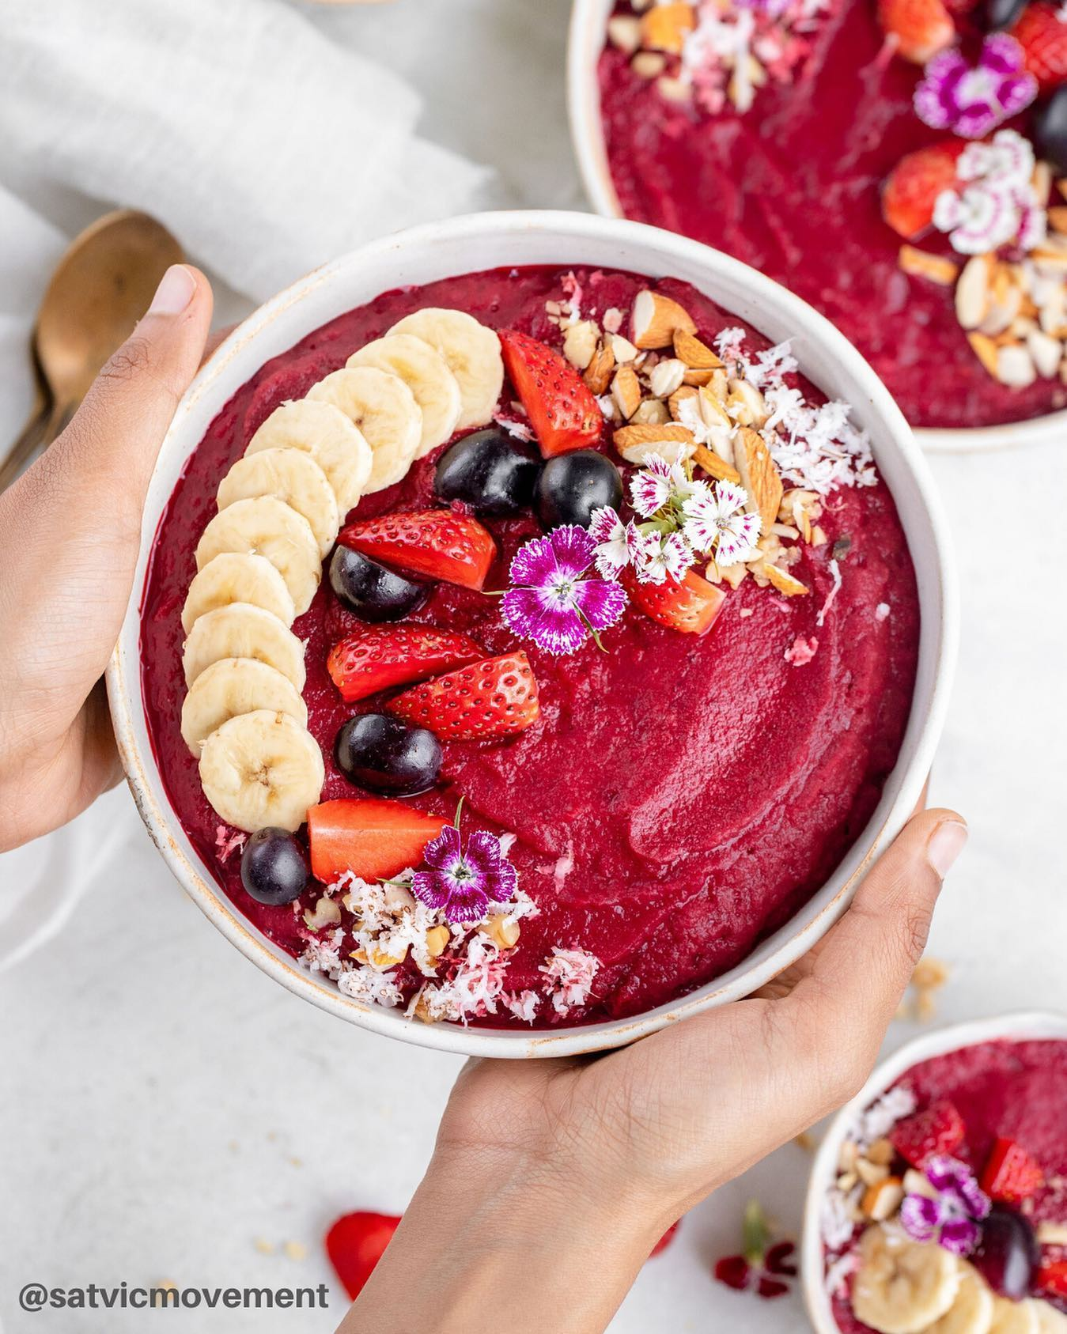

Blush Smoothie Bowl  Takes only 3 ingredients & 5 minutes! It’s incredibly tasty and makes a perfect satvic breakfast   
__________  
⠀⠀  
INGREDIENTS  
2 frozen bananas  
3 chopped pears  
1/2 cup chopped beetroot  
⠀⠀  
TOPPING  
Any seasonal fruits and nuts  
⠀⠀  
METHOD  
1. Take 2 bananas, peel, slice and put in freezer for about 5-6 hours.  
2. Place the pears, beetroot and frozen bananas in a blender and blend until smooth.  
3. Pour this smoothie base into bowls and top with any fresh seasonal fruits and nuts

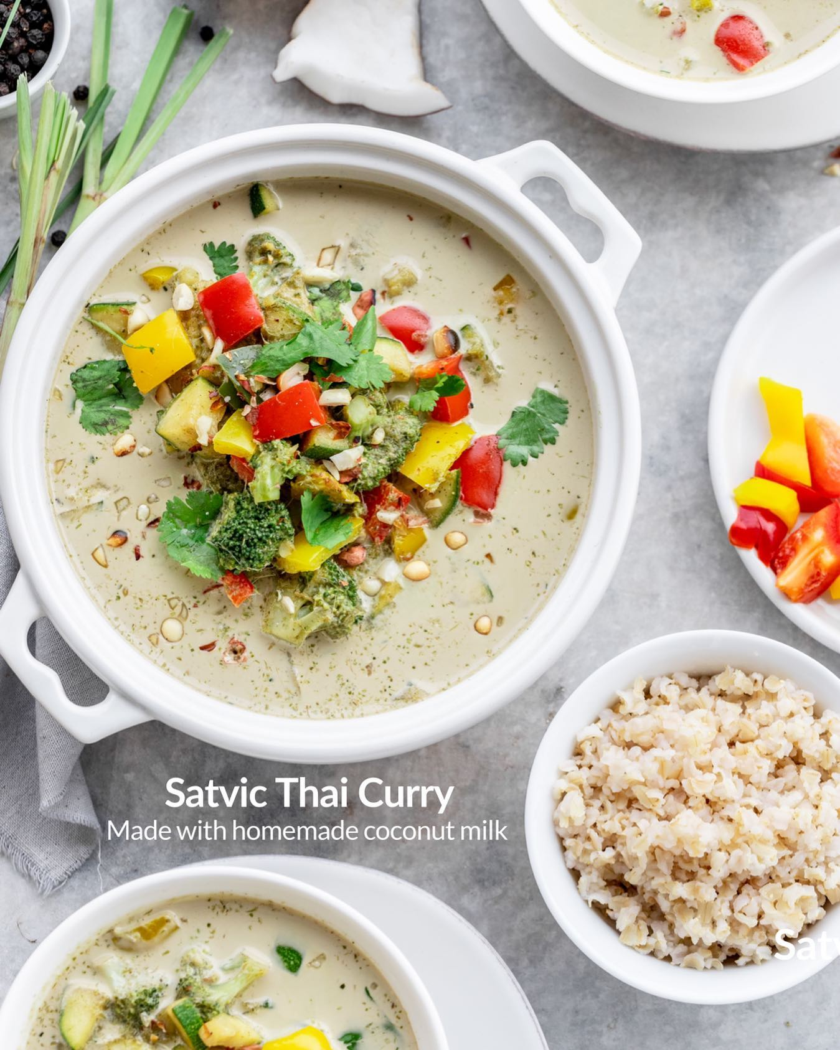

An easy Thai curry, packed with vegetables to make a warm family meal. No need to buy pre- packaged Thai curry paste when you can make it using all fresh herbs at your own home.⁣  
⁣  
INGREDIENTS ⁣  
SERVES 3, MAKES 900 ml⁣  
Paste⁣  
• 1⁄2 cup water⁣  
• 2 teaspoons coriander seeds⁣  
• 2 teaspoons cumin seeds⁣  
• 1 inch coin galangal⁣  
• 1 tablespoon powdered jaggery⁣  
• 1⁄4 cup chopped lemongrass stalks⁣  
• 1 teaspoon lemon zest⁣  
• 12 kaffir lime leaves⁣  
• 1⁄2 teaspoon black peppercorns⁣  
• 1 small green chillies⁣  
⁣  
Curry⁣  
• 3 cups lightly boiled vegetables (such as carrots, broccoli, sweet potato, beans, baby corn)⁣  
• 1⁄4 cup chopped bell peppers⁣  
• 11⁄2 cup thick coconut milk⁣  
• 2 teaspoon lemon juice⁣  
• 1 tablespoon rock salt⁣  
• 2 tablespoon peanuts, roasted and crushed⁣  
Brown rice, cooked⁣  
⁣  
PRE-PREPARATION⁣  
Prepare thick coconut milk by blending 1 cup coconut with 1 cup water and then straining it.⁣  
⁣  
METHOD⁣  
1. To prepare the paste, add all the paste ingredients to the blender and blend until absolutely smooth.⁣  
2. Pour the paste in a pan and cook on a low flame for 5 minutes.⁣  
3. Add the lightly boiled vegetables and bell peppers to the pan, and stir well for 5 minutes.⁣  
4. Switch off the stove. Add the coconut milk, lemon juice and salt to the pan. Stir well. Do not cook coconut directly over the stove.⁣  
5. Crush the roasted peanuts, and add to the curry.⁣  
6. Serve with brown rice.⁣  
Substitution In case galangal is not available, use fresh ginger.  
  
For more such delicious recipes, order the Satvic Food Book from our website  
Visit- [**www.satvicmovement.org**](https://l.facebook.com/l.php?u=http%3A%2F%2Fwww.satvicmovement.org%2F%3Ffbclid%3DIwZXh0bgNhZW0CMTAAAR2WEpeQHardVvP39LXfmOTUt_2gTqkbdOEsiQ5x7Gx9ot3QU6d1kTTWvso_aem_Fo5rgcauSlN0I7XiAyRe1Q&h=AT2fDFe-wQ4F_-34JDrZuD1hiCNPLQL-3d3AONh6c41o1AY_0GJYKux413LJf-UAPlXXDCJhl2ASAao-4e3eHrUqPDiNcoravgnOgPAUCtSqnGwXVmWn_sGGU3WL-ur3VmU4dThUcv_Ebudke4q4&__tn__=-UK*F)  
  
[**#SatvicMovement**](https://www.facebook.com/hashtag/satvicmovement?__eep__=6&__tn__=*NK*F) [**#SatvicLifestyle**](https://www.facebook.com/hashtag/satviclifestyle?__eep__=6&__tn__=*NK*F) [**#CleanEating**](https://www.facebook.com/hashtag/cleaneating?__eep__=6&__tn__=*NK*F) [**#PlantBasedRecipes**](https://www.facebook.com/hashtag/plantbasedrecipes?__eep__=6&__tn__=*NK*F) [**#RawFood**](https://www.facebook.com/hashtag/rawfood?__eep__=6&__tn__=*NK*F) [**#Nutrition**](https://www.facebook.com/hashtag/nutrition?__eep__=6&__tn__=*NK*F) [**#HealthyRecipes**](https://www.facebook.com/hashtag/healthyrecipes?__eep__=6&__tn__=*NK*F) [**#HealingFood**](https://www.facebook.com/hashtag/healingfood?__eep__=6&__tn__=*NK*F) [**#MotherNature**](https://www.facebook.com/hashtag/mothernature?__eep__=6&__tn__=*NK*F) [**#HealYourselfNaturally**](https://www.facebook.com/hashtag/healyourselfnaturally?__eep__=6&__tn__=*NK*F)

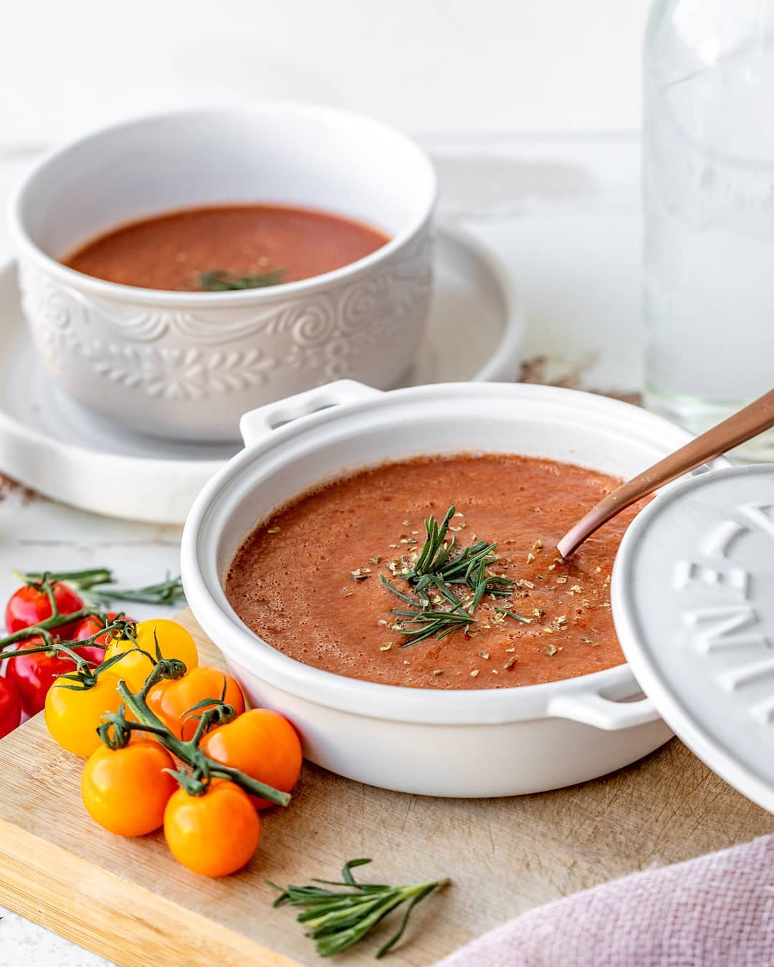

Here is a wonderfully easy recipe for our all-time favorite Tomato Soup. This dish is absolutely comforting, tastes delicious and allows you to enjoy the goodness of vegetables & tomatoes in one soup.  It can be served either for lunch or dinner.   
  
In Satvic cuisine, we do not cook tomatoes. We always add them in the end, because tomatoes are rich in Vitamin C, which is a very delicate vitamin and gets destroyed easily when heated. Therefore, in this soup, we only blanch the tomatoes, to preserve their nutrition.  
__________  
  
INGREDIENTS  
SERVES 1-2. MAKES 700 ml  
  
Soup Base  
8 medium tomatoes  
1⁄4 cup chopped bottle gourd  
1⁄4 cup chopped carrot  
1⁄4 cup chopped potato  
1⁄4 cup chopped red bell pepper  
1 1⁄2 cups water  
1⁄2 teaspoon dry rosemary  
3⁄4 teaspoon rock salt  
1⁄4 teaspoon black pepper powder  
1⁄2 teaspoon dry oregano  
  
METHOD  
  
Soup Base  
1) Dip the tomatoes in hot water for 15 minutes. Cover with a plate. After 15 minutes, peel off their skin and take out the seedy part from inside.  
2) Heat a saucepan over medium heat. Add the bottle gourd, carrot, potato, bell pepper and11⁄2 cups of water. Cover the pot and let the vegetables cook for 15 minutes.  
3) Add these vegetables and water to a blender, along with the peeled and de-seeded tomatoes and rosemary. Blend until smooth.  
4) Mix in the salt, pepper, and oregano. Serve.  
__________  
  
[**#satvicmovement**](https://www.facebook.com/hashtag/satvicmovement?__eep__=6&__tn__=*NK*F) [**#soup**](https://www.facebook.com/hashtag/soup?__eep__=6&__tn__=*NK*F) [**#healthyfood**](https://www.facebook.com/hashtag/healthyfood?__eep__=6&__tn__=*NK*F) [**#fresh**](https://www.facebook.com/hashtag/fresh?__eep__=6&__tn__=*NK*F) [**#eatmoremagic**](https://www.facebook.com/hashtag/eatmoremagic?__eep__=6&__tn__=*NK*F) s